**Title:** Registered Nurse Degree Apprentice

**Band:** Band 2

**Staff Group:** Nursing & Midwifery

**Programme Length:** 4 years

**Reports to:** Registered Professional

*\**

**Job Purpose:**

* To support and assist members of the multidisciplinary team in providing high-quality person-centred nursing care for a clearly defined group of patients, relatives and carers within a variety of different care settings (wards/theatres).
* Ensure patient safety is maintained and patient experience is positive by treating all patients, relatives, carers and colleagues with respect, dignity and courtesy in accordance with the values of our Trust and the NHS Constitution.
* Always ensure that you act within your sphere of competence.
* Apprentice nurses will divide their time between working as a Healthcare Support Worker in their designated clinical core base, completing protected supernumerary shifts in their role as a nursing apprentice, and participating in allocated study time.
* Healthcare Support Worker duties will vary based on the clinical area assigned to the Apprentice Nurse, within your scope of practise with specific responsibilities provided upon allocation.

**Key Responsibilities**

The following list is indicative as tasks and responsibilities will vary depending on the care setting the Registered Nurse Degree Apprentice is working in. This job description does not purport to cover all aspects of the job holder’s duties but is intended to be indicative of the main areas of role and responsibilities.

* Demonstrate proficient attitudes and behaviours compatible with Trust Values.
* Work as part of a designated clinical team delivering patient centred care.
* Deliver high quality, compassionate care and carry out delegated clinical care tasks and responsibilities, under the direction of a registered nurse (or other registered care professional dependent on setting), with a focus on promoting health and independence.
* Work with assessors and supervisor/s to take responsibility for developing own clinical competence, leadership and reflective practice skills within the workplace.
* Develop and improve practical and theoretical knowledge, competence and skills throughout the Registered Nurse Degree Apprentice programme and maintain all evidence required.

**Clinical responsibilities**

* Develop understanding of all elements of the nursing process and be able to assist the registered nurse in the on-going assessment, planning, management, and evaluation of care.
* Support individuals with all aspects of care including daily living, providing person-centred care, and promoting health and independence through awareness raising and care navigation to other professionals as appropriate.
* Recognise patient’s needs and changing condition and respond appropriately and effectively.
* Be responsible and accountable for your own practice, working within limits of competence and within professional boundaries.
* Provide care to patients to maintain their personal hygiene and physical. comfort ensuring that their privacy and dignity is always maintained. Work in partnership with patients to respect their rights and choices.
* Maintain a clean and safe environment for patients and ensure Trust Policy is followed regarding Infection Control and Prevention.
* Use frequent moderate effort when carrying out the manual handling of individuals and equipment in line with organisational guidelines.
* Act always within your sphere of competence as determined by the minimum skill set for Healthcare Support Workers.
* Ensure the privacy, dignity and safety of individuals is maintained at all times.
* Assist in the implementation of appropriate action to meet the specific physical, emotional and psychological, social, cultural and spiritual needs of individuals and carers.
* Engage in reflective practice including management of self and reflection on own reactions, asking questions and reflecting on answers given.
* Adhere to legislation, policies, procedures and guidelines both local and national.
* Ensure all patient related information is treated sensitively and adhere to the principals of confidentiality at all times.
* Report any accidents or incidents and raise any concerns as per Trust policy.
* Recognise issues relating to safeguarding vulnerable children and adults and report any problems or raise concerns to the appropriate registered care professionals.
* Ensure all possible steps are taken to safeguard the welfare, safety and security of patients, visitors and staff in accordance with Trust policies.
* Maintain a professional approach while working in challenging, distressing situations or dealing with challenging behaviour.
* Take reasonable care for your own Health and Safety and that of any other person who may be affected by your acts or omissions at work.
* Frequent exposure to unpleasant work conditions e.g. bodily fluids.

**Communication and relationships**

* Communicate effectively across a wide range of channels and with a wide range of individuals, the public, health and social care professionals, maintaining the focus of communication on delivering and improving health and care services.
* Always promote and demonstrate effective verbal and non-verbal communication with patients, relatives and colleagues recognising the need for tact, consideration and confidentiality.
* Engage in reflective practice including management of self and reflection on own reactions, asking questions and reflecting on answers given.
* Share ideas with colleagues to improve care and suggest areas for innovation.
* Demonstrate those inter-personal skills that promote clarity, compassion, empathy, respect and trust.
* Ensure clear, concise, accurate and legible records and all communication is maintained in relation to care delivered adhering to local and national guidance.

**Professional Education and Development**

* Complete the Trust Competency Framework for healthcare support workers and achieve the minimum skill set (list of competencies as defined in generic competency framework). Maintaining own learning record of evidence.
* To undertake and successfully complete The Care Certificate.
* Take responsibility for organising and attending statutory / mandatory updates in accordance with Organisational and University requirements.
* Develop skills relevant to the role as identified by ward/department leader and in accordance with Trust Policies.
* Recognise the need to participate in ongoing personal development by attending essential training for the role. Participate fully in the Appraisal and Development Review Process.
* Be proactive in seeking opportunities to develop own knowledge and skills, achieving clinical competencies and BSc (Hons) qualification within agreed timeframes. Seek support / guidance in timely manner if any difficulties are encountered.
* On completion of the Registered Nurse Degree Apprenticeship, demonstrate the ability to work without direct and constant supervision and assess and deliver care independently, within the parameters of a Registered Nurse.

This job description is not intended to be an exhaustive list and may be subject to change.

**Safeguarding Children, Young People and Adults with care and support needs**

All staff must understand and follow the Trust’s Safeguarding Children and Adults policies. Health professionals have a legal duty to safeguard and promote the welfare of children and adults with care needs, including when working with their parents, carers, or other significant adults.

All staff must complete safeguarding awareness training, and any additional role-specific safeguarding training as required.

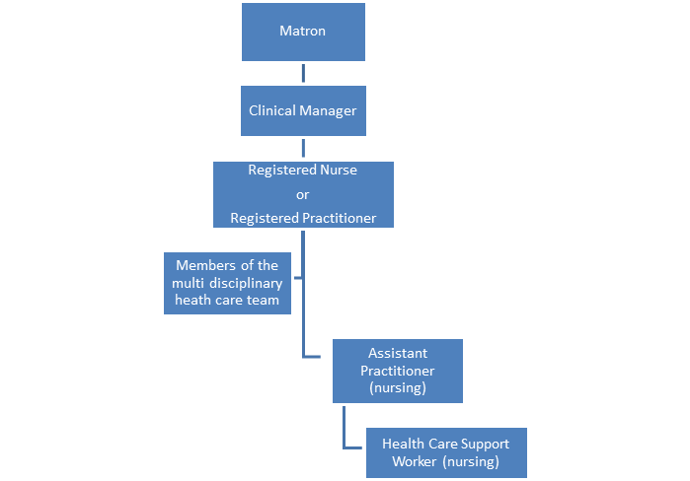**Organisational Chart**

**Other**

The Registered Nurse Degree Apprentice is a developmental role, which enables progression towards registration as an adult nurse through the successful completion of the Registered Nurse Degree Apprenticeship. This apprenticeship includes the attainment of a Level 6 Bachelor of Science (Hons) Degree in Adult Nursing. Registered Nurse Degree Apprentices will develop knowledge, skills and competencies related to the role of a nurse within a variety of clinical settings throughout the apprenticeship.

The blended learning Registered Nurse Degree Apprenticeship programme combines both academia and work-based learning to gain successful registration with the Nursing and Midwifery Council.

*\*The salary for existing NHS employees will be in line with Annex 30, NHS Terms and Conditions.*

*Progression to Band 3 will be dependent on a range of proficiencies being achieved at a formal review 24 months into programme.*

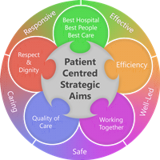**Person Specification**

**Qualifications**

*Essential*

* GCSE in English and Maths at Level C/4, or Level 2 Functional skills in standalone maths and English qualifications.
* Level 3 Qualification either: A Level’s at grade C or above or equivalent, or other Level 3 study recognised as sufficient for entry (this may include a full Level 3 Apprenticeship in Health and Social Care, T-Level, BTEC or Access to Higher Education).

*Desirable*

* Completion of the Care Certificate portfolio
* Evidence of continuous professional development during the last 3 years

**Experience**

*Essential*

* Desire to deliver compassionate hands-on care in the hospital environment.
* Can demonstrate understanding and share the Trust values of:

**Working Together for Patients, With Compassion, As One Team and Always Improving**

And

**C**ompassion**, A**ccountable**, R**espect**, E**veryone counts

**Skills & Knowledge**

*Essential*

* Demonstrate the ability to work effectively as a team player under appropriate supervision and as part of the multi-disciplinary team.
* Demonstrate excellent verbal and written communication skills.
* Demonstrate ability to effectively interact with patients, relatives, carers and colleagues.
* Work in an effective and organised manner demonstrating excellent time management and organisational skills to effectively deliver person-centred care.

*Desirable*

* Evidence of previous experience undertaking virtual/online learning.

**Personal Qualities and Attributes**

*Essential*

* Demonstrate motivation and commitment to undertaking the Registered Nurse Degree Apprenticeship and passion for providing high quality safe and effective care.
* Have insight into how to evaluate own strengths and development needs, seeking advice and support where appropriate.

**Demonstrate understanding of, and share in Portsmouth Hospitals University Trust Values:**

**Working Together For Patients with Compassion as One Team Always Improving**

**Strategic approach** (clarity on objectives, clear on expectations)

**Relationship building** (communicate effectively, be open and willing to help, courtesy, nurtures partnerships)

**Personal credibility** (visibility, approachable, back bone, courage, resilience, confidence, role model, challenge bad behaviour, manage poor performance, act with honesty and integrity)

**Passion to succeed** (patient centred, positive attitude, take action, take pride, take responsibility, aspire for excellence)

**Harness performance through teams** (champion positive change, develop staff, create a culture without fear of retribution, actively listen and value contribution, feedback and empower staff, respect diversity)

**Demonstrate understanding of, and share in the Isle of Wight NHS Trust Values:**

**Compassion** (Committed to clear communication, providing patient centred care, values others experience and learns from it, champion high standards, advocate for those whom we serve)

**Accountable** (committed to ensuring we have a workforce that has the right values, skills, support and development to deliver outstanding care)

**Respect** (Committed to ensuring every staff member and service user of the isle of wight NHS trust feels valued, is treated with dignity and integrity, respected and a fellow driver for continuous positive improvement)

**Everyone counts** (Committed to creating a positive culture in which diversity, equality and inclusion are promoted and discrimination is not tolerated. Be part of working towards building and maintaining an environment which values diversity)

Job holders are required to act in such a way that at all times the health and wellbeing of children and vulnerable adults is safeguarded. Familiarisation with and adherence to the Safeguarding Policies of the Trust is an essential requirement for all employees. In addition, all staff are expected to complete essential/mandatory training in this area.

**Print Name:**

**Date:**

**Signature:**

