
Job Description
Title: Sonographer in Ultrasound
Band: 7
Reports to: Ultrasound Superintendent
Enter the level of training below - delete the field if the job holder does not need to complete the Passport to Manage programme.

Passport to Manage

We are proud to support staff with a competency framework that is designed to equip staff with the skills and knowledge to become effective managers and leaders.

This post has been identified as a role that will benefit from the training and you will be enrolled onto the Passport to Manage programme upon commencement with the Trust.


Please click here for further information about the Passport to Manage programme.

Job Summary:

- To perform obstetric, gynaecological and general and acute abdominal ultrasound scans upon a range of patient types, both as an autonomous practitioner and as part of a multi-professional team, in a manner that meets professional and departmental standards and requirements.

- To assess and report on own ultrasound examinations and maintain appropriate records.

- To supervise and teach trainee sonographers, SpRs, student radiographers and other health professionals

- Ensure patient safety is maintained and patient experience is positive by treating all patients, relatives and colleagues with respect, dignity and courtesy in accordance with Trust values.

- To participate in research, audit and CPD.

Key Responsibilities:
Clinical/Operational/Professional
- To independently undertake a wide range of ultrasound examinations in line with Local, Regional and National guidelines as an autonomous practitioner. Undertaking ultrasound scans at remote satellite ultrasound facilities where there is no immediately available Consultant Radiologist support.

- To independently provide a daily acute abdominal ultrasound service to all departments at Queen Alexandra Hospital, working within own qualification & expertise.

- Have a detailed knowledge of ultrasound equipment and the physics of ultrasound and be able to operate a wide range of ultrasound machines. To use this skill and knowledge to operate machines safely to produce optimum images and most accurate diagnosis. Participation in evaluation of new equipment.

- To use own judgment to analyse and interpret ultrasound images in order to provide independent written reports. To give a diagnosis to the referring clinician which may directly impact on patient treatment and management; often resulting in surgical intervention. Provide specialist advice concerning the care and/or treatment of obstetric, gynaecological and abdominal patients.

- Make recommendations for further scans, assessment and referral where necessary.

- To report and communicate findings directly with referring Clinicians and other health professionals regarding patient’s ultrasound scans.

- To be accountable for own professional actions including reporting ultrasound findings.

- To provide ultrasound guidance for invasive ultrasound techniques such as amniocentesis, if trained to do so (not all do this)

- To lead by example; promoting high standards and maintaining a high standard of clinical expertise by being a role model and point of contact for more junior staff and trainees including registrars.

- To be responsible for own caseload and be able to plan and prioritise patients. Organise and co-ordinate ultrasound scans from a wide variety of referral pathways.

- To supervise and manage the radiographic assistants on a daily basis.

- To undertake Consultant Radiologists ultrasound lists as necessary during their absence.

- To supervise and assess work of other health professionals and provide clinical ultrasound training to MSc level. Also supervise and train Radiology and Obstetric registrars.

- To be responsible for safe use/ maintenance of specialist equipment used by self and others.

- To have a high level of dexterity and hand/eye co-ordination as is required to obtain optimum imaging. Frequent need for intense concentration. High physical effort is required when scanning immobile acutely ill patients. An awareness of repetitive strain injury (RSI) is essential at all times.

- To maintain own level of competence through continuing professional development through participation in internal and external development opportunities and to maintain a portfolio of evidence in support of CPD undertaken. To take part regularly in departmental audit and clinical trials.

- To regularly attend and contribute to Regional and Local Multi –disciplinary team meetings i.e. Wessex Antenatal Detected Abnormalities (WANDA), peri-natal mortality meetings.

- To provide sonographer led imaging to ‘One stop clinics’ i.e. Haematuria clinic, Post-menopausal bleeding clinic (PMB), Early Pregnancy Assessment Clinic (EPAU).

- To take part in the planning and implementation of new services and strategies concerning patient care, to enhance, develop and improve patient pathways.

- To be responsible for updating and correcting computerised and paper based patient records. To be responsible for checking and finalising all reported scans on the Radiology Information System (RIS).

- To be competent in the safe and correct use of the departmental PACS and RIS systems.

- Assist the appropriate Superintendent in identifying staff training and development needs. Including RIS, PACS, and scanning technique training.
- To observe all manual handling criteria when;
- Moving patients from waiting areas into the scanning rooms
- Transferring patients on and off the scanner tables
- Positioning patients into the correct scanning position
- Moving the scanner equipment

- To undertake the departmental and Trust induction programmes and maintain competency in Trust essential Skills

- To ensure a positive and professional image of the ultrasound department is presented to all users.

- To report all undue events in accordance with the Trust Incident Reporting policy

Communication

To communicate effectively and appropriately, with all users of the service, across all age groups and abilities, observing confidentiality and information governance. This will include: -

- To communicate highly sensitive information to patients and relatives including fetal abnormalities, fetal death, and, if appropriate, abdominal/pelvic pathology. Ability to deal with distraught and often angry patients after imparting bad news. Counselling and bereavement skills are required on a daily basis.
- Patients, Carers & Relatives: To explain procedures, pre and post care, follow up procedures, appointments. To overcome barriers to understanding patients with special needs. To communicate sensitive/complex information to some patients.
- Radiologists: To discuss examination techniques, results and outcomes, appointments,
- Other Health Care Professionals: To discuss patient examinations, preparation and post procedure care, diagnostic results, appointments, service issues and problems
- Wards/Depts: On any issues involving patients; on any issue affecting the provision of the Ultrasound service
- To be able to relate to all manner of patients with understanding and care, respecting their privacy and dignity to provide a caring and confidential service.
- Encourage and participate in active feedback of ideas, concerns and suggestions to the appropriate level and in an appropriate forum.
- Ensure all staff have access to the appropriate communication forum and are familiar with the Department’s objectives, plans and relevant Trust issues

Physical effort & Working Conditions

- To regularly undertake examinations of an intimate and often unpleasant nature, i.e. transvaginal scans, early pregnancy complications, where there is exposure to bodily fluids.

- Have regular exposure to distressing or emotional situations on a daily basis e.g. caring for terminally ill or badly injured patients, giving feedback of a negative nature to trainees.

- Have frequent use of VDU equipment.

- Have regular exposure to highly distressing situations e.g. severe trauma cases, cardiac arrest, discovering cancers.

- Have frequent exposure to body fluids e.g. blood, urine etc and infection risks and occasional exposure to fleas/lice.

- Have occasional exposure to intoxicated, aggressive or abusive patients and relatives.

- Have daily exposure to unpredictable workload.

- Be required to position and manoeuvre patients and equipment on a daily basis. In any clinical situation, patients may be ambulant, in a wheelchair, or on a bed or stretcher. Transfer to an ultrasound couch is necessary.

Organisational Chart

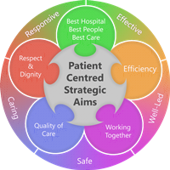
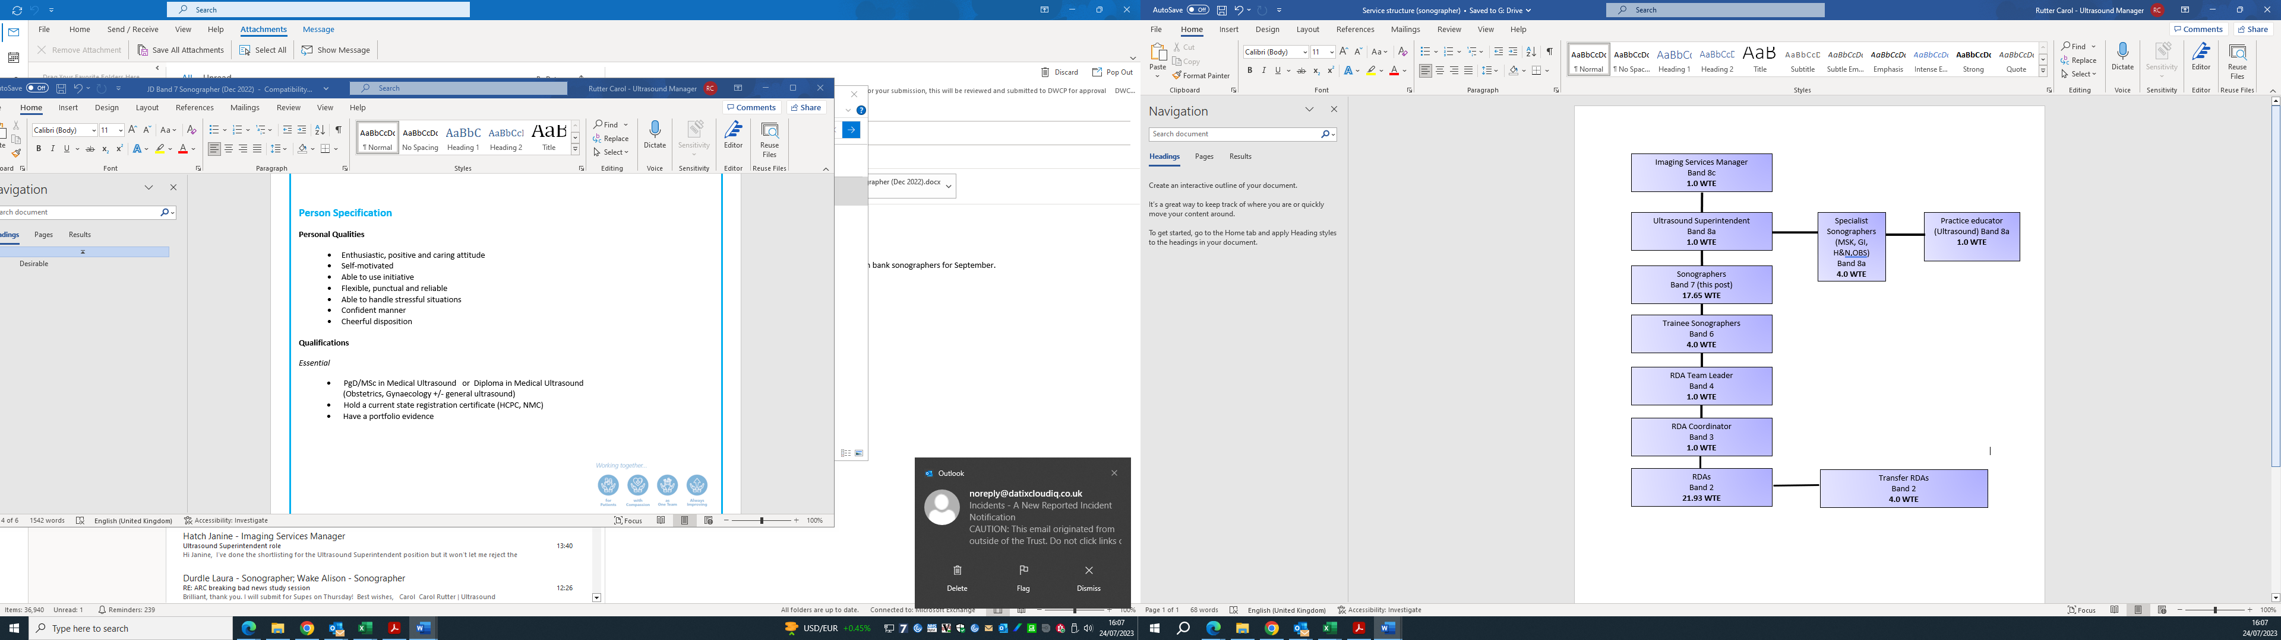
Person Specification
Personal Qualities
- Enthusiastic, positive and caring attitude
- Self-motivated
- Able to use initiative
- Flexible, punctual and reliable
- Able to handle stressful situations
- Confident manner
- Cheerful disposition

Qualifications
Essential
- PgD/MSc in Medical Ultrasound or Diploma in Medical Ultrasound
(Obstetrics, Gynaecology +/- general ultrasound)
- Hold a current state registration certificate (HCPC, NMC)
- Have a portfolio evidence

Desirable
- MSK
- Small parts (Testes/Thyroid etc.)
- Paediatrics
- Nuchal Translucency accredited (Fetal Medicine Foundation & DQASS)

Skills and Knowledge
- Highly developed physical skills (dexterity, co-ordination & sensory skills)
- Sound technical knowledge of equipment and ultrasound techniques
- Sound clinical knowledge
- Good clinical practice
- Ability to communicate effectively up to consultant level
- Competent in all aspects of obstetric, gynae, abdominal and trans-vaginal scanning
- Good communication and patient care skills
- Ability to work alone or as part of team
- Enthusiastic and self-motivated
- Reliable and trustworthy
- Good organisational skills
- Keen to develop and take on new roles
- Professional appearance
- A willingness to be flexible
- Ability to juggle many priorities at one time, whilst remaining calm

Experience
- Post graduate radiography/healthcare experience

Working Together For Patients with Compassion As One Team Always Improving
Strategic approach (clarity on objectives, clear on expectations)

Relationship building (communicate effectively, be open and willing to help, courtesy, nurtures partnerships)

Personal credibility (visibility, approachable, back bone, courage, resilience, confidence, role model, challenge bad behaviour, manage poor performance, act with honesty and integrity)

Passion to succeed (patient centred, positive attitude, take action, take pride, take responsibility, aspire for excellence)

Harness performance through teams (champion positive change, develop staff, create a culture without fear of retribution, actively listen and value contribution, feedback and empower staff , respect diversity)

Job holders are required to act in such a way that at all times the health and well being of children and vulnerable adults is safeguarded. Familiarisation with and adherence to the Safeguarding Policies of the Trust is an essential requirement for all employees. In addition all staff are expected to complete essential/mandatory training in this area.

Print Name:
Date:
Signature:

