**Title:** Specialist dietitian

**Band:** 6

**Staff Group:** Allied Health Professional

**Reports to:** Acute Dietetic Operational Lead

**Job Summary:**

* To deliver a specialist dietetic service, including enteral and parenteral nutrition, to patients under the care of Portsmouth Hospital University NHS Trust; working autonomously in delivering nutritional care to patients.
* To work autonomously to provide an outpatient service to patients, and their carers, requiring nutritional support, both within dietetic-led and multidisciplinary consultant-led clinics.
* To act as a core member of the Multidisciplinary Team by representing dietetics and promoting the role of nutrition within patient care to members of medical and surgical teams.
* To act as a resource to the dietetic team, supporting junior and community dietitians.
* To assist the Operational Lead in developing acute dietetic team resources, skills and knowledge – ensuring continuity of care across local and regional dietetic services.
* A highly skilled clinical expert with specialised knowledge in caring for patients and their carers.

**Key Responsibilities:**

***Clinical/Professional***

* To deliver Specialist Dietetic intervention within Portsmouth Hospitals NHS Trust, making sound professional judgments regarding nutrition and hydration, frequently requiring urgent intervention by the nutrition support MDT.
* Working autonomously in managing a caseload of patients demanding specialised dietetic assessment and intervention using specialist knowledge and skills in the in-patient and out-patient settings including wards, clinics and telephone contact.
* As a core member of the surgical and nutrition support MDT, to lead dietetic care by signposting patients down appropriate dietetic care pathways, working closely with regional specialist colleagues, and liaising with other members of the dietetic, and nutrition nurse teams in hospital, in the community and across the region to ensure continuity of care.
* To act as an advocate for patients, carers and relatives to ensure dietary intake and nutritional status are considered as part of medical treatment pathways – liaising with key members of both the local MDT, and other regional services where required, to achieve this.
* Play a lead role in proactively recommending artificial nutrition support in a timely way to prevent unnecessary/prolonged admissions and to improve patient clinical outcomes.
* Act as the patient advocate on nutritional issues when devising treatment plans with other professionals.
* Demonstrate regular personal development activities. To keep up to date on professional matters actively pursuing training for self-development relevant to the role through an individual training plan.
* Implement evidence-based practice, initiate, manage and evaluate changes that lead to improved and high standards of care, and particularly any service changes following feedback from patients.
* Communicating, influencing, and working with the multidisciplinary team in different ways to improve quality of care, and inform clinical decisions. Promote innovation and participate in benchmarking and quality audits to measure effectiveness of current practices.
* Create a culture for learning and development that will sustain person-centred safe and effective care.
* Support junior colleagues in the provision of direct care; facilitate learning in and from practice at the same time as working alongside; or undertaking a care plan review if a serious incident or complaint has occurred.
* Ensure concerns raised by patients and their families are dealt with in an open, honest, and transparent way, quickly and effectively, in line with trust policies, procedures and Duty of Candour legislation.
* Ensuring that accurate and timely dietetic records are maintained, monitoring standards, and taking corrective action as required.

***Management/Leadership***

* Accountable for the direct delivery of the Dietetic service within the specialised clinical area of your contract.
* Advocate for nutrition and dietetics within the trust.
* Responsible for the line-management of a band 5 Dietitian as agreed with Acute Operational Team Lead Dietitian; undertaking supervision and appraisal/ADPR as required.
* Undertake other tasks or accept additional responsibilities (e.g. Student training liaison, health & safety liaison, social media lead) delegated by the Acute Operational Lead or Service Manager that contribute to the effective provision of the Dietetic Service. To undertake such other tasks and occasional relief duties as may be required from time to time by the Dietetic Services Manager
* Contribute to the department pay and non-pay budgets by ensuring good housekeeping, economic and sustainable use of resources.
* Work closely with Trust partners i.e. Engie, resolving any issues regarding provision of food and maintenance of the environment efficiently, and ensure staff are aware how to escalate when issues cannot be resolved.

**Research and Education**

***Research***

* Contribute to a research culture within the dietetic team to identify current knowledge and deliver evidence-based care. Seek out ways to evaluate service provision.
* Support local research teams, actively contribute to local department multidisciplinary audits, represent the clinical area at governance meetings and highlight areas for change.

***Education***

* Create an environment that is conducive to learning and encourage team open-ness so that an evidence-based approach is utilised and applied to nursing care.

Act as a mentor and coach for dietitians, support staff and junior team members.

* Contribute to the direct supervision of dietetic students; commit to and encourage a culture where student dietitians receive quality placements supported by coaching-style of supervision, including mentorship and teaching from the multi-professional team as appropriate.
* Responsible for ensuring that Trust requirement for mandatory/essential training is completed.

***Communication and Working Relations***

* Provide and receive complex, sensitive or contentious clinical and personal data/information, treating this in line with trust information governance policy.
* Use highly developed interpersonal verbal and non-verbal counseling skills to overcome significant barriers to nutritional care and in dealing with distressing symptoms.
* Communicate sensitively and effectively with patients, carers, relatives and other professionals in situations that may be highly emotive, dealing with frequent exposure to distressing and emotional circumstances.
* Establish robust communication channels with other professionals to facilitate effective dietetic intervention and continuity of care, for example for enteral tube feeding discharges, including regional working.
* Responsible for recording personally generated information regarding patients e.g. written and electronic records, reports, and activity data in accordance with professional and local standards. To keep patient records and record information on case notes/care plans as per Department/Trust procedures.
* Concentrate while undertaking work that is not always predictable. With competing demands for attention, prioritize workload and manage interruptions relating to patient care.

***Working Conditions and Effort***

* May be frequently exposed to distressing circumstances (e.g. working with patients who are given distressing diagnoses, those terminally ill and their families) and/or exposed to other conditions.
* Frequent exposure to unpleasant or highly unpleasant working conditions e.g. noise levels, bodily fluids, smell.
* **Other duties within capability as agreed with the department manager or acute dietetic operational lead**

**Organisational Chart**

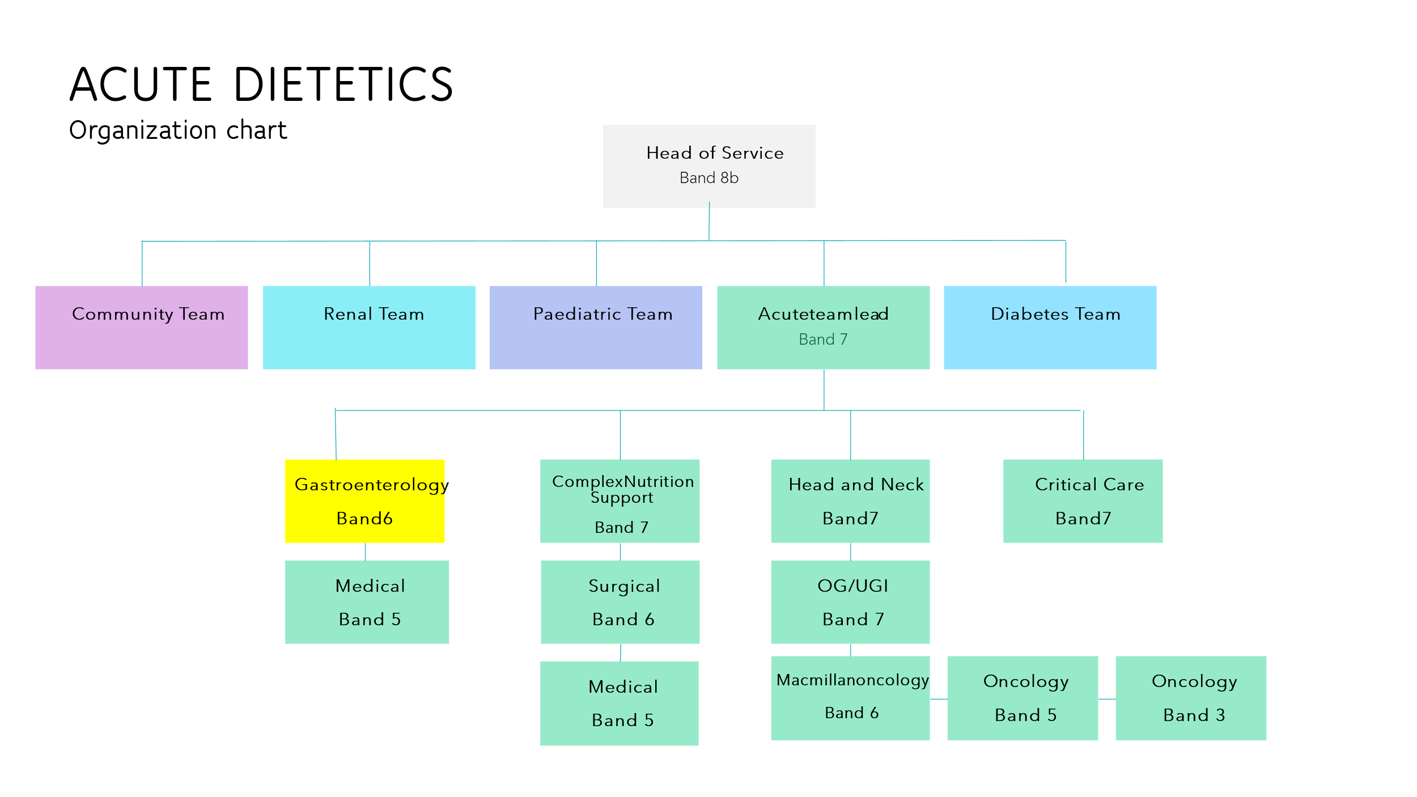

**Other**

This job description does not purport to cover all aspects of the job holder’s duties but is intended to be indicative of the main areas of responsibility.

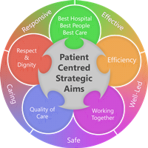**Person Specification**

**QUALIFICATIONS**

**Essential**

* Degree/Diploma in Dietetics
* HCPC Registered Dietitian
* Evidence of professional development or commitment to postgraduate study

**Desirable**

* Evidence of postgraduate education, training
* Completed PENG Clinical Update course or equivalent nutrition support qualification.
* Member of the British Dietetic Association and relevant specialist groups

**EXPERIENCE**

**Essential**

* Experience as a dietitian in a clinical setting.
* Experience of acute hospital dietetics within a range of medical and surgical specialties, including enteral nutrition support
* Evidence of recent service improvement work
* Experience of team-working within acute dietetics

**Desirable**

* Significant dietetic experience within a range of specialties such as surgery, gastroenterology and oncology including complex enteral and parenteral nutrition support
* Experience of clinical or non-clinical teaching
* Experience of facilitating student dietitian training/supervision
* Experience of peer supervision and/or supervision of junior dietetic staff.
* Evidence of service evaluation, audit or research

**SKILLS & KNOWLEDGE**

**Essential**

* Competent practitioner with well-developed clinical and reasoning skills.
* Able to promote role of nutrition to others
* Able to communicate with people from a variety of backgrounds. Good interpersonal skills.
* Able to think/plan strategically and develop the role in conjunction with other dietitians, dietetic leads and various stakeholders.
* Excellent presentation skills and ability
* Ability to demonstrate advanced communication skills including confidence within the multidisciplinary team.
* Able to work autonomously with individuals and groups
* Competent in use of Microsoft word, excel and outlook
* Willing to participate in clinical supervision and contribute to team clinical governance

**Desirable**

* Strong interest in nutrition support e.g. member of relevant BDA specialist group

**PERSONAL QUALITIES**

**Essential**

* Confident, self-motivated, flexible, adaptive and creative
* Able to prioritize and self-manage within a team environment
* Responsible, reliable and strives for efficiency
* Knows own limitations and willing to seek and provide support/guidance within the dietetic team
* Empathetic, supportive

**CIRCUMSTANCES**

**Essential**

* Able to conduct work across a variety of settings and worksites.
* Able to work within agreed hours.

**Desirable**

* Car owner/driver.
* Able to offer some flexibility e.g. some evening/weekend education sessions

**Working Together For Patients with Compassion as One Team Always Improving**

**Strategic approach** (clarity on objectives, clear on expectations)

**Relationship building** (communicate effectively, be open and willing to help, courtesy, nurtures partnerships)

**Personal credibility** (visibility, approachable, back bone, courage, resilience, confidence, role model, challenge bad behaviour, manage poor performance, act with honesty and integrity)

**Passion to succeed** (patient centred, positive attitude, take action, take pride, take responsibility, aspire for excellence)

**Harness performance through teams** (champion positive change, develop staff, create a culture without fear of retribution, actively listen and value contribution, feedback and empower staff , respect diversity)

Job holders are required to act in such a way that at all times the health and wellbeing of children and vulnerable adults is safeguarded. Familiarisation with and adherence to the Safeguarding Policies of the Trust is an essential requirement for all employees. In addition all staff are expected to complete essential/mandatory training in this area.

**Print Name:**

**Date:**

**Signature:**