

**Trainee Paediatric Advanced Clinical Practitioner (ACP)**

**Job Title:** Trainee Paediatric Advanced Clinical Practitioner

**Grade:** Band 7

**Department:** Children’s Services

**Reports to:** Consultant Practitioner, Lead ACP, Corporate Lead for Advanced Practice

**Job Summary**

* The post holder will be practice under supervision as a Trainee Paediatric Advanced Clinical Practitioner (PACP) within the Paediatric Emergency Department (PED) of the Medicine and Urgent Care Division, the Children’s Assessment Unit (CAU) of the Network Services Division and across the wider community setting.
* As a trainee, the post holder will work under supervision within an agreed scope of practice and will be expected to ensure high standards of evidence-based practice.
* Under supervision, the post holder will provide patient-centred quality care for children presenting with a broad range of conditions, including both illness and injury. This will encompass the skills of assessment, examination, diagnosis, and treatment within an agreed scope of practice.
* The post holder will support a new way of working that emphasises a more efficient and patient focused service.
* The post holder will assist in the safe referral, admission avoidance and discharge of children with undifferentiated and undiagnosed presentations across PED, CAU and the wider community setting.
* The training will involve the completion of a formal ACP programme, at the centre of which will be a recognised clinical competency framework such as detailed by the Royal College of Emergency Medicine (RCEM) or the Royal College of Paediatrics and Child Health (RCPCH).
* The role involves an 80% direct clinical component (DCC) and 20% related to management, leadership, innovation and education (SPA).

**PHU Organisation Chart**

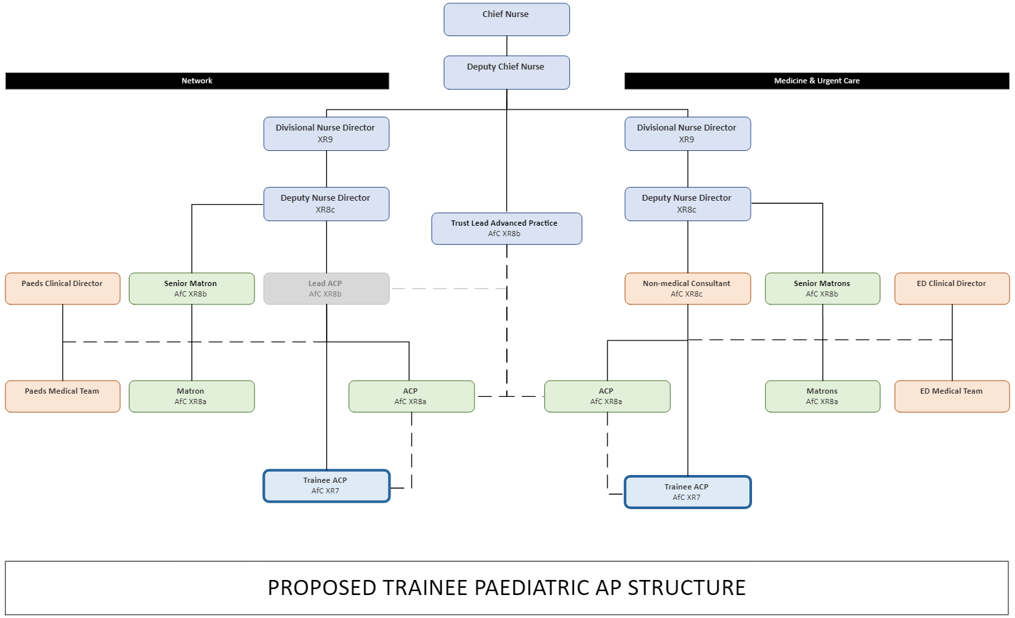

**Management & Leadership**

* Choose an area of specialist interest within advanced practice with the intention to develop and take this forward in your ACP role.
* To develop own leadership skills within the ACP team.
* To assist the wider team in the development and improvement of systems and processes that facilitates patient flow across children’s services.
* Contribute to the review and development of integrated care pathways and clinical guidelines to ensure a standardised approach across children’s services.
* To participate in the implementation and development of assessment systems, processes and tools across children’s services and adjacent clinical/assessment areas.
* To help the ACP team in the clinical development of staff working across children’s services and support the development of advanced practice within the team.
* Participate in the recruitment, selection, and retention of staff.
* To represent the organisation, its beliefs and governance in relation to advanced practice, when participating or contributing to local, regional, or national paediatric forums.
* To participate in the clinical supervision process and provide the opportunity to reflect and discuss areas of practice.

**Clinical Practice**

* Work towards successful completion of a recognised clinical capability framework.
* Under supervision, deliver and participate in the clinical care of children accessing children’s services.
* To improve the quality and experience of children, young persons and their families or carers by identifying and meeting the individual clinical needs of the patient.
* Practice within your own level of competence ensuring this is in line with professional and organisational guidelines (E.g., Nursing and Midwifery Council (NMC), HCPC (Health and Care Professions Council), General Pharmaceutical Council (GPhC).
* To ensure that accurate documentation and records of patient care are kept.
* Under supervision, be able to adapt clinical knowledge and skills to different clinical settings and influence service delivery and patient care.
* Under supervision, be responsible for the management of patients within own case load.
* Under supervision, appropriately assess, examine, investigate, diagnose, and treat patients, resulting in the safe management and appropriate referral, admission avoidance and discharge of children with undifferentiated and undiagnosed presentations.
* Undertake the non-medical independent prescribing course and on successful completion, prescribe and review medication, following best practices, national and local protocols, and within the role's legal framework.
* To rigorously review all aspects of the patient’s plan of care and identify and address issues that may result in a sub-standard service.
* To develop and maintain effective communication with the multidisciplinary team to ensure high standards of care.
* To work collaboratively and strategically with representatives of other clinical areas, disciplines, and services to provide a seamless pathway of care across children’s services.
* To develop and maintain a positive learning environment across children’s services, ensuring developmental requirements are addressed.
* Act as a resource for junior staff, advising on local, national, and Trust policies, procedures, and guidelines to ensure patient safety and clinical governance.

**Education & Research**

* To exhibit a personal commitment to education and work towards successful completion of a Postgraduate diploma in Advanced Clinical Practice or academic equivalent through an ePortfolio supported route.
* To participate in the process of clinical supervision and provide the opportunity to reflect and discuss areas of practice.
* To help plan, implement and participate in teaching programmes for nursing, medical and allied health professional staff of all grades in support of staff development across children’s services.
* To maintain close links with local Universities and to participate in the development and delivery of new and established specialist practice programmes as appropriate.

**Audit, Research & Quality Improvement**

* Actively implement effective systems and processes for infection control management and relevant audit within their clinical area.
* To assist in development of evidence-based policies and procedures specifically required by the team.
* Contribute to the development of multidisciplinary research and clinical audit across children’s services, implementing effective and evidence-based practice.
* Develop research skills, provide support, and appropriate implementation strategies for changes in clinical practice.
* Conduct audit to evaluate the advanced clinical practitioner team and any strategies that have been implemented and disseminate results within the Trust, locally and nationally.
* Participate and contribute to any ongoing regional and national research to evaluate the effectiveness of care strategies related to the patient experience across children’s services.
* To share best practice through publications and attendance/presentation opportunities at conference level.

**Communication**

* Exhibit the high level of interprofessional and communication skills and develop effective communication strategies with other members of the multi-disciplinary team.
* Provide, analyse, and receive highly complex information.
* To develop specialist knowledge and experience to be able to provide professional advice and support to nurses, midwives, other staff, and managers across children’s services.
* Challenge practice standards and influence constructive and positive change.
* Utilise and demonstrate sensitive communication styles to ensure patients are fully informed and consent to treatment.
* Frequently communicate effectively with patients and carers recognising the need for alternative methods of communication to overcome different levels of understanding, cultural background, and preferred ways of communicating to anticipate barriers to communication.
* Frequently communicate effectively about complex, sensitive, and potentially distressing information with patients and carers.
* Create a trusting partnership with patients and/or relatives and under supervision, communicate and explain complex medical issues including new diagnoses and agree a management/treatment plan.
* Ensure awareness of sources of support and guidance such as Patient Advice and Liaison Service (PALS) and provide information.
* Be responsible for the delivery of a detailed, accurate, and potentially complex clinical handover to other specialties, including general practice.
* Produce detailed, accurate written information within the medical notes regarding all clinical assessments, investigations completed requested, and treatments administered.
* Maintain confidentiality as required by professional, local, and national policy but acknowledge situations where there can be a breach of confidentiality.
* Frequently able to recognise and defuse potentially aggressive and violent individuals/situations in line with local policy and legal frameworks.

**Professional Responsibility**

* To ensure that systems are in place to manage, reduce and prevent clinical risk to self and others across children’s services.
* To monitor incidents highlighted by members of the team and communicate to appropriate areas to address risk issues.
* Promote best practice in health & safety, utilising children’s services, and Trust policies.
* Recognise and work within a multi-professional framework for advanced practice, own capability, and own professional code of conduct as regulated by relevant professional body/regulator.
* Ensure own practice is kept updated, using an acceptable model of clinical supervision.
* Take every opportunity to expand individual practice and role in line with the principles contained within the relevant professional code of conduct and in line with the multi-professional consultant-level practice capability and impact framework. Identifies personal career development pathway as part of the formal appraisal system.
* Ensures that all elements contained within own professional code of conduct are adhered to those relating to professional accountability.
* Develop clinical knowledge and professional skills through relevant training and study to support development alongside the multi-professional consultant-level practice capability and impact framework.
* Under supervision, be able to work on their initiative, independently, and within a team.
* Maintain the ability to read and interpret extensive policy documentation, sometimes of a clinical nature requiring periods of intense concentration.

**Other**

Job Holders are required to:

* Maintain personal and professional development to meet the changing demands of the training post, participate in appropriate training activities and encourage and support staff development and training.
* Always keep requirements in mind and seek out to improve, including achieving customer service performance targets.
* Adhere to Trust policies and procedures, e.g., Health and Safety at Work, Equal Opportunities, and No Smoking.
* Always act in such a way that that the health and well-being of children and vulnerable adults are safeguarded. Familiarisation with and adherence to the Safeguarding Policies of the Trust is an essential requirement for all employees. In addition, all staff are expected to complete essential and mandatory training in this area.
* Respect the confidentiality of all matters that they may learn relating to their employment and other members of staff. All staff are expected to respect and conform to the requirements of the Data Protection Act 1998, including the responsibility to ensure that personal data is accurate and kept up to date.

**Person Specification**

**QUALIFICATIONS AND EXPERIENCE- Essential**

* Current professional registration with a relevant professional regulator (e.g., NMC, HCPC, GPhC).
* Evidence of working as a senior paediatric nurse or equivalent in an acute paediatric setting. There should be demonstrable evidence of role consolidation.
* Willingness to complete an Advanced Practitioner MSc pathway.
* Immediate Life Support qualification as minimum standard.
* Service improvement skills.
* Mentorship qualification.

**QUALIFICATIONS AND EXPERIENCE - Desirable**

* Current NMC Registration RN Child / RSCN.
* APLS / CIT provider.
* Evidence of ability to study at master's level or working towards MSc in Advanced Practice.
* Post-registration experience in Paediatrics in a practitioner role.
* Non-medical independent prescriber.

**SKILLS & KNOWLEDGE - Essential**

* History taking and physical assessment skills.
* Knowledge pertaining to pathophysiology and clinical diagnostics.
* Experience in clinical audit.
* Interest in clinical research.
* Experience of appraisal of others.

**SKILLS & KNOWLEDGE - Desirable**

* Teaching Qualification.
* Previous publication(s) or presented at local or national conference.

**PERSONAL QUALITIES - Essential**

* Evidence of multidisciplinary team working.
* Evidence of supporting other’s development.
* Competent and confident approach to practice.
* Proven leadership skills.

**PERSONAL QUALITIES - Desirable**

* Leadership qualification.

**Working Together (Trust Values)**

**For Patients**

* Priorities safety.
* Focus on the quality of patient care.
* Deliver great customer care and experiences.
* Act with professionalism.
* Pursue the best outcome.
* Take personal responsibility and make no excuses.

**With Compassion**

* Compassionate and kind.
* Friendly and courteous.
* Attentive and helpful.
* Protective of patient dignity.

**As One Team**

* Listen and hear.
* Break down silos and work in partnership internally and externally.
* Explain and involve patients and staff in decisions.
* Respect everyone’s time.

**Always Improving**

* Seek and give feedback.
* Identify and make improvements to how we do things, however big or small.
* Work efficiently and keep things simple.
* Live within our means.
* Develop through learning.
* Engage, innovate, and improve.

**Values based behaviours for leaders**

In discussion with its leaders The Trust has developed a Leadership Framework, based on its Values. As a result, the following expected standards for leadership have been identified, which all leaders will be required to demonstrate.

**Strategic approach** (clarity on objectives, clear on expectations)

* Plans and takes initiative in the best interest of the patient.
* Makes decisions based on organisation strategic direction.
* Makes success criteria clear to others and focuses them on what matters most.
* Avoids major problems through anticipation and contingency planning.
* Relationship building (communicate effectively, be open and willing to help, courtesy, nurtures partnerships).
* Consistently seeks to understand and meet the needs and interests of patients.
* Asks open questions and listens to other ideas to develop joint solutions.
* Involves key stakeholder and staff in planning organisational change.

**Personal credibility** (visibility, approachable, back bone, courage, resilience, confidence, role model, challenge bad behaviour, manage poor performance, act with honesty and integrity)

* Articulates a compelling vision of how things could be and might be.
* Consistently delivers on promises.
* Consistently acts in accordance with, and champions PHTs values.
* Displays sensitivity to the needs and feelings of others.
* Has a zero tolerance to, and challenges bad behaviour.
* Actively manages poor performance.

**Passion to succeed** (patient centred, positive attitude, take action, take pride, take responsibility, aspire for excellence)

* Motivates others through infectious enthusiasm and ‘can do’ attitude.
* Maintains optimism and sense of humour in stressful situations.
* Emphasises the positive side of difficulties, portraying them as opportunities.
* Finds ways around seemingly insurmountable obstacles, not easily defeated.
* Infuse pride and joy in work.
* Lead by example by taking responsibility, being compassionate and aspiring for excellence.

**Harness performance through teams** (champion positive change, develop staff, create a culture without fear of retribution, actively listen and value contribution, feedback and empower staff, respect diversity)

* Takes proactive steps to develop team members using a variety of approaches.
* Involves team members in planning and delivering change.
* Stimulates and communicates cross disciplinary communication.
* Recognises and rewards effort, not just achievement.
* Matches the needs of activity to available resources.
* Seeks out and listens to team members and stakeholders, welcoming warnings, or problems.

