

**Qualified Paediatric Advanced Clinical Practitioner**

**Job Title:** Advanced Paediatric Clinical Practitioner

**Grade:** Band 8a

**Department:** Children’s Services

**Reports to:** Consultant Practitioner, Lead ACP, Corporate Lead for Advanced Practice

**Job Summary**

* The post holder will be practicing autonomously as a Paediatric Advanced Clinical Practitioner (PACP) within the Paediatric Emergency Department (PED) of the Medicine and Urgent Care Division, the Children’s Assessment Unit (CAU) of the Network Services Division and across the wider community setting.
* The post holder will provide patient-centred quality care for children presenting with a broad range of conditions, including both illness and injury. This will encompass the skills of assessment, examination, diagnosis, and treatment within an agreed scope of practice.
* The post holder will support a new way of working that emphasises a more efficient and patient focused service.
* The post holder will ensure the safe referral, admission avoidance and discharge of children with undifferentiated and undiagnosed presentations across PED, CAU and the wider community setting.
* The role involves an 80% direct clinical component (DCC) and 20% related to management, leadership, innovation, and educational responsibilities (SPA).
* requirement for all employees. In addition, all staff are expected to complete essential and mandatory training in this area.
* Respect the confidentiality of all matters that they may learn relating to their employment and other members of staff. All staff are expected to respect and conform to the requirements of the Data Protection Act 1998, including the responsibility to ensure that personal data is accurate and kept up to date.

**PHU Organisation Chart**

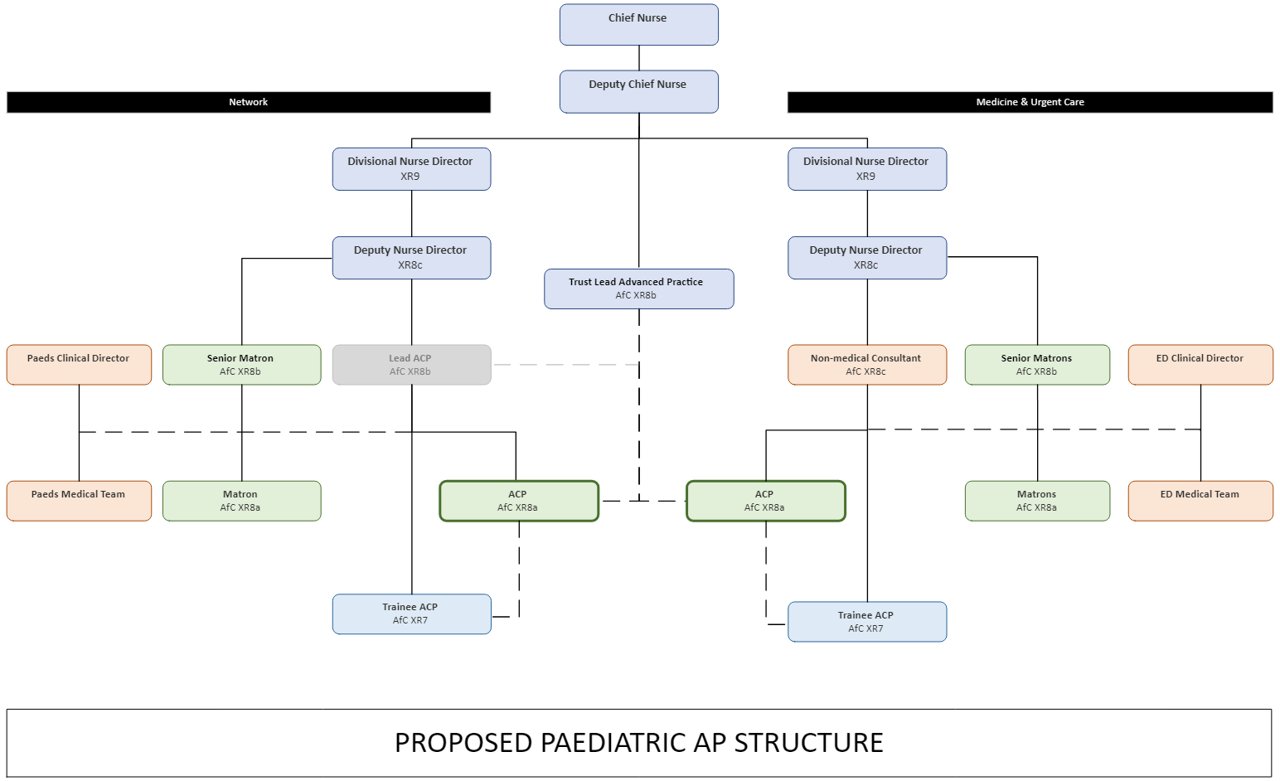

**Management & Leadership**

* To contribute to the development and improvement of systems and processes that facilitates patient flow across children’s services.
* Contribute to the review and development of integrated care pathways and clinical guidelines to ensure a standardised approach across children’s services.
* To provide specialist advice on patient care to the healthcare team considering all aspects of clinical governance, and act as a specialist resource within children’s services and the Trust.
* To lead the implementation and development of assessment systems, processes and tools across children’s services and adjacent clinical/assessment areas.
* Ability to adapt specialist clinical knowledge and skills to different clinical settings and influence service delivery and patient care.
* Lead and develop an area of responsibility related to advanced clinical practice.
* To co-ordinate and provide leadership for the Trainee Paediatric Advanced Clinical Practitioner Team and the Emergency Nurse Practitioner Teams as appropriate across children’s services.
* Participate in the development of a specialist service and act as a change agent, where necessary leading staff and facilitating the change process whilst encouraging others to be innovative and adaptable in the approach to change.
* To help identify, plan, and implement goals for clinical development of staff working across children’s services and support the development of advanced practice within the team.
* To develop clinical capabilities for staff working within the team.
* Participate in the recruitment, selection and retention of staff.
* To represent the organisation, its beliefs and governance in relation to advanced practice, when participating or contributing to local, regional, or national paediatric forums.
* To assist in the provision of clinical supervision and provide the opportunity to reflect and discuss areas of practice.

**Clinical Practice**

* Demonstrate completion of a recognised clinical capability framework.
* To deliver and participate in the clinical care of children accessing children’s services.
* To improve the quality and experience of children, young persons and their families or carers by identifying and meeting the individual clinical needs of the patient.
* Practice with confidence and competence within professional and organisational guidelines (E.g., Nursing and Midwifery Council (NMC), HCPC (Health and Care Professions Council), General Pharmaceutical Council (GPhC).
* To ensure that accurate documentation and records of patient care are kept.
* Ability to adapt specialist clinical knowledge and skills to different clinical settings and influence service delivery and patient care.
* Be directly responsible for the management of patients within own case load and supervision /development of junior members of the multidisciplinary team across children’s services.
* To appropriately assess, examine, investigate, diagnose, and treat patients, resulting in the safe management and appropriate referral, admission avoidance and discharge of children with undifferentiated and undiagnosed presentations.
* Prescribe and review medication as an independent prescriber, following best practices, national and local protocols, and within the role's legal framework.
* To rigorously review all aspects of the patient’s plan of care and identify and address issues that may result in a sub-standard service.
* To develop and maintain effective communication with the multidisciplinary team to ensure high standards of care.
* To work collaboratively and strategically with representatives of other clinical areas, disciplines and services to provide a seamless pathway of care across children’s services.
* To develop and maintain a positive learning environment across children’s services, ensuring developmental requirements are addressed.
* Act as a resource for staff, advising on local, national, and Trust policies, procedures, and guidelines to ensure patient safety and clinical governance.

**Education & Research**

* To exhibit a personal commitment to education and work towards successful completion of an MSc in Advanced Clinical Practice or academic equivalence through an ePortfolio-supported route.
* To participate in the clinical supervision process and provide the opportunity to reflect and discuss areas of practice.
* To plan, implement and participate in teaching programmes for trainee ACPs, nursing, medical and allied health professional staff of all grades in support of staff development across children’s services.
* To maintain close links with local Universities and to participate in the development and delivery of new and established specialist practice programmes as appropriate.

**Audit, Research & Quality Improvement**

* Actively implement effective systems and processes for infection control management and relevant audit within their clinical area.
* To develop evidence-based policies and procedures specifically required by the team.
* To develop clinical competencies for staff working within the team.
* Contribute and at times lead the development of multidisciplinary research and clinical audit across children’s services, implementing effective and evidence-based practice.
* Exhibit advanced research skills, provide support, and appropriate implementation strategies for changes in clinical practice.
* Conduct audit to evaluate the advanced clinical practitioner team and any strategies that have been implemented and disseminate results within the Trust, locally and nationally.
* Participate and contribute to any ongoing regional and national research to evaluate the effectiveness of care strategies related to the patient experience across children’s services.
* To share best practice through publications and attendance/presentation opportunities at conference level.

**Communication**

* Exhibit the highest level of interprofessional and communication skills and develop effective communication strategies with other members of the multi-disciplinary team.
* Provide, analyse, and receive highly complex information.
* Use expert knowledge and experience to provide professional advice and support to nurses, midwives, other staff, and managers across children’s services.
* Challenge practice standards and influence constructive and positive change.
* Utilise and demonstrate sensitive communication styles to ensure patients are fully informed and consent to treatment.
* Frequently communicate effectively with patients and carers recognising the need for alternative methods of communication to overcome different levels of understanding, cultural background, and preferred ways of communicating to anticipate barriers to communication.
* Frequently communicate effectively about complex, sensitive, and potentially distressing information with patients and carers.
* Create a trusting partnership with patients and/or relatives to communicate and explain complex medical issues including new diagnoses and agree a management/treatment plan.
* Ensure awareness of sources of support and guidance such as Patient Advice and Liaison Service (PALS) and provide information.
* Be responsible for the delivery of a detailed, accurate, and potentially complex clinical handover to other specialties, including general practice.
* Produce detailed, accurate written information within the medical notes regarding all clinical assessments, investigations completed requested, and treatments administered.
* Maintain confidentiality as required by professional, local, and national policy but acknowledge situations where there can be a breach of confidentiality.
* Frequently able to recognise and defuse potentially aggressive and violent individuals/situations in line with local policy and legal frameworks.

**Professional Responsibility**

* To ensure that systems are in place to manage, reduce and prevent clinical risk to self and others across children’s services.
* To monitor incidents highlighted by members of the team and communicate to appropriate areas to address risk issues.
* Promote best practice in health & safety, utilising unit, and Trust policies.
* Recognise and work within a multi-professional framework for advanced practice, own capability, and own professional code of conduct as regulated by relevant professional body/regulator.
* Ensure own practice is kept updated, using an acceptable model of clinical supervision.
* Take every opportunity to expand individual practice and role in line with the principles contained within the relevant professional code of conduct and in line with the multi-professional consultant-level practice capability and impact framework. Identifies personal career development pathway as part of the formal appraisal system.
* Ensures that all elements contained within own professional code of conduct are adhered to those relating to professional accountability.
* Develop clinical knowledge and professional skills through relevant training and study to support development alongside the multi-professional consultant-level practice capability and impact framework.
* Ensure the ability to be able to work on their initiative, independently, and within a team.
* Maintain the ability to read and interpret extensive policy documentation, sometimes of a clinical nature requiring periods of intense concentration.

**Other**

Job Holders are required to:

* Maintain personal and professional development to meet the changing demands of the job, participate in appropriate training activities and encourage and support staff development and training.
* Always keep requirements in mind and seek out to improve, including achieving customer service performance targets.
* Adhere to Trust policies and procedures, e.g., Health and Safety at Work, Equal Opportunities, and No Smoking.
* Always act in such a way that the health and well-being of children and vulnerable adults are safeguarded. Familiarisation with and adherence to the Safeguarding Policies of the Trust is an essential requirement for all employees. In addition, all staff are expected to complete essential and mandatory training in this area.
* Actively implement effective systems and processes for infection control management and relevant audit within their clinical area.
* Maintain and develop a positive learning environment across children’s services by providing support and ensuring developmental requirements are addressed.
* Respect the confidentiality of all matters that they may learn relating to their employment and other members of staff. All staff are expected to respect and conform to the requirements of the Data Protection Act 1998, including the responsibility to ensure that personal data is accurate and kept up to date.

**Person Specification**

**QUALIFICATIONS AND EXPERIENCE- Essential**

* Current professional registration with a relevant professional regulator (e.g., NMC, HCPC, GPhC).
* Completion of a recognised Paediatric Advanced Clinical Practitioner programme which is in line with the RCEM Paediatric ACP competency framework or equivalent.
* A robust clinical portfolio is mandatory, and this should demonstrate that the applicant has achieved core and Paediatric competencies across a broad clinical base (including injury and illness of all levels / severity). Evidence of a final sign off must be included.
* Completion of a PGDip Advanced Clinical Practice.
* Independent non-medical prescriber qualification.
* Advanced Paediatric Life Support provider (APLS / EPLS).
* IRMER regulation certificate.
* Significant post registration experience in acute Paediatrics.
* Involvement with scope of practice development.

**QUALIFICATIONS AND EXPERIENCE - Desirable**

* Current NMC Registration RN Child / RSCN.
* Working towards completion of MSc Advanced Clinical Practice or academic equivalence through an ePortfolio-supported route.
* APLS / EPLS instructor.
* Post-registration experience in Paediatrics as an Advanced Clinical Practitioner.
* Digital Badge Advanced Practice.

**SKILLS & KNOWLEDGE - Essential**

* Competent clinical assessment skills.
* Evidence of Clinical Audit.
* Red Dot or equivalent course in essential radiology.
* Interest in clinical research.
* Teaching/education skills.

**SKILLS & KNOWLEDGE - Desirable**

* Research skills
* Evidence of appraisal training.
* Previous publication(s) or presented at local or national conference.
* Competent to perform a range of clinical skills.
* Good Clinical Practice (GCP) Certification.

**PERSONAL QUALITIES - Essential**

* Evidence of multidisciplinary team working.
* Evidence of supporting other’s development.
* Competent and confident approach to practice.
* Proven leadership skills.

**PERSONAL QUALITIES - Desirable**

* Leadership qualification.

**Working Together (Trust Values)**

**For Patients**

* Priorities safety.
* Focus on the quality of patient care.
* Deliver great customer care and experiences.
* Act with professionalism.
* Pursue the best outcome.
* Take personal responsibility and make no excuses.

**With Compassion**

* Compassionate and kind.
* Friendly and courteous.
* Attentive and helpful.
* Protective of patient dignity.

**As One Team**

* Listen and hear.
* Break down silos and work in partnership internally and externally.
* Explain and involve patients and staff in decisions.
* Respect everyone’s time.

**Always Improving**

* Seek and give feedback.
* Identify and make improvements to how we do things, however big or small.
* Work efficiently and keep things simple.
* Live within our means.
* Develop through learning.
* Engage, innovate, and improve.

**Values based behaviours for leaders**

In discussion with its leaders The Trust has developed a Leadership Framework, based on its Values. As a result, the following expected standards for leadership have been identified, which all leaders will be required to demonstrate.

**Strategic approach** (clarity on objectives, clear on expectations)

* Plans and takes initiative in the best interest of the patient.
* Makes decisions based on organisation strategic direction.
* Makes success criteria clear to others and focuses them on what matters most.
* Avoids major problems through anticipation and contingency planning.
* Relationship building (communicate effectively, be open and willing to help, courtesy, nurtures partnerships).
* Consistently seeks to understand and meet the needs and interests of patients.
* Asks open questions and listens to other ideas to develop joint solutions.
* Involves key stakeholder and staff in planning organisational change.

**Personal credibility** (visibility, approachable, back bone, courage, resilience, confidence, role model, challenge bad behaviour, manage poor performance, act with honesty and integrity)

* Articulates a compelling vision of how things could be and might be.
* Consistently delivers on promises.
* Consistently acts in accordance with, and champions PHTs values.
* Displays sensitivity to the needs and feelings of others.
* Has a zero tolerance to, and challenges bad behaviour.
* Actively manages poor performance.

**Passion to succeed** (patient centred, positive attitude, take action, take pride, take responsibility, aspire for excellence)

* Motivates others through infectious enthusiasm and ‘can do’ attitude.
* Maintains optimism and sense of humour in stressful situations.
* Emphasises the positive side of difficulties, portraying them as opportunities.
* Finds ways around seemingly insurmountable obstacles, not easily defeated.
* Infuse pride and joy in work.
* Lead by example by taking responsibility, being compassionate and aspiring for excellence.

**Harness performance through teams** (champion positive change, develop staff, create a culture without fear of retribution, actively listen and value contribution, feedback and empower staff, respect diversity)

* Takes proactive steps to develop team members using a variety of approaches.
* Involves team members in planning and delivering change.
* Stimulates and communicates cross disciplinary communication.
* Recognises and rewards effort, not just achievement.
* Matches the needs of activity to available resources.
* Seeks out and listens to team members and stakeholders, welcoming warnings, or problems.

