Title: Band 5 Registered Midwife
Band: 5
Staff Group: Midwifery
Reports to: Midwifery Team Leader

Job Summary:
- To consolidate midwifery training and develop in depth knowledge of midwifery practice.
- To maintain high standards of midwifery care at all times.
- To acquire additional competencies to fulfil the role of the midwife providing total care to women and progress to a band 6 midwife.
- To be responsible for delivering and maintaining a high standard of day to day evidence-based practice for all women in the designated clinical area
- To engage with women and their families to encourage and promote women centred care
- To engage and successfully complete the maternity preceptorship programme

Key Responsibilities:
Trust Organisational Expectations
The post holder will:
- Proactively and positively contribute to the successful overall performance of the Trust.
- Deliver excellent levels of service to all patients/visitors and staff at the Trust.
- Develop effective ways of working and create strong partnerships and relationships with all stakeholders to support the implementation of the Government’s policies on Health.
- Act as an advocate for the Trust & its contribution to the Health Service arena through creating effective partnerships and relationships with internal and external stakeholders.
- Comply with corporate governance structure in keeping with the principles and standards set out by the Trust.
- Support the Trust culture of collaborative, flexible cross-team working and commitment to delivering quality services and outcomes, which support the Government’s policies on public health.
- If your employment is conditional upon you continuing to be registered with the inappropriate professional body. The Trust will require evidence of current registration.
- In compliance with the Trust’s practices and procedures associated with the control of infection, you are required to:
- Adhere to Trust infection Control Polices assuring compliance with all defined infection control standards at all times.
- Conduct head hygiene in accordance with Trust policy, challenging those around you that do not.
- Challenge poor practice that could lead to the transmission of infection.
Proactively, meaningfully and consistently demonstrate the Trust Values in your everyday practice, decision making and interactions with patients and colleagues.


Shared Core Functions
- Proactively and positively contribute to the achievement of deliverables through individual and team effort. Manage the production of the required deliverables and control risks.
- Support team members to deliver on their functionally relevant objectives through offering advice, guidance and support as appropriate.
- Ensure that approved budgets are spent effectively and in accordance with agreed procedures.
- Liaison with Senior Professionals and related functions to ensure that work is neither overlooked nor duplicated.
- Build and sustain effective communications with other roles involved in the shared services as required.
- Maintain and continuously improve specialist knowledge in an aspect of Health Service which significantly contributes to the Trust’s stated objectives & aims.
- Establish and maintain strategic links with a range of external partners/stakeholders or manage the links made through the team. Engage with external partners/stakeholders to gain their necessary level of contribution & commitment to the successful delivery of your work.
- Undertake proactive horizon scanning for either developments relating to Trust work or opportunities for Trust involvement around health issues.
- Increase the level of knowledge & skills within the Trust through documenting key learning and supporting others to develop their professional abilities.
- Dissemination of knowledge through engagement in report writing and reviewing, taking full responsibility for technical accuracy and reliability and being sensitive to the wider implications of that dissemination.
- Ensure that expertise is seen as a resource within and outside the Trust and form working partnerships with government departments, national agencies and key stakeholders.
- Develop structures, systems ways of working and personal values that will support the Trusts sustainable development objectives with regard to issues such as Carbon reduction and waste minimisation, and to encourage all stakeholders of the Trust to act as enthusiastic agents of change.
Professional Leadership & Communication
- Work collaboratively with the multi-disciplinary team, ensuring effective communication.
- Provide on call cover as per service need.
- Ensure professional and clinical standards are maintained and developed in response to new evidence.
- Establish and maintain relationships with women, families and the multi-professional team.
- Demonstrate the ability to motivate, negotiate and train others.
- Empower women to make informed choices and act as an advocate as required.

Women Centred Care
- Using a woman focused approach assess, plan, implement and evaluate individual programmes of care, ensuring clinical practice is clinically effective and research based.
- Demonstrate a commitment to evidence-based practice, highlight areas for change, then initiate and evaluate evidence to improve and develop woman centred care.
- Promote health education within the clinical area and be able to advise the women, families and others in health promotion.
- Develop and strengthen interpersonal relationships with all members of the multi-disciplinary team ensuring good team working, collaborative working practices and professionalism through liaison with associated services including child Protection, Social Services, teenage pregnancy groups etc.
- Comply with NMC standards for records are maintained to reflect the care, treatment, advice and tests provided.
Service Development Implementation
- Engage in any internal quality assurance and patient safety activities such as audits and incident reporting encouraging others to do the same.
- Monitors the quality of work in own area and alerts others to quality issues, reporting any concerns to the appropriate person.
- Contribute to improving services and be aware of planned service improvements.
Information Resources
- To ensure data is recorded accurately and timely into maternity records and hospital information systems
- Attend training and updates on implementation of Maternity Information system
- Maintain confidentiality
Research and Development
- Has knowledge of the audit process and methods of critically appraising research
- Demonstrate clinical competence and fitness for purpose
- Be involved in clinical audit and evaluation of practice in the clinical area
- Contribute ideas and undertake monitoring with regards to quality of women centred care
Professional Development
- Demonstrate awareness in dealing with interpersonal conflict and adverse situations/incidents.
- Provide a positive learning environment, participate in teaching and act as a clinical resource/role model.
- In association with Universities of Bournemouth and Southampton take responsibility for the provision of effective mentorship, auditing the clinical learning environment and actioning outcomes.
- Participate in formal and informal review of own performance with designated team leader through personal development plans/knowledge and skills framework.
Other
- Work towards clinical skills requiring accuracy precision and co-ordination, i.e. performing episiotomies, suturing, facilitating birth, injections, cannulation.
- Frequently required to use unpredictable levels of concentration and respond to emergency situations.
- Occasionally required to deal with distressing situations including child protection and difficult family situations
- Required to work in highly unpleasant working conditions, dealing with bodily fluids and foul linen as well as infectious material
- Facilitating birth frequently requires the midwife to adopt different postures and alternative positions of stance.
Other
Job Holders are required to:
- Maintain personal and professional development to meet the changing demands of the job, participate in appropriate training activities and encourage and support staff development and training
- Always keep requirements in mind and seek out to improve, including achieving customer service performance targets.
- Adhere to Trust policies and procedures, e.g. Health and Safety at Work, Equal Opportunities, and No smoking.
- Act in such a way that at all times the health and well-being of children and vulnerable adults is safeguarded. Familiarisation with and adherence to the Safeguarding Policies of the Trust is an essential requirement for all employees. In addition, all staff are expected to complete essential/mandatory training in this area.
- Respect the confidentiality of all matters that they may learn relating to their employment and other members of staff. All staff are expected to respect conform to the requirements of the Data Protection Act 1998, including the responsibility to ensure that personal data is accurate and kept up to date.

Organisational Chart
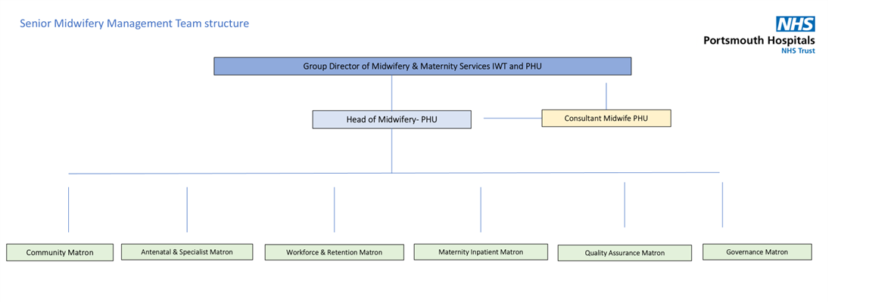
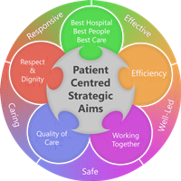
Person Specification
Qualifications
- Current RM registration with the NMC and any other relevant post registration qualifications
Skills and Knowledge
- Effective team building skills
- Interpersonal skills
- Articulate and knowledgeable in current health care issues
- Skill in organising resources and establishing priorities
- The ability to work using own initiative and without supervision.
- Excellent verbal and written communication skills
- Skill in organising resources and establishing priorities
- Ability to develop and maintain record keeping systems and procedures.
- Ability to make clinical decisional judgments
- An understanding of the political sensitivities of the Trust
- Ability to demonstrate confidentiality and trustworthiness.
- Ability to calmly identify priorities and react accordingly
- Strong interpersonal skills
- Effective communicator both orally and on paper
- Skills in motivating self and others
- Skills in working with cross functional teams
- Well-developed influencing skills across disciplines
- Good management skills
- Ability to act and ensure delivery of maternity services.
- Responsive and flexible attitude and approach.
Experience
- To work towards and commit to midwifery preceptorship programme.
Working together:
For Patients
• Priorities safety
• Focus on the quality of patient care
• Deliver great customer care and experiences
• Act with professionalism
• Pursue the best outcome
• Take personal responsibility and make no excuses

With Compassion
• Compassionate and kind
• Friendly and courteous
• Attentive and helpful
• Protective of patient dignity
As one Team
• Listen and hear
• Break down silos and work in partnership internally and externally
• Explain and involve patients and staff in decisions
• Respect everyone’s time
Always Improving
• Seek and give feedback
• Identify and make improvements to how we do things, however big or small.
• Work efficiently, and keep things simple
• Live within our means
• Develop through learning
• Engage, innovate and improve
Working Together For Patients with Compassion as One Team Always Improving
Strategic approach (clarity on objectives, clear on expectations)

Relationship building (communicate effectively, be open and willing to help, courtesy, nurtures partnerships)

Personal credibility (visibility, approachable, back bone, courage, resilience, confidence, role model, challenge bad behaviour, manage poor performance, act with honesty and integrity)

Passion to succeed (patient centred, positive attitude, take action, take pride, take responsibility, aspire for excellence)

Harness performance through teams (champion positive change, develop staff, create a culture without fear of retribution, actively listen and value contribution, feedback and empower staff , respect diversity)

Job holders are required to act in such a way that at all times the health and well being of children and vulnerable adults is safeguarded. Familiarisation with and adherence to the Safeguarding Policies of the Trust is an essential requirement for all employees. In addition all staff are expected to complete essential/mandatory training in this area.
Print Name:
Date:
Signature:

