**Title: Clinical Rotational Pharmacist**

**Band: 6**

**Staff Group: Clinical Support Services**

**Reports to: Band 7 Pharmacy Manager**



**Pharmacy’s Vision**

*A Happy, Fulfilled workforce that provides outstanding care to the local community.*

**Pharmacy’s Mission**

*The role we play is as Medicines experts providing safe, effective, and timely access to medicines and medication advice to Portsmouth Hospital University and other NHS providers utilising advances in digital technology. Working with multi-disciplinary team within PHU and across the Integrated Care System (ICS) we work to improve the information available to staff, patients and their carers to optimise and personalise patient care.*

**Job Purpose:**

To promote the responsible, safe and cost-effective prescribing of medicines within Portsmouth Hospitals to optimise clinical outcomes, minimise adverse reactions and improve medicines safety. The post holder will be supporting the clinical teams to deliver high quality clinical pharmacy services across the hospital sites.

To participate in the delivery of a comprehensive pharmacy service and to provide operational support to the department as agreed in the rotational programme. You will be able to undertake a postgraduate diploma in clinical pharmacy to support your training.

**Key Responsibilities**

1. The successful overall performance of the Trust; in line with organisational strategy “Working Together”.

Delivery of the Trust’s vision – “Working together to drive excellence in care for our patients and communities”.

1. Act as an advocate for the Trust & its contribution to the Health Service arena through creating and maintaining effective partnerships and relationships with staff, patients and the general public.
2. Support the Trust culture of collaborative, flexible cross-team working and commitment to delivering quality services and outcomes, which support the Government’s policies on public health.
3. Comply with corporate governance structure in keeping with the principles and standards set out by the Trust.
4. Work with political sensitivity and an understanding of the issues facing those working to deliver Health services to the UK population.
5. Support your Trust colleagues to successfully perform their roles through developing informal peer networks where appropriate.
6. Providing training, teaching and support to underpin CPD in the Pharmacy department and deliver general and specialist pharmaceutical education to other healthcare professionals.
7. Provide competency-based assessments of pharmacy trainees, pharmacy technicians and pharmacy undergraduates using work-based assessment tools.
8. Identify and make use of opportunities for sharing best practice and learning’s.
9. Proactively ensuring you are aware of relevant organisational communications.

**Shared Core Functions**

1. Provide a high-quality service and oversee comprehensive clinical support for a function, programme or project.
2. Liaison with other senior personnel and their support personnel for close co-ordination of diverse aspect of work.
3. Support team members to deliver on their functionally relevant objectives through offering advice, guidance and support as appropriate.
4. Work with those you support to develop a collaborative working partnership, which positively contributes to their overall efficiency & role performance.
5. Proactively identify additional support services, which would increase the efficiency of those you support and instigate these activities in agreement with your team.
6. Maintain and improve your knowledge & understanding of the health service arena; including health systems, policy support and current issues.
7. Engage with external clients/partners/stakeholders (e.g. Patients, Health practitioners, individuals and representatives’ bodies) to gain their necessary level of contribution & commitment to the successful delivery of your work.
8. Increase the level of guidance knowledge & skills within the Trust through documenting key learning’s and supporting others to develop their abilities.
9. Dissemination of knowledge, taking full responsibility for technical accuracy and reliability and being sensitive to the wider implications of that dissemination.

**Specific Core Functions**

1. Supervising the dispensing of medicines within legal and ethical requirements and local guidelines to ensure that patients receive the correct medications in a timely manner.
2. Applying pharmaceutical knowledge, skill and judgement to prescription screening, to ensure that medicines are used safely, cost effectively and within local guidelines.
3. Providing clinical pharmacy services to agreed standards in accordance with service level agreements.
4. Offering pharmaceutical and therapeutic advice at all stages of the drug use process to ensure patient safety and optimal individualised pharmaceutical care.
5. Undertaking vocational training to develop knowledge and skills in a wide range of aspects of hospital pharmacy.
6. Applying pharmaceutical knowledge to the receiving and answering of medicines information enquiries to ensure that answers are given promptly and that the information provided is factually correct and relevant to the question asked.
7. Counselling patients and carers to ensure they have sufficient understanding of how to take their medicines.
8. Participating in and contributing to departmental audits.
9. Treating all individuals with courtesy and showing consideration for patient’s privacy and at all times to ensure that pharmacy is regarded as a caring organisation.
10. Participating in the Band 6 rotation to ensure development of a wide range of experience in hospital pharmacy services, rotating through different specialities.
11. Working some weekends and Bank Holidays as part of a rota to ensure continuity of pharmaceutical services. Participate to the late-night dispensary working.
12. Participating in the out of hours on call service to ensure continuous 24 hour availability of medicines and pharmaceutical advice. Will be required to be within 30 minutes away commute distance from the hospital.

**This job description does not purport to cover all aspects of the job holder’s duties but is intended to be indicative of the main areas of responsibility.**

**Organisational Chart**

**Other**

This job description does not purport to cover all aspects of the job holder’s duties but is intended to be indicative of the main areas of responsibility

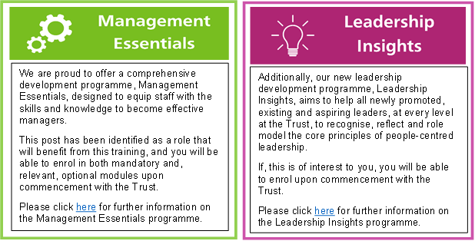

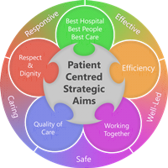**Person Specification**

**Qualifications**

**Essential**

* Master’s degree in pharmacy plus one year’s pre-registration training
* Registered as a pharmacist or currently as a Pre-registration/Trainee Pharmacist with the General Pharmaceutical Council (GPhC)
* Degree with 2.1 or above

**Desirable**

* Previous Hospital work experience/ Completion of Summer Placements in Healthcare
* Experience in voluntary sector
* Membership of the British Pharmaceutical Student’s Association

**Skills and Knowledge**

**Essential**

* Good communication skills -both written and spoken English with a range of people on a range of matters.
* Good understanding of Clinical Pharmacy - knowledge to undertake clinical screening of prescriptions
* Ability to prioritise
* Team worker
* Shows a flexible approach to changing circumstances and have an innovative approach to problem solving.
* IT skills

**Desirable**

* Post graduate certificate in pharmacy practise

**Personal Qualities**

* Able to work flexibly and work under pressure
* Ability to develop own skills
* Ability to handle conflict appropriately
* Shows empathy towards patients
* Recognises the value of other pharmacy team members and other healthcare professionals, and works effectively as part of these teams
* Good attendance and time keeping record
* Professional appearance
* Able to take part in the out of hours service, weekend

**Working Together For Patients with Compassion as One Team Always Improving**

**Strategic approach** (clarity on objectives, clear on expectations)

**Relationship building** (communicate effectively, be open and willing to help, courtesy, nurtures partnerships)

**Personal credibility** (visibility, approachable, back bone, courage, resilience, confidence, role model, challenge bad behaviour, manage poor performance, act with honesty and integrity)

**Passion to succeed** (patient centred, positive attitude, take action, take pride, take responsibility, aspire for excellence)

**Harness performance through teams** (champion positive change, develop staff, create a culture without fear of retribution, actively listen and value contribution, feedback and empower staff , respect diversity)

Job holders are required to act in such a way that at all times the health and well being of children and vulnerable adults is safeguarded. Familiarisation with and adherence to the Safeguarding Policies of the Trust is an essential requirement for all employees. In addition all staff are expected to complete essential/mandatory training in this area.

**Print Name:**

**Date:**

**Signature:**