Leaders Job Description
Title: Highly specialist pharmacist – Older persons medicines (OPM)
Band: 8a
Staff Group: Pharmacy (Clinical Delivery and Family Services Division)
Reports to: Pharmacist Team Lead for Medicine and OPM
Job Summary:

Job Purpose
Leads the provision and development of clinical pharmacy services to the OPM and general medicine care group in accordance with the pharmacy care group:
- Provides pharmaceutical advice and develops clinical pharmacy services to OPM in order to optimise patient benefit from treatment with medicines and ensure the safe, efficacious and cost-effective use of medicines.
- Undertakes risk management and ensures compliance with medicines legislation.
- Be the named pharmacist for the OPM service
- To be responsible for financial savings within OPM.
- To deliver an education and training programme relevant to role

Key Dimensions
- Capital and Revenue Budgets – Contributory impact on the medicine’s budgets for OPM

- Staff Numbers – Supervises and manages rotational pharmacists and tutor trainee pharmacists

Key Responsibilities:
Shared Core Functions
- Proactively and positively contribute to the achievement of deliverables through individual and team effort. Manage the production of the required deliverables and control risks.
- Support team members to deliver on their functionally relevant objectives through offering advice, guidance and support as appropriate.
- Ensure that resources are used effectively and in accordance with agreed procedures
- Liaison with Senior Professionals and related functions to ensure that work is neither overlooked nor duplicated
- Build and sustain effective communications with other roles involved in the shared services as required
- Maintain and continuously improve specialist knowledge in an aspect of Health Service which significantly contributes to the Trust’s stated objectives & aims
- Establish and maintain strategic links with a range of external partners/stakeholders or manage the links made through the team. Engage with external partners/stakeholders to gain their necessary level of contribution & commitment to the successful delivery of your work.
- Undertake evidence-based practice for either developments relating to Trust work or opportunities for Trust involvement around health issues
- Increase the level of knowledge & skills within the Trust through documenting key learning’s and supporting others to develop their professional abilities.
- Dissemination of knowledge, taking full responsibility for technical accuracy and reliability and being sensitive to the wider implications of that dissemination.
- Ensure that expertise is seen as a resource within and outside the Trust and form working partnerships with government departments, national agencies and key stakeholders internationally, nationally, regionally and across sectors.

Specific Core Functions
- Providing clinical pharmacy expertise in use of medicines for patients within the OPM care group during an inpatient hospital stay or on an outpatient, Homecare or day case basis.
- Participating in multidisciplinary meetings as required for the service.
- Lead on addressing overprescribing and polypharmacy within the Trust.
- Provide support to the palliative care and Parkinson’s Disease teams.
- To undertake the role of pharmacy independent prescriber, with the appropriate qualifications where appropriate and according to the needs of the service.
- Identifying potential and clinical development within OPM and planning for implementation to ensure services continue to meet requirements and income is sufficient to fund development.
- Interpreting budgetary information for finance staff at agreed intervals to ensure that significant variances are highlighted together with proposals for appropriate action.
- Assisting the Pharmacist Team Leader for Medicine in evaluating the costs and benefits of new drug developments and presenting evaluated information to division and directorate lead clinicians and managers to aid them in deciding if new products or approaches to treatment should be used in the division.
- Assisting the clinicians in the preparation of business case applications to the Formulary and Medicines Group and/or Area Prescribing Committee, and where necessary taking cases of need to purchasers to ensure that funding for new products or approaches to treatment is secured in contracts.
- Contributing to the production of prescribing guidelines and PGDs/PSDs to ensure that medicines are used safely and in such a way as to maximise benefits to patients within available resources.
- Participating governance meetings as the joint lead for clinical governance of medicines management issues, ensuring issues are communicated with the OPM service.
- Tutor a trainee pharmacist or postgraduate pharmacist student.
- Manage and mentor junior pharmacy staff.
- Providing training, teaching and support to underpin CPD and postgraduate qualifications in the Pharmacy department and deliver general and specialist pharmaceutical education to other healthcare professionals.
- Contributing to clinical audit to ensure that national and local prescribing guidelines are implemented and followed.
- Supervising the dispensing of medicines within legal and ethical requirements and in accordance with local work instructions to ensure that patients receive the correct medication in a timely manner.
- Participating in dispensary cover for 10% of working time and the Bank Holiday and weekend working rota to maintain basic pharmacy services and personal competency.

OTHER
Job Holders are required to:
- Maintain personal and professional development to meet the changing demands of the job, participate in appropriate training activities and encourage and support staff development and training.
- Always keep requirements in mind and seek out to improve, including achieving customer service performance targets.
- Adhere to Trust policies and procedures such as: Health and Safety at Work, Equal Opportunities, No Smoking
- Respect the confidentiality of all matters that they may learn relating to their employment and other members of staff. All staff are expected to respect the requirements of the Data Protection Act 2018.
- Comply with corporate governance structure in keeping with the principles and standards set out by the Trust.
This job description does not purport to cover all aspects of the job holder’s duties but is intended to be indicative of the main areas of responsibility

Organisational Chart

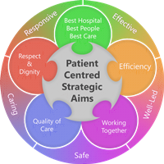
Person Specification
Qualifications
Essential
- Masters or Bachelors Degree in Pharmacy
- Registered with the General Pharmaceutical Council
- Certificate in Clinical Pharmacy
- Completed or studying for Diploma in Clinical Pharmacy
- NMP qualification or working towards and eligible for training
Desirable
- Member of Royal Pharmaceutical Society
- Member of specialist pharmacist practice group e.g. UKCPA
- Post graduate qualifications in Parkinson’s Disease or Palliative Care

Experience
Essential
- Completed or studying for Diploma in Clinical Pharmacy
- Hospital pharmacy experience involving clinical pharmacy services
- Participation in weekly dispensary cover, Bank Holiday and weekend working (to demonstrate maintenance of basic pharmacy services and personal competency)

Desirable
- Previous experience of OPM medicine including addressing polypharmacy and deprescribing.
- Previous experience of working within a multi-disciplinary team in a clinic setting.
- Previous experience of homecare services
- Previous management experience
- Previous leadership experience
- Previous education and training experience
- Identifying and implementing change to processes and team culture
- Working across care boundaries in general practice or care homes

Skills and Knowledge

Essential
- Good interpersonal skills
- Excellent communication skills
- Demonstrable ability to prioritise, organise and manage workload in an environment that has frequent disruptions
- Demonstrable ability to motivate self and others
- Demonstrable ability to work in a team
- Demonstrable confidence as a clinical pharmacist
- Demonstrable ability to use initiative
- Demonstrable ability to maintain quality standards
- Sound knowledge of acute medical therapeutics
- Experience of writing clinical guidelines
- Experience of leading a team
Desirable
- Word and data processing
- Clinical appraisal skills
- Experience of writing shared care protocols and Patient Group Directions
- Experience of providing education to multi-disciplinary teams
- Experience of leading service development

Personal Qualities
- Role model
- Prepared to work flexibly in multidisciplinary environment
- Ability to remain calm and work under pressure
- Able to work flexible hours to meet the needs of the service
Working Together For Patients with Compassion as One Team Always Improving
Strategic approach (clarity on objectives, clear on expectations)

Relationship building (communicate effectively, be open and willing to help, courtesy, nurtures partnerships)

Personal credibility (visibility, approachable, back bone, courage, resilience, confidence, role model, challenge bad behaviour, manage poor performance, act with honesty and integrity)

Passion to succeed (patient centred, positive attitude, take action, take pride, take responsibility, aspire for excellence)

Harness performance through teams (champion positive change, develop staff, create a culture without fear of retribution, actively listen and value contribution, feedback and empower staff , respect diversity).

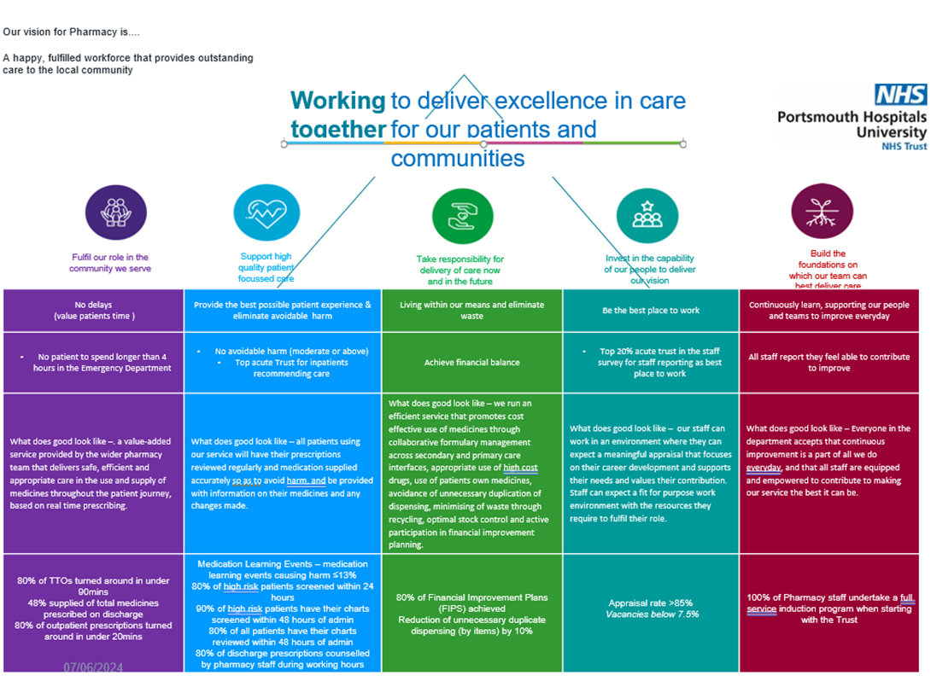
Pharmacy Mission:
The role we play is as medicines experts providing safe, effective, and timely access to medicines and medication advice to PHU and other NHS providers utilising advances in digital technology. Working with the multidisciplinary team within PHU and across the Integrated Care System (ICS) we work to improve the information available to staff, patients and their carers to optimise and personalise patient care.
Job holders are required to act in such a way that at all times the health and wellbeing of children and vulnerable adults is safeguarded. Familiarisation with and adherence to the Safeguarding Policies of the Trust is an essential requirement for all employees. In addition, all staff are expected to complete essential/mandatory training in this area.
Print Name:
Date:
Signature:

