Title: Pharmacy Manufacturing – Manufacturing Assistant Quality Control
Band: 3
Staff Group: Clinical Support Services
Reports to: Operation Manager – Pharmacy Manufacturing Unit

Job Purpose:
- To assist in the day-to-day operational work in the Quality Assurance department of the Pharmacy Manufacturing Unit, working in accordance with GMP and departmental procedures to provide services for customers both inside and outside the Trust.

Key Responsibilities
Undertaking day to day activities within section under the direction of Senior staff to include supervising and directing staff if required to ensure all deadlines are met and that work is completed according to written work instructions and Good Manufacturing Practice, Health and Safety at work act, COSHH and any other legislation where applicable.
Enforcement of quality management systems within the section including completion of documentation, maintenance of quality indicators and compliance with results of audits to ensure the standards of GMP and GLP required by the MHRA are met at all times.
Prepare weekly QC Rota and ensure that all the tasks are completed in a timely manner. Acting as trouble-shooter in areas of competence.
Microbiological identification using gram staining techniques.
Performing routine microbiological monitoring
Collating those identities and preparing reports & invoices for the senior QC staff and customers
Liaising with senior production to ensure all monitoring is completed according to schedule.
Complying the broth tests schedule and liaising with production to ensure suitable completion dates.
Undertaking the pre-release of products manufactured under the departments licence ensuring completion of the batch records and/or necessary paperwork. Taking appropriate action to deal with any deviations as necessary to ensure patient safety is not compromised at any time in the preparation process.
Monitoring the quality of raw materials, components and finished products to ensure compliance with the specifications.
Undertaking the release or rejection of raw materials / unlicensed finished products against stated specifications
Working within the Checking and Labelling area, ensuring completion of the batch records and/or necessary paperwork. Taking appropriate action to deal with any deviations as necessary to ensure patient safety is not compromised at any time in the preparation process.
Preparation of TTO specifications
Performing internal audits and collating monitoring data to produce reports.
Assisting the Senior Technician Production to ensure that the appropriate working environment is maintained and that equipment is maintained and calibrated to the required standard
Supervising and if required undertaking daily, weekly and monthly cleaning duties within and outside the QC areas as directed by Senior Technician Quality Assurance, including familiarity with spillage procedures and dealing with hazardous chemicals.
Undertaking in-house training and all necessary academic, practical and portfolio building work in order to achieve internal accreditation in area/s of work
Assisting in the training of all grades of staff under the guidance and supervision of senior staff, using written training programmes to ensure trainees are fully competent and ready for assessment by suitably qualified staff.
Acting as mentor to less qualified staff members / new members of staff within the constraints of current role
Performs assessments in areas of competence.
Ensuring Housekeeping duties and stock checks are completed, and the consumables are ordered in a timely manner to ensure an accurate stock holding
Contributes to the Pharmacy manufacturing workforce through participation in weekend and Bank Holiday working as required.

Other
Job Holders are required to:
1. Maintain personal and professional development to meet the changing demands of the job, participate in appropriate training activities and encourage and support staff development and training.
2. Always keep requirements in mind and seek out to improve, including achieving customer service performance targets.
3. Adhere to Trust policies and procedures, e.g. Health and Safety at Work, Equal Opportunities and No Smoking.
4. Act in such a way that at all times the health and wellbeing of children and vulnerable adults is safeguarded. Familiarisation with, and adherence to, the Safeguarding Policies of the Trust is an essential requirement for all employees. In addition, all staff are expected to complete essential/mandatory training in this area.
5. Respect the confidentiality of all matters that they may learn relating to their employment and other members of staff. All staff are expected to respect the requirements of the Data Protection Act 1998.

This job description does not purport to cover all aspects of the job holder’s duties but is intended to be indicative of the main areas of responsibility.

Organisational Chart
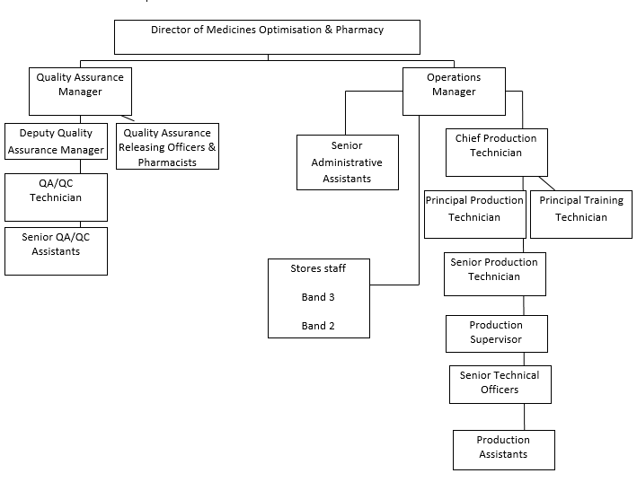

Other
This job description does not purport to cover all aspects of the job holder’s duties but is intended to be indicative of the main areas of responsibility.


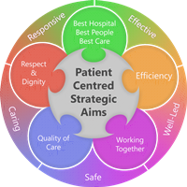
Person Specification
Qualifications
Essential
GCSE level C or above including maths, English and a science or equivalent qualifications or previous work experience that demonstrates comparable ability within a GMP/GLP environment
Demonstrated ability to work to set procedures and follow written instructions.
Minimum 2 years working in an aseptic preparation / GMP / GLP environment in a Pharmacy Support worker post equivalent or above.
Completion of in-house or equivalent training packages and proven competence.

Desirable
Completion of external training packages relating to GMP
Competence in Microsoft excel / word and report monitoring experience.

Skills and Knowledge
Knowledge of GMP, GLP, Quality assurance and microbiology
Demonstrated ability to work under pressure accurately.
Demonstrated ability to prioritise workload and supervision of others undertaking routine daily tasks.
Good communication skills and clear, spoken English.
Clear literate handwriting
Good organisational skills
Good interpersonal skills and ability to work as part of a team.
Able to carry out light lifting and undertake cleaning duties safely.
Proactive attitude to ongoing training and assessment
Demonstrated ability to clearly and accurately complete all types of documentation.
Demonstrated ability to sit or stand in a restricted position at a work bench for periods of the working time.
Ability to wear specific clean room clothing.
Demonstrated ability to handle hazardous materials safely and according to local work instructions.
Ability to use computer-based programmes and input data as required
Demonstrated accurate numeracy skills including calculations.
Self-motivation and ability to motivate others.
Team player who leads by example
Commitment to high standards of work and attention to detail
Reliable and honest
High standards of personal discipline and professionalism
Ability to work contracted hours and participate in bank holiday and or weekend duties as requested.
Good attention to detail, capable of following complex instructions and ensuring compliance of others.
Experience
Similar Pharmacy Manufacturing Experience / Pharmaceutical BTEC qualification

Working Together For Patients with Compassion as One Team Always Improving
Strategic approach (clarity on objectives, clear on expectations)

Relationship building (communicate effectively, be open and willing to help, courtesy, nurtures partnerships)

Personal credibility (visibility, approachable, back bone, courage, resilience, confidence, role model, challenge bad behaviour, manage poor performance, act with honesty and integrity)

Passion to succeed (patient centred, positive attitude, take action, take pride, take responsibility, aspire for excellence)

Harness performance through teams (champion positive change, develop staff, create a culture without fear of retribution, actively listen and value contribution, feedback and empower staff, respect diversity)

Job holders are required to act in such a way that at all times the health and wellbeing of children and vulnerable adults is safeguarded. Familiarisation with and adherence to the Safeguarding Policies of the Trust is an essential requirement for all employees. In addition, all staff are expected to complete essential/mandatory training in this area.
Print Name:
Date:
Signature:

