Title: DAWN Coordinator
Band: 2
Staff Group: Admin & Clerical
Reports to: Patient Pathway Supervisor/Service Floor Manager

Job Purpose:
- Day to day management of patient monitoring on DAWN, date entry and date collection for patients on immunosuppression medication.
- Support patient pathway team managing biologic pathways, Daycase diaries and patient helpline.
- Communicate with external healthcare providers to obtain medication and blood test updates.

Key Responsibilities
- Follow departmental guidelines and pathways for blood monitoring of patients on immunosuppression treatment.
- Communicate with patients and external health care providers to update treatment plans and ensure appropriate blood monitoring is taking place.
- Have sufficient understanding of the department and monitoring processes to understand how to respond to and provide information of a non-clinical nature to patients and healthcare providers, exercise judgement when deciding to escalate queries and responses and/or to be able to redirect as necessary to the correct part of the organisation.
- Ensure monitoring systems and pathways are kept up to date, identify changes to care in clinical documentation and enter/update data as required. Maintenance of accessible and accurate electronic data storage for the department.
- Generate reports from monitoring system to support departmental processes, drug changes and research studies.
- Use template letters to provide patients with blood results and blood phase requirements as instructed by clinical/medical team.
- Answer patient calls, take messages, redirect and answer queries as appropriate.
- Download patient calls and emails from the patient advice and information line, upload, redirect and respond to admin queries.
- Support admin duties across the department.
- Have sufficient understanding of Biologic and Daycase pathways to provide support and cover if required.
- Support and implement monitoring changes.
Other
- Maintain personal and professional development to meet the changing demands of the job, participate in appropriate training activities and encourage and support staff development and training.
- Always keep requirements in mind and seek out to improve, including achieving customer service performance targets.
- Adhere to Trust policies and procedures.
- Respect the confidentiality of all matters that they may learn relating to their employment and other members of staff. All staff are expected to respect the requirements of the Data Protection Act 1998.
This job description does not purport to cover all aspects of the job holder’s duties but is intended to be indicative of the main areas of responsibility.

Organisational Chart

ORGANISATIONAL CHART

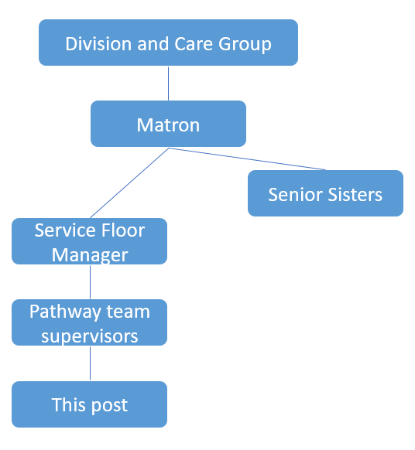


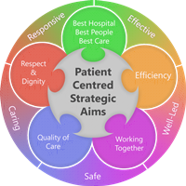
Person Specification
Qualifications
Essential
- GCSE grade C or equivalent in English Language

Experience
Essential
- Previous experience of working in a busy office environment
- Experience of working in a patient focused environment

Skills & Knowledge
Essential
- Proven effective written and oral communication skills for liaison with colleagues, medical staff and members of the public.
- Proven ability to use a personal computer with knowledge of word processing, and Windows applications.
- Proven ability to work on own initiative and manage own workload.
- Proven experience of working with cross-functional teams.

Personal Qualities

Essential
- Proven strong interpersonal skills
- Proven strong administration skills
- Effective communicator both orally and on paper
- The ability to act and ensure delivery
- Is responsive and flexible
Working Together For Patients with Compassion as One Team Always Improving
Strategic approach (clarity on objectives, clear on expectations)

Relationship building (communicate effectively, be open and willing to help, courtesy, nurtures partnerships)

Personal credibility (visibility, approachable, back bone, courage, resilience, confidence, role model, challenge bad behaviour, manage poor performance, act with honesty and integrity)

Passion to succeed (patient centred, positive attitude, take action, take pride, take responsibility, aspire for excellence)

Harness performance through teams (champion positive change, develop staff, create a culture without fear of retribution, actively listen and value contribution, feedback and empower staff , respect diversity)

Job holders are required to act in such a way that at all times the health and well being of children and vulnerable adults is safeguarded. Familiarisation with and adherence to the Safeguarding Policies of the Trust is an essential requirement for all employees. In addition all staff are expected to complete essential/mandatory training in this area.
Print Name:
Date:
Signature:

