SINGLE CORPORATE SERVICES

Governance and Risk
Information Governance
Job title: | Head of Information Governance and Data Protection Officer (DPO) | To be completed by HR  Job Reference Number
Reporting to: | Associate Director of Corporate Governance
Accountable to: | Director of Governance and Risk
Pay Band: | 8a

As part of the Single Corporate Service, the role provides a service across both Isle of Wight NHS Trust and Portsmouth Hospitals University NHS Trust.

As the single corporate service will be delivered across both organisations, individuals may be required to undertake business travel between sites. The frequency and arrangements will be discussed on an individual basis and the staff mobility local agreement will apply.

For our leaders managing staff across multi-site locations, they will need to be visible and provide in person leadership. The arrangements and frequency will be agreed locally.

Job purpose
To ensure both Trusts meet their legal and regulatory obligations associated with information governance and data protection and to ensure that there are robust arrangements in place to continue to be well led organisations. This includes assurance and escalation as necessary.

Job summary
- Using expertise to advise the Senior Information Risk Owner (SIRO) and Caldicott Guardian to ensure they fulfil their responsibilities effectively.
- Providing strategic leadership on Information and providing assurance that the Trust’s are compliant with regulations and national guidance regarding information governance
- Lead on the development and monitoring of the Trusts’ Information Governance Strategy and associated policies.
- Act as a primary point of contact for data subjects and the Information Commissioner’s Office.
- Provide overall leadership and management for the Information Governance function.

Organisational Chart

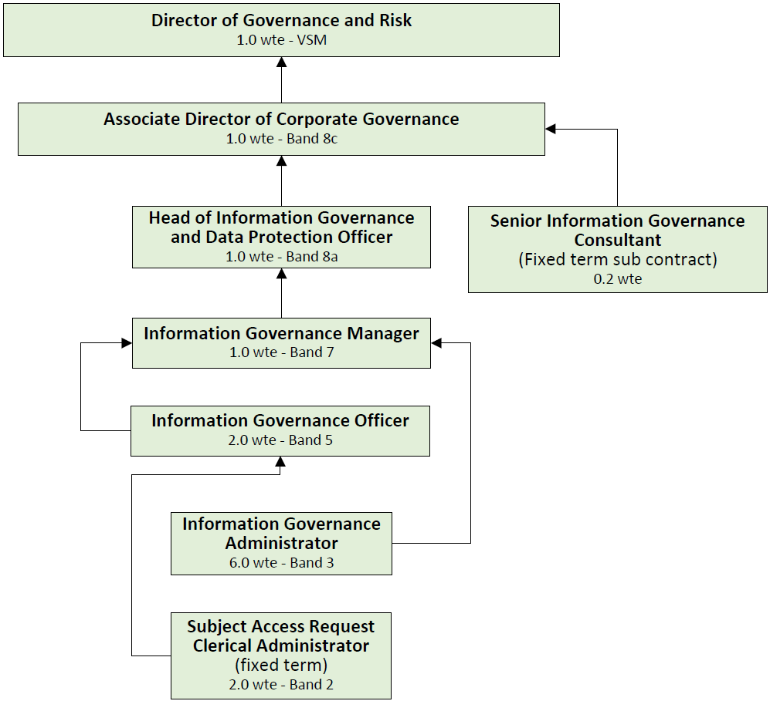

Specific Core Functions
- Act as the Data protection Officer for both Isle of Wight NHS Trust and Portsmouth Hospitals University NHS Trust.
- Act as the Trusts’ expert for Information Governance, having an in-depth knowledge of the complexity and relevance of appropriate legislation. Apply this detailed knowledge to analysing levels of Information Governance compliance across the organisation, interpreting evidence and using well-developed judgement skills to assess working practices. Counsel about legal & regulatory compliance. Involved as a key stakeholder in all issues which relate to the protection of personal data.
- Act as a primary contact point for data subjects and the Information Commissioner’s Office ensuring that there are clear systems and processes in place to facilitate this in both Trusts.
- Sufficient understanding of the processing operations carried out, as well as the information systems and data security and data protection needs of the Trust.
- Facilitating the Trust’s accountability and its ability to demonstrate compliance with GDPR and UK Data Protection Act.
- Maintain specialist knowledge of the law and best practice relating to Information Governance and identify implications of legislative changes for the Trust. Interpret and incorporate national legislation and best practice into Trust policies and processes. Provide advice to the Trust and its employees on compliance obligations.
- Lead on the ongoing evaluation of the effectiveness of the Trust’s Information Governance processes.
- Take lead responsibility for the Data Security & Protection Toolkit submission and ensure the action plan for ongoing improvements and subsequent work programmes is taken forward by appropriate leads across the organisation. Co-ordinate responses and the Trusts’ action plans for the Data Security & Protection Toolkit.
- Develop and undertake audits to provide assurance that appropriate systems are in place to manage confidentiality and information security, and to satisfy applicable legal and regulatory requirements. Develop action plans to address issues identified through the audit process and liaise with internal and external stakeholders in the communication of audits action plans / results.
- Lead and develop the delivery of the Information Governance Strategy, implementing legislative changes and ongoing service adjustments.
- Develop and implement a training programme for staff ensuring that it meets the legal and regulatory requirements.
- Organising and prioritising own workload to ensure timely responses to internal and external stakeholders, effective incident management and leadership of the information governance team ensuring deadlines are met.
- Effective communication to ensure understanding of complex information governance matters by patients, staff and other internal and external stakeholders.
- Liaise with representatives of external agencies such as – The Information Commissioner’s Office, the Department of Health, local counterparts, external specialists and users / suppliers of information systems or services.
- Contribute to regional and national Information Governance networks / groups as required.
- Communicate information to senior managers in relation to information governance requirements. Give formal presentations to key Trust groups on existing and emerging information governance issues and implementation requirements, influencing co-operation to achieve compliance. Liaison with external agencies as required within the remit of this role.
- Ensure all sharing and/or processing of personal information has a lawful basis as defined by UK GDPR and UK Data Protection Act.
- Exercise leadership and influence within the organisation in matters relating to Information Governance management, in particular, Data Protection Act, Freedom of Information Act, records management and confidentiality, providing detailed, specialist advice as required.
- Make judgements involving complex facts or situations, requiring analysis and interpretation e.g. interpretation of complex legislation relating to Information Governance, and the implications across the organisations.
- Formulate and develop and monitor long-term Information Governance programmes and plans, which impact across the organisations. Create an operational Information Governance Framework and provide operational support across the organisation to ensure successful delivery.
- Responsible for proposing, implementing and developing Information Governance-related strategies, policies and procedures across the organisation.
- Provide specialist advice to the Director of Governance and Risk (and Senior Information Risk Officer), Caldicott Guardian, and board-delegated committees as necessary, to ensure the Trusts operate within the legal and ethical frameworks.
- Review and investigate Information Governance adverse incidents and act as a panel member for Information Governance-related serious incidents.
- To ensure that the Trusts have established processes for information asset management, Data Protection Impact assessments, Subject Access Requests and freedom of Information requests.
- To produce reports on behalf of the Director of Governance and Risk, SIRO and Caldicott Guardian for submission to meetings, including Trust Leadership, committees and Board.
- To monitor compliance with the GDPR and organisational policies, including staff awareness and provisions for training.
- To provide leadership and management for the Information Governance function including line management of the Information Governance Team and having the right structures in place for management and support of all staff working within the function.
- Maintain the Trust’s annual notification registration with the Information Commissioner, informing all relevant locations of the details of the registration and identifying the responsibilities within it.
- Ensure risks regarding information are captured and monitored.
- This is not an exhaustive list of duties and responsibilities, and the post holder may be required to undertake other duties, which fall within the grade of the job, in discussion with the manager.
- This job description will be reviewed regularly in the light of changing service requirements and any such changes will be discussed with the post holder

Key Responsibilities

Communication and Working Relationships
The post holder will be providing and receiving highly complex, highly sensitive or highly contentious information, where developed persuasive, motivational, negotiating, training, empathic or re-assurance skills are required. This may be because agreement or co-operation is required or because there are barriers to understanding and/or presenting complex, sensitive, or contentious information to a large group of staff.

Analytical and Judgement
Judgements involving highly complex facts or situations, which require the analysis, interpretation, and comparison of a range of options.

Planning and organising
Planning and organisation of a broad range of complex activities or programmes, some of which are ongoing, which require the formulation and adjustment of plans or strategies.

Physical Skills
The post requires physical skills which are normally obtained through practice over a period of time or during practical training e.g. standard driving or keyboard skills, use of some tools and types of equipment.

Patient Client Care
Provides general non-clinical advice, information, guidance or ancillary services directly to patients, clients, relatives or carers.

Policy and Service Development
The post holder is responsible for major policy implementation and policy or service development, which impacts across or beyond the organisation.

Financial Management
The post holder will monitor and/or contributes to the drawing up of department/service budgets or financial initiatives.

Management/Leadership
The post holder is the line manager for the Information Governance Team, responsible for appraisals, managing sickness absence, dealing with disciplinary and grievance issues, leading on recruitment and selection, staff development and succession planning and managing all aspects of people management.

Information Resources
The post holder has occasional requirement to use computer software to develop or create statistical reports requiring formulae, query reports or detailed drawings /diagrams using desktop publishing (DTP) or computer aided design (CAD).

Research and development
Undertakes surveys or audits, as necessary to own work; may occasionally participate in R&D, clinical trials or equipment testing.

Freedom to Act
The post holder is guided by general health, organisational or broad occupational policies, but in most situations the post holder will need to establish the way in which these should be interpreted.

Physical effort
A combination of sitting, standing, and walking with little requirement for physical effort. There may be a requirement to exert light physical effort for short periods.

Mental effort
There is a frequent requirement for intense concentration.

Emotional Effort
Exposure to distressing or emotional circumstances is rare, or occasional indirect exposure to distressing or emotional circumstances.

Working conditions
Occasional exposure to unpleasant working conditions, or occasional requirement to use road transportation in emergency situations, or frequent requirement to use road transportation, or frequent requirement to work outdoors, or requirement to use Visual Display Unit equipment more or less continuously on most days.

Person Specification

Criteria | Essential | Desirable | How criteria will be assessed
Qualifications | Minimum of first degree  Qualification in Data Protection Legislation or equivalent | Management qualification  Law qualification
Experience | Significant experience in an Information Governance role (minimum 5 years)  Experience of management of DPIA’s; Asset management; FOI’s; and SAR’s  Project Management experience  Experience of managing staff  Excellent communication skills, both written and oral  Effective analytical and interpretation skills  Business planning skills  Good keyboard skills  Ability to organise workload, manage and achieve priorities and effectively manage competing priorities.
Knowledge | Expert knowledge of the Information Governance and Management requirements and application into practice  Policy development  Advanced IT skills and ability to use applications available (e.g. Word, Excel, Teams)

Compliance statement to expected organisational standards.

To comply with all Trust Policies and Procedure, with particular regard to
• Risk Management
• Health and Safety
• Confidentiality
• Data Quality
• Freedom of Information
• Equality Diversity and Inclusion
• Promoting Dignity at Work by raising concerns about bullying and harassment
• Information and Security Management and Information Governance
• Counter Fraud and Bribery

The Trust has designated the prevention and control of healthcare associated infection (HCAI) as a core patient safety issue. As part of the duty of care to patients, all staff are expected to:

- Understand duty to adhere to policies and protocols applicable to infection prevention and control.
- Comply with key clinical care policies and protocols for prevention and control of infection at all time; this includes compliance with Trust policies for hand hygiene, standards (universal) infection precautions and safe handling and disposal of sharps.
- All staff should be aware of the Trust’s Infection Control policies and other key clinical policies relevant to their work and how to access them.
- All staff will be expected to attend prevention and infection control training, teaching and updates (induction and mandatory teacher) as appropriate for their area of work, and be able to provide evidence of this at appraisal.
- To perform your duties to the highest standard with particular regard to effective and efficient use of resources, maintaining quality and contributing to improvements.
- Ensure you work towards the Knowledge and Skills Framework (KSF) requirements of this post. KSF is a competency framework that describes the knowledge and skills necessary for the post in order to deliver a quality service.
- Your behaviour will demonstrate the values and vision of the Trust by showing you care for others, that you act professionally as part of a team and that you will continually seek to innovate and improve. Our vision, values and behaviours have been designed to ensure that everyone is clear about expected behaviours and desired ways of working in addition to the professional and clinical requirements of their roles.
- Ensure you adhere to and work within local and national safeguarding children legislation and policies including the Children Act 1989 & 2004 , Working Together to Safeguard Children 2013, 4LSCB guidance and the IOW Safeguarding Policy.
- Ensure you adhere to and work within the local Multiagency safeguarding vulnerable adults policies and procedures
- Ensure that you comply with the Mental Capacity Act and its Code of Practice when working with adults who may be unable to make decisions for themselves,
- Ensure that you maintain personal and professional development to meet the changing demands of the job, participate in appropriate training activities and encourage and support staff development and training.
- Respect the confidentiality of all matters that they may learn relating to their employment and other members of staff. All staff are expected to respect conform to the requirements of the Data Protection Act 1998, including the responsibility to ensure that personal data is accurate and kept up to date
- If your employment is to a post that requires you to be registered with a professional body, the continuation of your employment is conditional upon you continuing to be registered with the appropriate professional body. The Trust will require evidence of current registration.
- Proactively, meaningfully and consistently demonstrate the Trust Values in your every day practice, decision making and interactions with patients and colleagues.
- Perform any other duties that may be required from time to time.

This job description may be altered, from time to time, to meet changing needs of the service, and will be reviewed in consultation with the post holder.

