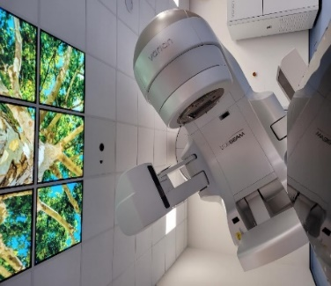
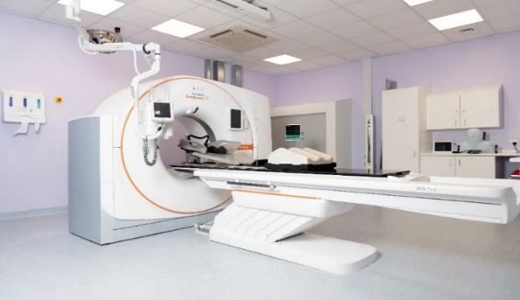
Title: Therapeutic Radiographer
Band: 5
Reports to: Team Leader
Accountable to: Radiotherapy Services Manager
Job Summary:
- Undertake radiotherapy treatment and planning, on a rotational basis, using ionising radiation to treat patients with cancer or benign disease, with both curative and palliative intent
- Carry out radiotherapy procedures using a variety of specialised high energy radiation equipment, operating in conjunction with radiotherapy IT systems and various imaging systems
- Liaise with medical, physics, nursing, clerical and support staff within the department, and throughout the institution, to ensure optimum patient care.
Key Responsibilities:
- Deliver radiotherapy treatment and participate in radiotherapy planning activities, providing a safe and efficient service to patients. Interpret complex technical data, utilising professional judgment in the practical application of treatment plans in accordance with national standards and local guidelines.
- Provide a high standard of patient care and support through all stages of the radiotherapy process, ensuring that all patients receive timely and accurate information regarding planning and treatment.
- Responsible for the daily clinical evaluation of the patient before, during and after treatment, assessing their fitness for treatment, ensuring the safe delivery of the patient’s radiation exposure, and the accurate recording of treatment data.
- Possess knowledge of equipment, and to keep abreast of new trends, technologies and techniques.
- Be individually responsible for compliance with quality assurance protocols within the department and national IR(ME)R regulations, pertaining to the radiotherapy treatment equipment and pre treatment equipment.
- Maintain professional standards of work, and conduct, and follow agreed protocols. Responsible for proper and safe use of highly expensive equipment and all facilities provided to carry out tasks and duties.
- Demonstrate ability to communicate to a high level, including the ability to provide and receive technical information in an understandable language, manage highly sensitive information and to deal with anxious cancer patients and their families, using exemplary diplomacy and persuasion, overcoming barriers when necessary.
- Provide treatment advice on management of radiotherapy side effects, and instruct patients in necessary aftercare following radiotherapy. Evaluate emotional and medical needs, and deal with appropriately, referring patients, when necessary, to the wider multi-disciplinary team.
- Perform patient positioning and marking techniques, to conform to a high degree of accuracy, requiring a high level of patient compliance, and post holder persuasion.
- Perform in vivo dosimetry as per departmental protocols.
- Perform radiotherapy dosimetric calculations, and record for use by self and others, for the course of a patient’s treatment.
- Participate in ongoing audit.
- Provide supervision and support to apprentice radiographers and students in training.
- Regularly deal with aggressive pathologies and very unpleasant bodily fluids produced as a result of the specificity of the disease, or as a result of the treatment.
- Perform basic nursing skills in a clinic environment.
- Participate as part of the multi-disciplinary team on R&D and service improvement activities, such as working groups to develop and implement new techniques, equipment and working practices.
- Agree and maintain a personal structured continuous professional development programme, in compliance with current legislative and registration requirements.
- Participate in on-call duties and bank holiday working.

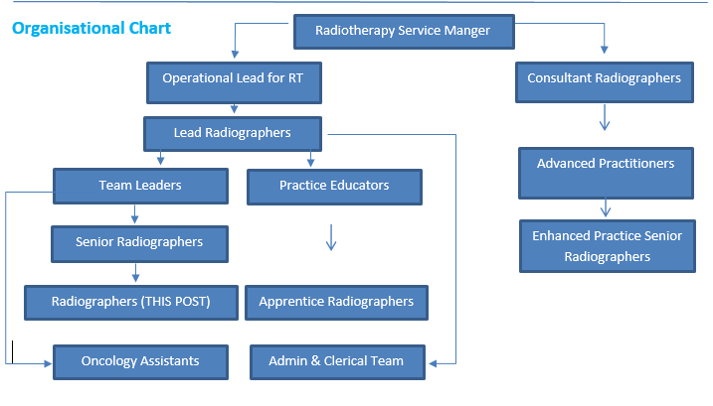
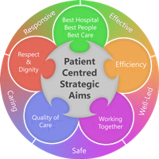
Person Specification
Qualifications
- BSc Therapeutic Radiography or DCR(T) or equivalent
- HCPC registration to practice as a Therapeutic Radiographer

Experience

- Experience of a range of radiotherapy planning and treatment techniques
- Experience of using a range of radiotherapy planning and treatment equipment
- Previous experience of working within an NHS environment

Skills and Knowledge
- Ability to operate modern radiotherapy linacs, including IGRT equipment efficiently and confidently.
- Ability to correctly assess IGRT images and confidently take subsequent action.
- Ability to operate CT scanner equipment to accurately plan a patients treatment
- Ability to operate radiotherapy software, including virtual simulation, record & verify and treatment imaging systems
- Knowledge of ISO9001 quality systems and ability to work within a quality driven environment
- Knowledge of wider cancer agenda in the NHS

Working Together For Patients with Compassion as One Team Always Improving
Strategic approach (clarity on objectives, clear on expectations)

Relationship building (communicate effectively, be open and willing to help, courtesy, nurtures partnerships)

Personal credibility (visibility, approachable, back bone, courage, resilience, confidence, role model, challenge bad behaviour, manage poor performance, act with honesty and integrity)

Passion to succeed (patient centred, positive attitude, take action, take pride, take responsibility, aspire for excellence)

Harness performance through teams (champion positive change, develop staff, create a culture without fear of retribution, actively listen and value contribution, feedback and empower staff, respect diversity)

Job holders are required to act in such a way that at all times the health and well being of children and vulnerable adults is safeguarded. Familiarisation with and adherence to the Safeguarding Policies of the Trust is an essential requirement for all employees. In addition, all staff are expected to complete essential/mandatory training in this area.
Print Name:
Date:
Signature:

