**Title:** Stroke Specialist (Hyper-Acute Stroke Team - HAST)

**Band:** Band 6

**Staff Group:** Nursing & Midwifery / Allied Healthcare Professionals

**Reports to:** Stroke Specialist Band 7

**Job Purpose:**

* The post holder will have a high level of clinical skill and has a pivotal role in the coordination and provision of urgent hyperacute stroke care, including thrombolysis/ thrombectomy and high-risk TIA management.
* The role includes day to day delivery of thrombolysis/thrombectomy, stroke outreach and stroke coordination as well as taking a lead on the nursing aspects of thrombolysis/ thrombectomy and the direct admission pathways.
* The post holder will provide clinical leadership and co-ordination of stroke care for patients, families and staff across both specialist and non-stroke specialist areas with Queen Alexandra Hospital.
* This post is clearly central to our successful stroke pathway and as such is rotational across HAST and F4 (HASU – Hyper-Acute Stroke Unit).

**Key Responsibilities**

1. Act as a professional role model for the stroke specific staff within PHU. Using stroke skills, knowledge and experience to coach and mentor more junior staff.
2. To provide Stroke Specialist assessment and advice for all suspected, or actual, stroke patients across the stroke pathway.
3. The post holder will demonstrate effective communication with ambulances services, ED, the Operations Centre, radiology, Wessex Neurological Centre, F4 (HASU) and other departments or hospitals as appropriate.
4. Work in collaboration with medical and nursing colleagues to co-ordinate the patient journey from admission to Hyper-Acute stroke Unit (HASU), ensuring efficient bed management and a seamless journey
5. Liaise with patient and relatives to ensure appropriate and informed care choices can be made
6. Support the completion of the stroke quality markers identified within SSNAP to promote clinical excellence
7. Adherence to NMC/HCPC Code at all times
8. Perform extended clinical practice roles where appropriate e.g., swallow screening, cannulation, venepuncture, ECG recording and interpretation
9. To support the Senior Lead Nurse, Matrons and Senior Ward Sisters with clinical leadership
10. To be an integral part of Older Persons Medicine (OPM) and support education across OPM with formal and informal teaching
11. Flexibility to support working within a small team.

**Organisational Chart**

**Other**

This job description does not purport to cover all aspects of the job holder’s duties but is intended to be indicative of the main areas of responsibility

**The post holder will:**

1. Proactively and positively contribute to the achievement of deliverables through individual and team effort.
2. Assist in the management of the departmental/ward activities and control risks with the focus being on delivering excellent customer service as a front line of the team.
3. Support team members to deliver on their functionally relevant objectives through offering advice, guidance and support as appropriate.
4. Assist with the effective management of departmental budgets in accordance with agreed procedures.
5. Liaison with Senior Professionals and related functions to ensure that work is neither overlooked nor duplicated.
6. Build and sustain effective communications with other roles involved in the shared services as required.
7. Maintain and continuously improve specialist knowledge in an aspect of Health Service, which significantly contributes to the Trust’s stated objectives & aims within the specialty.
8. Establish and maintain strategic links with a range of external partners/stakeholders or manage the links made through the team. Engage with external partners/stakeholders to gain their necessary level of contribution & commitment to the successful delivery of your work.
9. Undertake evidence based practice for either developments relating to Trust work or opportunities for Trust involvement around health issues
10. Increase the level of knowledge & skills within the Trust through documenting key learning and supporting others to develop their professional abilities.
11. Dissemination of knowledge through engagement in report writing, and reviewing, taking full responsibility for clinical accuracy and reliability and being sensitive to the wider implications of that dissemination.
12. Ensure that expertise is seen as a resource within and outside the Trust and form working partnerships with other key stakeholders and health and social care service providers.

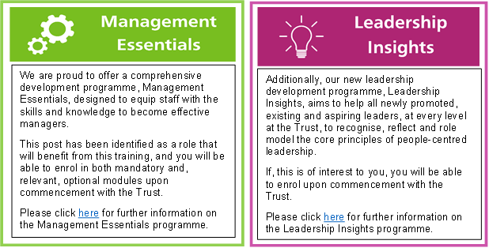

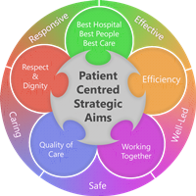**Person Specification**

**Qualifications**

*Essential*

* Registered Nurse/AHP Registered
* Relevant post registration qualifications / CPD including mentoring / coaching

*Desirable*

* Educated to first degree level
* History taking and physical assessment course
* Management and / or leadership course
* Formal teaching qualification
* IMER qualification

**Skills and Knowledge**

*Essential*

* Excellent verbal, written and interpersonal communication skills
* Evidence of high level clinical skill
* Knowledge and clinical application of National Stroke Strategy (2007)
* Knowledge and clinical application of NICE and RCP guidelines.
* Knowledge and clinical application of evidence based stroke management across acute, rehabilitation and life-long care.
* Basic IT skills
* Evidence of engagement with research and/or evidence based practice
* Ability to make sound clinical judgements
* Level 2 dysphagia

*Desirable*

* Evidence of ability and confidence to work alongside different teams and with all levels of staff
* Evidence of engagement with research and/or evidence based practice
* Level 3 dysphagia
* Venepuncture, cannulation and/or ECG recording and interpretation competency

**Experience**

*Essential*

* A minimum of 2 years post-registration experience, with a minimum of 1 year in stroke, neurology, ED or high-dependency care
* Evidence of developing staff

*Desirable*

* Evidence of previous autonomous working
* Evidence of innovation or quality improvement work

**Working Together For Patients with Compassion as One Team Always Improving**

**Strategic approach** (clarity on objectives, clear on expectations)

**Relationship building** (communicate effectively, be open and willing to help, courtesy, nurtures partnerships)

**Personal credibility** (visibility, approachable, back bone, courage, resilience, confidence, role model, challenge bad behaviour, manage poor performance, act with honesty and integrity)

**Passion to succeed** (patient centred, positive attitude, take action, take pride, take responsibility, aspire for excellence)

**Harness performance through teams** (champion positive change, develop staff, create a culture without fear of retribution, actively listen and value contribution, feedback and empower staff , respect diversity)

Job holders are required to act in such a way that at all times the health and well being of children and vulnerable adults is safeguarded. Familiarisation with and adherence to the Safeguarding Policies of the Trust is an essential requirement for all employees. In addition all staff are expected to complete essential/mandatory training in this area.

**Print Name:**

**Date:**

**Signature:**

