Title: Vascular Scientist
Department: Vascular Assessment Unit (VAU)
Band: Band 7
Reports to: Head of Vascular Assessment Unit
Job Summary:
1. To work as an independent, fully qualified, reporting Vascular Scientist within the specialised area of Vascular Ultrasound. To take responsibility for the selection of appropriate scan method and performance of a wide range of unsupervised Vascular Ultrasound investigations on patients involving a broad range of specialised and complex procedures.
2. To produce a clinically diagnostic report from each investigation and take responsibility for directly discussing the results with the referring clinician, as appropriate.
3. To manage the patient workload on a daily basis including prioritising routine and urgent referrals.
4. To participate in the introduction and evaluation of new and improved methods, techniques and service developments.
5. To participate in the teaching and training of staff within the Vascular Assessment Unit, including overseeing the work of trainees, ensuring compliance with professional standards.
6. If required, as the most senior staff member on duty, manage any incidents within the departmental and Trust incident management processes and escalate appropriately where required.

Key Responsibilities:
- Provide highly specialised scientific and technical services in the field of Vascular Ultrasound.
- Liaise with Clinical Consultants and Medical Staff to provide highly specialised scientific and technical advice on selection and implementation of appropriate diagnostic procedures.
- Interpret clinical referral information and select appropriate scan protocol, deciding whether a routine protocol or an unprecedented and unique protocol should be used depending on the particular clinical information required for each patient.
- Prioritise unit’s workload on a day-to-day basis, frequently rescheduling to take account of any urgent assessments. Shared responsibility for allocation and checking of junior staff workload.
- Employ empathy, reassurance and negotiating skills in communications with patients prior to assessment to ensure that results will be of the highest quality, paying particular attention to patients where there may be communication or understanding difficulties.
- Independently perform all routine and non-routine complex Vascular Ultrasound scans, deducing circulation conditions from very fine manipulation of ultrasound probes in 3 dimensions and analysing corresponding images and measurements. Regularly perform scans requiring the highest levels of concentration, speed and precision in blood velocity measurement with very narrow margins of error, enabling clinical decisions on appropriate surgery to be made accurately.
- Independently interpret findings using specialist knowledge of complex vascular anatomy and pathology, exercising judgement in complicated cases where individual results may be conflicting. Independently write clear and concise reports.
- Communicate results to patients where appropriate, including the sensitive imparting of bad news (for example presence of Deep Vein Thrombosis (DVT), failure of reconstructive surgery).
- Take responsibility for the initiation of further scan protocols based on extensive knowledge of likely treatment options, where additional information will be beneficial to the patient.
- Identify the limitations of each assessment and suggest further diagnostic tests to the referring clinicians as required.
- Take responsibility for ensuring the results are appropriately acted upon in cases where urgent notification of unusual/adverse results is required. Ensure that findings requiring urgent attention (including those that are unexpected) are promptly reported to the referring clinician, and the reasons explained to the patient.
- Ensure that scans are carried out with due attention to the safety of patients and accompanying staff, minimising the risk of injury. Take responsibility for safe use and maintenance of expensive specialised ultrasound equipment.
- Independently provide mobile Vascular Ultrasound Services at consultant led rapid access clinics and for patients in theatres and critical care units.
- Participate in the training and assessment of trainee Vascular Ultrasonographers/Scientists, taking responsibility for their work on a day-to-day basis. Act as a mentor for staff training within the Vascular Assessment Unit.
- Ensure record keeping for diagnostic tests and patient data base is accurate and up to date using the IT resources within the unit.
- Supervise and direct the work of the support staff to ensure that service commitments are met in a timely manner and patients are cared for in an appropriate way whilst in the Vascular Assessment Unit. Liaise with clerical staff, porters, nursing and medical staff as appropriate in the interest of patients and their escorts.
- Ensure that Control of Infection Guidelines are observed in relation to personnel and equipment. Take the necessary precautions in the frequent cases of patients with ulcers, open wounds and necrotic tissue/gangrene.
- Participate within clinical governance, research and audit activities within the Vascular Assessment Unit as directed by the Head of Service.
- Maintain awareness of developments in Vascular Ultrasonography and be responsible for continuing professional development and achievement of own objectives. Undertake appropriate continuing professional development schemes to maintain State Registration, as appropriate, and The Society of Vascular Technology Accreditation.
- Propose service developments and evolution of scanning protocols, as appropriate, to the Head of Service and participate in evaluation and implementation of new techniques.
- Attend internal and external courses/ seminars and lectures to maintain knowledge and state registration as identified within the appraisal process and for CPD. Represent the Vascular Assessment Unit at joint clinical review meetings as directed by the Head of Service.
- Take responsibility for specific roles in the day to day running of the Vascular Assessment Unit as directed by the Head of Service. e.g. health and safety, quality assurance, clinical audit and governance.
- If required, as the most senior staff member on duty, manage any incidents within the departmental and Trust incident management processes and escalate appropriately where required.
- Contribute to the processes of equipment procurement, budget control, and service development.

Organisational Chart
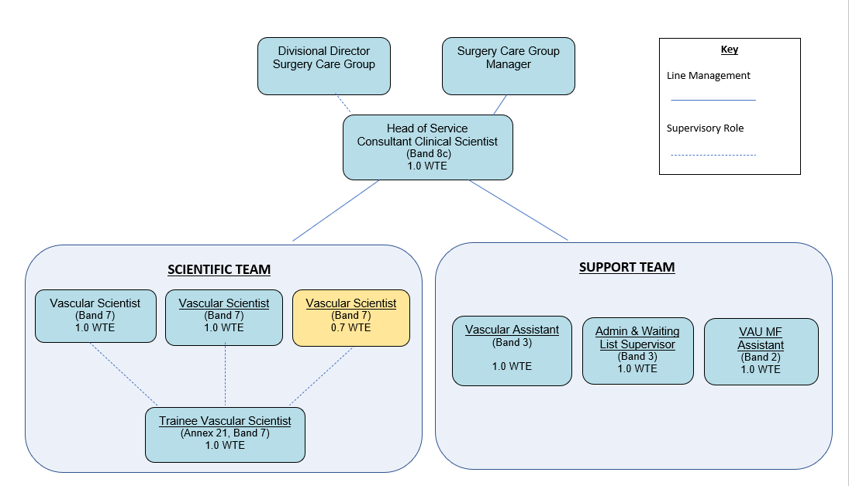
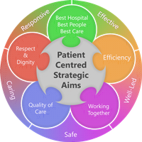
Person Specification
ESSENTIAL QUALIFICATIONS
- Applicants must have AVS (Full Accreditation with Society of Vascular Technology for Great Britain and Ireland - requiring 3-4 years post graduate study, training and experience of Vascular Ultrasound) or equivalent qualification.
- Applicants must have an honours degree or equivalent in Medical, Biological or Physical Sciences (1st or 2.1)

Desirable
- MSc in Medical or Physical Science
- Physics A level or equivalent
- HCPC Registration
ESSENTIAL SKILLS & KNOWLEDGE
- Advanced knowledge and experience of Vascular Ultrasound
- Highly developed physical skills in performing highly complex Vascular Ultrasound scans with the highest levels of precision, speed and accuracy.
- Highly developed reporting skills for Vascular Ultrasound scans.
- Advanced analytical skills in problem solving.
- Highly developed communication skills, both written and spoken.
- Ability to communicate complex results to clinical colleagues, including scientific and technical interpretation of complex anatomy and physiology.
- Highly developed skills in working with advanced complex and expensive equipment.
- Physically able to move heavy equipment, assist with transfer of patients, and maintain awkward scanning positions with limited scope for movement in order to obtain adequate images.
- Able to deal with distressing circumstances and frequently unpleasant working conditions.
- Able to sensitively impart bad news, including test results, to patients.
- Highly effective at making appropriate decisions and recommendations regarding referral of patients for further tests.
- Highly effective at organising work of self and others, prioritising work according to service demands, competing pressures and time scales.
- Able to deal with clinicians, general practitioners, management of staff, patients and the general public.
- Flexible working attitude, being self-motivated and able to work within a team structure.

Desirable
- Experience of Research and Development
- Training skills

ESSENTIAL PERSONAL QUALITIES
- Responsive, resourceful and flexible approach.
- Ability to prioritise whilst remaining calm and logical.
- Self-motivated and able to enlist the co-operation and support of others.
- Understands and adhere to the requirements of confidentiality.
- Able to communicate with a wide range of professional groups and patients.
- Sensitive to the needs of patients and colleagues and diligent on matters where care and support is needed.
- Ability to communicate with patients displaying challenging behaviour
- Well developed communication and interpersonal skills
- Well developed administrative skills
- Able to work with multi-disciplinary teams
- Ability to act and ensure delivery of objectives
- Physically able to undertake tasks requiring movement of patients and equipment and maintain awkward scanning positions

Working Together For Patients with Compassion as One Team Always Improving

Strategic approach (clarity on objectives, clear on expectations)

Relationship building (communicate effectively, be open and willing to help, courtesy, nurtures partnerships)

Personal credibility (visibility, approachable, back bone, courage, resilience, confidence, role model, challenge bad behaviour, manage poor performance, act with honesty and integrity)

Passion to succeed (patient centred, positive attitude, take action, take pride, take responsibility, aspire for excellence)

Harness performance through teams (champion positive change, develop staff, create a culture without fear of retribution, actively listen and value contribution, feedback and empower staff , respect diversity)

Job holders are required to act in such a way that at all times the health and well being of children and vulnerable adults is safeguarded. Familiarisation with and adherence to the Safeguarding Policies of the Trust is an essential requirement for all employees. In addition all staff are expected to complete essential/mandatory training in this area.
Print Name:
Date:
Signature:

