Grade: Consultant Radiologist
Department: Radiology
Reports to: Clinical Director for Radiology

Additional Information:
Portsmouth Hospitals University NHS Trust is a provider of Acute Health Services under contract to a range of Purchasers in the area of the Hampshire basin and Western South Downs. The catchment is in excess of 675,000 people. The area served by the Trust is on the Solent and English Channel and includes the City of Portsmouth and the Boroughs of Gosport, Fareham and Havant extending from Warsash in the west to Emsworth on the Sussex border and its northern boundaries encompass Petersfield and Liss. With the exception of the rural north, it is an essentially urban area having grown up around the Royal Naval establishments in Portsmouth and Gosport. It now provides a wide range of modern high-tech industry and the facilities associated with a commercial port and cross Channel ferry terminal.

Portsmouth is a thriving naval city, steeped in history, on the South Coast. It is ninety minutes from central London and has good transport links, including regular ferries to France and Spain. The major airports are easily accessible. It has some of the best water sports facilities in Europe and sandy beaches are within easy reach. Developments within the city itself and on the Gosport side of the harbour suggest a vibrant future for the area. Inland from the hospital is the beautiful and relatively unspoilt countryside of rural Hampshire. Close by is the New Forest and the recently designated National Park of the South Downs. The area combines the advantages of city life with pleasant villages and seaside towns. There are a number of first-rate schools both in the state and private sector and it is an excellent place to raise a family.

Portsmouth Hospitals University NHS Trust

Portsmouth Hospitals University NHS Trust has a vision to be recognised as a world-class hospital, leading the field through innovative healthcare solutions, focusing on the best outcomes for our patients, delivered in a safe, caring and inspiring environment.

At present PHU provides the following services, Emergency Medicine, Trauma and Orthopaedic Surgery, Oncology, Radiology, Orthodontic and Oral Surgery, General and Specialist Medicine, General Surgery, Breast Screening and Surgery, Plastic Surgery, Renal Services, Acute Medical Admissions, Ophthalmology, Maxillofacial, ENT, Critical Care, Coronary Care, Elderly Medicine, Rheumatology, Elderly Medicine, Rehabilitation, Dermatology, Maternity, Gynae, Paeds and Neurology.

The Department

Diagnostic Imaging in Portsmouth
The radiology team comprises of 35 NHS consultant radiologists, a nuclear medicine physician, a military radiologist and 18 specialty trainees. All NHS consultants are employed according to the new consultant contract.

Consultants contribute to the acute corridor and general radiology work of the department and have a subspecialty interest developed according to body system lines. This is reinforced by close co-operation with clinical colleagues, aided by regular MDT meetings in all areas.
The radiology service is supported by a team of radiographers, nurses, radiographic assistants, secretarial and clerical staff and a general management team.

The department has been proactive in-service redesign, embracing role extension. Radiographic assistants provide venous access for CT. Radiographers report ED films and perform independent fluoroscopy lists, and sonographers provide a general acute ultrasound service. Speciality radiographers perform CT colongraphy and independent cardiac CT lists. We currently have one consultant radiographer. The department provides placements for student radiographers from the University of Portsmouth and teaching for medical undergraduates from the University of Southampton.

Team Working

Radiology Access Unit (RAU)
Radiologists are expected to contribute to the acute radiology services. There are four x2 hour RAU sessions a day, allocated on a weekly rota, 2 consultants are rostered to cover inpatient CT and other reporting from 9 am to 5 pm. A full-time equivalent consultant would be expected to undertake a minimum of 4 hours per week in the RAU.

Elective Reporting
CT and MR machines run through the week and weekend (0800-2000hrs). Reporting of all modalities is distributed to the relevant subspecialty work lists. Every effort is made to ensure reports are available for the relevant MDT meetings.

Weekend Working and on call
General work includes taking part in an on-call service and weekend working. The department provides a 7-day service. Currently the duty radiologist and trainee on weekend and bank holidays, are in and working for 8-10 hours
This time is recompensed by time off in lieu to be taken within 3 months of the on-call date at time and a half.

6 Colleagues provide a separate Interventional Radiology on call. The appointee would not be expected to contribute to this.

There is out of hour’s emergency MRI for metastatic cord compression, cauda equina, post anaesthetic epidural haematoma and acute stroke neuro.

The Radiology Trainees, ST3-6, provide the evening on call service. Emergency imaging is outsourced to an external provider from 22:00-09:00hrs. The on-call Consultant is expected to be remotely available to support the trainees.
Home reporting
Remote reporting is in place.

Portsmouth Hospitals NHS Trust Sites

Queen Alexandra Hospital

The main X-Ray and scanning departments have been designed to provide separate acute/ inpatient and elective/ outpatient facilities. The breast unit and nuclear medicine department have dedicated imaging facilities and further satellite imaging units can be found in the emergency, paediatric and head and neck departments. The department is fully digital with Sectra PACS and HSS CRIS. Dragon voice recognition software integrated with CRIS is used for reporting across all modalities. Image sharing through the patient pathway is promoted by involvement in the SWASH (Salisbury, IOW and South Hampshire) RIS/PACS consortium that uses XDS standards.

Outpatient department
- 6 plain X-ray rooms: 4 Siemens Ysio and 2 Philips Easy Diagnost, all with WiDi wireless detectors (all 2009)
- 4 ultrasound rooms: 3 Canon Aplio i800 (2018), and 1 Samsung RS85v2(2021)
- 3 CT scanners: Canon Prime SP (2020) , 1 Canon Aquilion 1 (2016) and Canon Prime (2019)
- 2 MR scanners: 1 Siemens 1.5T Avanto (2018) and 1 GE 3.0T MR750w GEM (2014)
- 1 Fluoroscopy suite: Siemens Artis Zee Multipurpose (2009)
- 1 paediatrics ultrasound room: Canon Aplio XG (2018)

Inpatient department
- 2 plain X-ray rooms: 1 Siemens Ysio and 1 Philips Easy Diagnost (2009)
- 3 ultrasound rooms (including H&N): 1 Samsung RS85 Prestige v2.04 (2022), 2 Canon Aplio i800(2018)
- 1 CT scanner: Canon Aquilion Prism (2020)
- 1 MR scanner: GE 1.5T MR450w Optima (2015)

Radiology Day Case Unit
- 9 care spaces
- 2 interventional suites: 1 Siemens Artis Q Ceiling (August 2021) and 1 Siemens Artis Zee Ceiling (2010)
- 1 fluoroscopy suite : Siemens Artis Zee Multipurpose (2017)
- 4 Ultrasound machines : 1 Canon Aplio i800 (2022), 1 Samsung HS60 (2020), 2 Canon Viamo c100 laptops (2022).

New Emergency Department

- 2 plain X-ray rooms: 1 Siemens Ysio Max X.Pree and 1 MIS GC85 AccE (2024)
- 1 paediatric plain X-ray room: MIS GC85 AccE (2024)
- 2 CT scanner: Canon Aquilion Prism (2024)

Paediatric department
- 2 plain X-ray rooms: 2 Siemens Ysio (2009)
- 1 ultrasound room: 1 Canon Aplio i800 (2018)

Head and Neck department
- 2 room department: 1 Instrumentarium Focus with Vistascan CR (intra-oral) and 1 Instrumentarium OC200d (OPG and ceph) (2009)
- Cone beam CT

Nuclear Medicine department
- 1 SPECT Gamma cameras : 1 Siemens Symbia T (2009)
- 2 SPECT-CT scanner : 1 Siemens Symbia T16 (2009) and 1 GE 870 Discovery (2023)
- 1 Siemens Biograph Truepoint PET-CT scanner, installed October 2009, service managed by Alliance Medical under the National Contract

Further PET-CT scanning is offered to the district by an independent provider from a mobile site at Southampton General Hospital. PET-CT scans performed on Portsmouth patients are reported by a small group of Portsmouth radiologists together with the Nuclear Medicine physician.

The service currently has 1 temporary CT scanner located at Rodney Road CDC and 2 temporary MRI scanner located at St Mary’s and Fareham Community hospitals supporting elective imaging.

St Mary’s Hospital

This site provides:
- Dermatology
- GU medicine
- Post-acute general and elderly medicine
- Satellite maternity unit

The St Mary’s Hospital site also hosts an Independent Sector Treatment Centre that has some imaging services provided for primary care referrals. Although this is separate from Portsmouth Hospitals NHS Trust, close collaboration exists between the two providers ensuring seamless patient care.

Community Units
Small community hospitals in the district providing plain films and ultrasound:
- Gosport War Memorial Hospital – 1 Canon Aplio i700 (2020)
- Petersfield Community Hospital – 1 Samsung RS85 Prestige v2.04 (2022)
- Fareham Community Hospital – 1 Samsung RS85 Prestige v2.04 (2022)

Radiology Workload – Exams

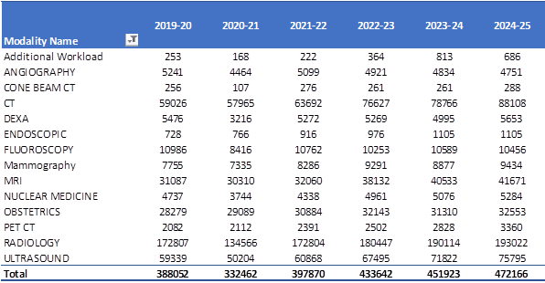

Departmental Staff

Diagnostic Imaging Services Manager:
Mrs Janine Hatch, email: Janine.Hatch1@nhs.net

Clinical Director:
Mr Rob Bunting (Advanced Practitioner Radiographer)
Dr Paula McParland – Consultant Radiologist
Dr Chris Ball - Consultant Radiologist

Email via PA : pho-tr.radiologysecretaries@nhs.net

Radiographic and Support Staff

In Portsmouth Hospitals NHS Trust a superintendent radiographer supervises each of the imaging sections, namely General Radiology (QAH and Community Hospitals), Ultrasound, CT and MR, Breast Imaging and Nuclear Medicine.

Funded Establishment

Consultants 39.5 WTE

Trainees 20 WTE
Radiographers 180 WTE (including superintendents)
RDAs/ Assistant practitioners 101 WTE
Nurses / HCSW 15 WTE
Clerical and Secretarial inc Management 51 WTE

Secretarial Support and Office Accommodation

Shared office space and shared secretarial support will be provided at QAH.
Radiologists

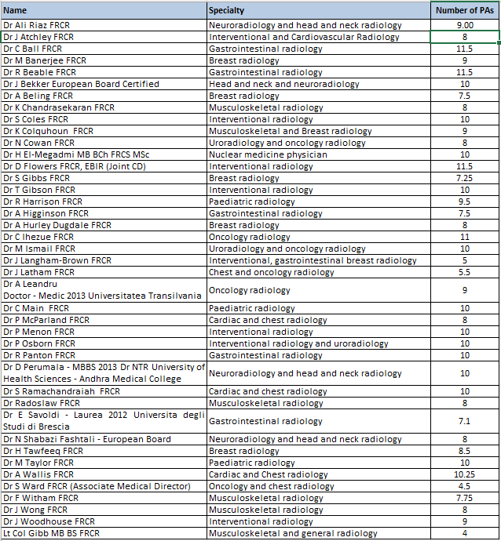

General requirements
Radiologists are expected to participate in the general development of the Radiology Department by involvement with departmental or Trust projects/committees, equipment procurement, administration and management, audit, teaching, research, fostering good working relations within the department and provide high quality communication with hospital clinicians and GPs.

Medical Staffing - Consultants
The consultant’s job plan is subject to change at any time, by negotiation with the Consultant and Trust management.

Education & Research
It is expected that the appointee will contribute to the active teaching programme for junior medical staff within the Trust and nurses within the Health Safety and Wellbeing Service.

The post holder is strongly encouraged to develop the academic potential of the service and will be expected to have an active interest in academic developments in Occupational Medicine, to promote an academic ethos amongst all staff and where appropriate to carry out and encourage research projects.

Conditions of Service
The post is covered by the Terms and Conditions of Service Consultant Contract (2003)

The Trust expects all Medical and Dental staff to work within the guidelines of the GMC ‘Guide to Good Medical Practice’ which can be viewed on the GMC website www.gmc-uk.org.

Where the post holder manages employees of the Trust, he/she will be expected to follow the local and national employment and personnel policies and procedures.

Accommodation
Shared office accommodation will be made available within the department together with secretarial support.

Management
The post holder will be expected to work with local managers and professional colleagues in the efficient running of services including the medical contribution to management. Subject to the provisions of the Terms and Conditions of Service, the post holder is expected to observe agreed policies and procedures drawn up on consultation with the profession on clinical matters and follow the standing orders and financial instructions of the Portsmouth NHS Trust. In particular, Managers of employees of the Portsmouth Hospitals NHS Trust are expected to follow the local and national employment and personnel policies and procedures. The post holder will be expected to ensure that there are adequate arrangements for hospital staff involved in the care of patients to be able to contact him/her when necessary.

All medical and dental staff are expected to comply with the Portsmouth Hospitals NHS Trust Health and Safety Policies.

All medical and dental staff are expected to proactively, meaningfully and consistently demonstrate the Trust Values in their every day practice, decision making and interactions with patients and colleagues.

Study leave
30 days within a three-year period, subject to national and local policies will be allowed.

Status of Post
This is a full-time post. Applicants interested in part time working are also welcome.

Residence
Residence within either 10 miles or 30 minutes by road from Queen Alexandra Hospital is usually required unless alternative arrangements agreed with the Trust management. His/her private residence must be maintained in contact with the public telephone service.

Safe Guarding
Act in such a way that at all times the health and wellbeing of children and vulnerable adults is safeguarded. Familiarisation with and adherence to the Safeguarding Policies of the Trust is an essential requirement for all employees. In addition, all staff are expected to complete essential/mandatory training in this area.

Infection Control
In compliance with the Trust's practices and procedures associated with the control of infection, you are required to:
- Adhere to Trust Infection Control Policies assuring compliance with all defined infection control standards at all times.
- Conduct hand hygiene in accordance with Trust policy, challenging those around you that do not.
- Challenge poor practice that could lead to the transmission of infection.

Hand Hygiene Policy
The Trust has adopted "Naked Below the Elbow" strategy which means that when involved in patient care and direct physical contact with patients, you must wash or decontaminate your hands as per the Hand Hygiene Policy.

Compliance with the Hand Hygiene Policy is mandatory; you must wear short sleeved shirts/blouses/uniform, remove any out jackets and roll up your sleeves. No jewellery should be worn below the elbow (except a plain wedding band) and wrist watches must be removed.

Compliance with this policy will be monitored and any noncompliance may be subject to disciplinary action."

Rehabilitation of Offenders
Because of the nature of the work for which you are applying, this post is exempt from the provisions of Section 4(2) of the Rehabilitation of Offenders Act, 1974 by virtue of the Rehabilitation of Offenders Act, 1974 (exceptions) order 1975. Applicants are therefore not entitled to withhold information about convictions. This could result in dismissal or disciplinary action from the Trust.

Any information given will be completely confidential and will be considered only in relation to an application for positions to which the order is applied.

Post Vacant
The post is currently available, and the appointee will be required to take up the post no later than four months from the date of the offer of an appointment, unless a special agreement has been made between the appointee and Portsmouth Hospitals NHS Trust

If you consider it unlikely that you will be able to take up the appointment within such a period, you are advised to point this out at the time of your application.

Visiting Arrangements

Intending applicants may obtain further information and/ or arrange a visit by contacting Dr Paula McParland or Rob Bunting via PA
Email pho-tr.radiologysecretaries@nhs.net

Tel: 023 9228 6000 Ext 5302

Please note that Portsmouth Hospitals University NHS Trust will reimburse expenses for one pre-interview visit in respect of short-listed candidates.

Due to the high volume of recruitment and our desire to treat all applicants fairly it is not possible to meet with the Chief Executive prior to the Appointments Advisory Committee.

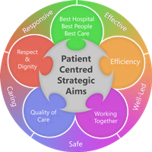
However, arrangements to meet with Dr Steve Mathieu, Medical Director, can be made by contacting his PA on 02392 286342. Both Dr Mathieu and the Group Chief executive Penny Emerit are extremely committed and supportive of this appointment and to appointing the right candidate and, as part of the induction programme, the successful applicant will have an opportunity to meet with them.

