

Aspect Treetop School - School Support Officer

POSITION PROFILE

PART A: POSITION DESCRIPTION

Position Title: School Support Officer | Location: Aspect Treetop School
Group: Education | Reports to: Principal
Industrial Award Coverage: Educational Services (Schools) General Staff Award | Classification Level: Level 2

Organisation Purpose

A different brilliant ® - Understanding, engaging and celebrating the strengths, interests and aspirations of people on the autism spectrum.

Vision | Mission | Values
The best opportunities for people on the autism spectrum | We work with people of all ages on the autism spectrum, delivering evidence-informed solutions that are person-centred, family-focused & customer-driven | We are passionate about people, about being positive and about what’s possible

Team Purpose
To collaborate as a team of specialists including teachers, school support officers, school therapists, co-ordinators, administrators and other Aspect staff, using a person-centred approach, to deliver the Aspect Comprehensive Approach (ACA) to teach students the skills to be the best they can be and allow them to positively engage with their community.

Position Purpose
To assist teachers in the delivery of the Aspect Comprehensive Approach (ACA) through the student’s Individual Programs (IPs), i.e. assessment and learning activities, in an Autism Spectrum Australia (Aspect) school. This role supports teachers with positive behaviour support, community access programs and the integration of students into less restrictive settings.

Outcomes

Key Result Area | Requirements & Expectations | Success Indicators
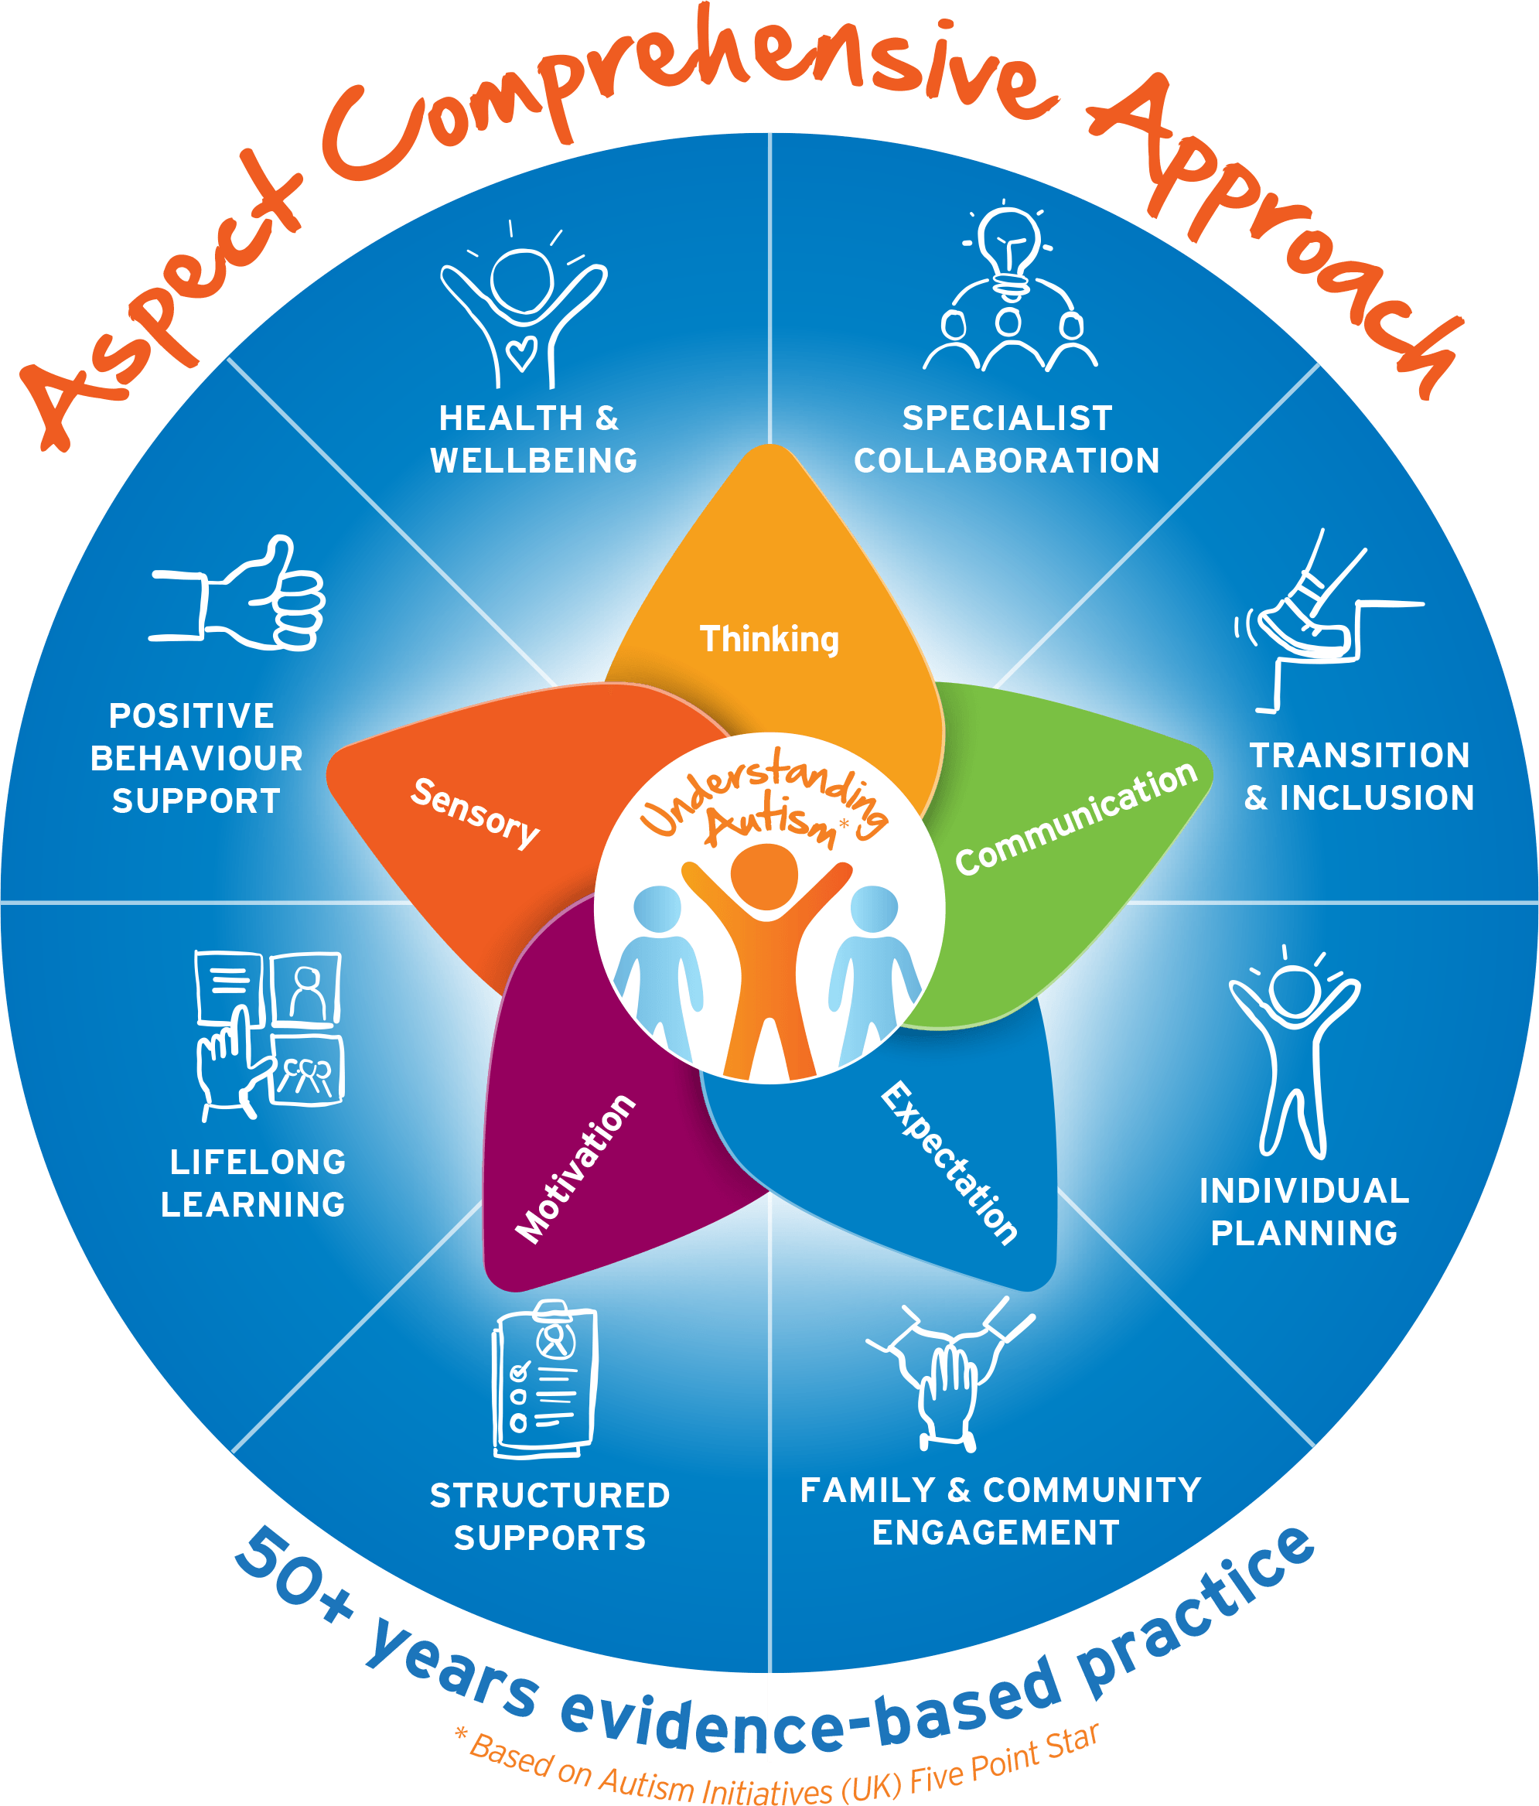  Aspect Comprehensive Approach (ACA) | - Assist teachers to implement the Aspect Comprehensive Approach for Education (ACA)  - Collect data to assist and develop IPs.  - Be familiar with students’ IP outcomes/priorities.  - Assist teachers to implement the IPs.  - Collect data for ongoing assessments  - assist teachers in working towards the provision of educational programs that move students to a mainstream or less specialised setting and aid their participation in the local community  - Be familiar with the curriculum. | - Observe, record and report data relevant to students IP’s  - Comprehensive knowledge of students IP  - Actively participate in implementing and ongoing support of students IP’s  - Through collaboration with teachers, students meet their goals to be the best they can be  - Understands the expectations of Aspect’s ACA and curriculum and demonstrate in the classroom
Student Support | - Be responsible for the welfare and safety of pupils in the classroom, playground, school activities or excursions and elsewhere in the course of professional duties and have ongoing 'duty of care' at all times  - Use Positive Behaviour Support Programs to facilitate the development of self-management in students with challenging behaviour  - Support teaching and learning through use of visually based alternative and augmentative functional communication systems based on assessment of individual needs/strengths of each student to facilitate the participation of students in daily life  - When required supervise a small group of children without a teacher present  - Support strategies for student well-being | - Students are safe and any behavioural concerns or incidents are reported to the teacher /school management immediately  - Demonstrates effective planning, preparation and organisation for daily activities  - Students are positively supported at all times using the tools agreed with the Teacher i.e. visuals, PBS practices, well-being strategies
Professional/Development Skills | - Maintain knowledge of current theory and practise of professional domains relevant to the education of children on the autism spectrum (AS) under the guidance of the school  - Develop an annual learning plan and actively work towards achieving the objectives set in conjunction with School Management | - Participate and implement skills gained at professional development as directed by the Principal  - Annual learning plan objectives are met within agreed timeframes
Safeguarding the people we support | Aspect is committed to providing an environment free from abuse, neglect and exploitation of the people we support. Staff are expected to:  - Demonstrate a duty of care to students  - Treat students with dignity and respect  - Complete mandatory Child Protection training and implement into day to day operations and practice  - Be vigilant and maintain a heightened sensitivity to recognising signs of abuse, neglect or exploitation and escalate/report those signs/concerns  - Escalate/report other staff practices which deviate from policy/procedure  - Adhere to student’s individual plans recognising their personal needs, choices and control | - Demonstrated evidence that issues / concerns are escalated/reported to supervisor / manager  - Completion of Child Protection on-line training  - Personal commitment and day to day demonstration of competency in safeguarding
Work, Health & Safety | It is a requirement for all staff to:  - Take reasonable care for own health and safety  - Comply, so far as the worker is reasonably able, with any reasonable instruction that is given by the person conducting the business or undertaking to allow the person to comply with legislative requirements  - Report unsafe conditions or practices, and make suggestions to their manager on improving work, health & safety at Aspect.  - Exercise duty of care in the health, safety and welfare of pupils and ensure they are treated with dignity and respect  - Participate in the staff consultation process about work health & safety matters | - Aspect’s safety policies and procedures are followed including site specific work practices and management instructions  - All hazards, incidents and injuries are reported to management as per Aspect’s risk management procedures  - Health safety and welfare of self and others is ensured as far as reasonable  - Actively participate in safety consultation as required

PART B: POSITION CRITERIA

Capabilities | Student Support | Make genuine effort to listen to & understand the student; anticipating the needs of the client. Supervise a small group of students without a teacher present as required.
Capabilities | Flexibility/Adaptability | Is open to change, can think independently, exercises independent initiative and judgement
Capabilities | Attention to Detail | Follows a method of work that is organised, logical and accessible ensuring information is accurate and meets information and reporting needs of the school.
Capabilities | Teamwork | Active participation in and facilitation of team effectiveness. Providing professional and prompt support to the Education team as required.
Capabilities | Technical/Professional Knowledge | Having achieved a satisfactory level of technical and professional skills/knowledge in job related areas, keeping up with current developments and trends in areas of expertise showing a depth of understanding of the characteristics of autism and related teaching practices.
Knowledge & Experience | - Knowledge and understanding of Autism  - Individualised Education Plan (IP) practices in Special Education is desirable  - Experience with students on the autism spectrum desirable  - Ability to perform complex tasks with limited direction
Qualifications/ Licence | - Certificate and / or experience in schools and autism  - Depending on the school’s location/requirements it may be essential to have a current, valid driver’s licence.  - Working with Children Check or equivalent state clearance to work with children  - Responding to Risks of Harm, Abuse and Neglect (RRHAN) certificate
Job Requirements | - May supervise a small group of students without a teacher present  - May supervise up to three employees  - A Light Rigid (LR) Driver’s licence is desirable
Functional capacity requirements | In providing services to the people Aspect supports, the nature of the work in Aspect Education inherently involves some exposure to behaviours of concern from our students.  Behaviours of concern are defined by the South Australian Department for Education as, “challenging, complex or unsafe behaviours that are of greater severity, frequency or duration and require more persistent or intensive intervention to address. Does not include low level, developmentally appropriate transgressions that test the boundaries of established rules, standards and norms but are relatively simple to direct and minimise through universal behaviour support strategies.”  Behaviours of concern occur for a reason and communicate important information about a student’s stress, distress and skill development. They are typically outlined in a student’s behaviour support plan, along with the interventions expected, based on a positive behaviour support (PBS) approach. You can learn more about Aspect’s approach to PBS on our website.  Aspect provides comprehensive safety intervention training to all staff who work directly with students. |  | Note: Frequency refers to an approximate percentage of time in a typical shift or period on duty:  Rarely: Up to 7%  Occasionally: 8% to 33%  Often: 34% to 66%  Continuously: More than 66%
Functional capacity requirements | Requirement |  | Frequency
Functional capacity requirements | Resilience to behaviours of concern |  | Often
Functional capacity requirements | Sitting, standing, walking |  | Continuously
Functional capacity requirements | Postural positioning – crouching, kneeling, stooping |  | Often
Functional capacity requirements | Reaching, pulling, pushing, lifting < 10kg, carrying |  | Occasionally
Functional capacity requirements | Fine motor skills – keyboarding, writing |  | Often

PART C: APPROVED BY

Position Approved by: (Date)

PART D: ACKNOWLEDGEMENT OF INCUMBENT

I have read and understood the requirements of the position

Name: (Date)

