

Special Education Teacher

POSITION PROFILE

PART A: POSITION DESCRIPTION

Position Title: Special Education Teacher | Location: Aspect School
Group: Education | Reports to: Principal
Industrial Award Coverage: Educational Services (Teachers) Award | Classification Level: Level 1 to Level 9

Organisation Purpose

A different brilliant ® - Understanding, engaging and celebrating the strengths, interests and aspirations of people on the autism spectrum.

Vision | Mission | Values
The best opportunities for people on the autism spectrum | We work with people of all ages on the autism spectrum, delivering evidence-informed solutions that are person-centred, family-focused & customer-driven | We are passionate about people, about being positive and about what’s possible

Team Purpose
To collaborate as a team of specialists including teachers, teachers’ aides, school therapists, co-ordinators and administrators to support the students with education programmes and therapeutic activities. Work within a team using a person-centred approach to deliver the ACA to teach students the skills to be the best they can be and all them to positively engage with their community.

Position Purpose
To work within a team using a person-centred and family-focused approach to deliver Aspect Comprehensive Approach (ACA) and its aims. This role is to teach, coach and mentor students to be the best they can be and enable them to positively engage within their community.

Outcomes

Key Result Area | Requirements & Expectations | Success Indicators
Aspect Comprehensive Approach (ACA)  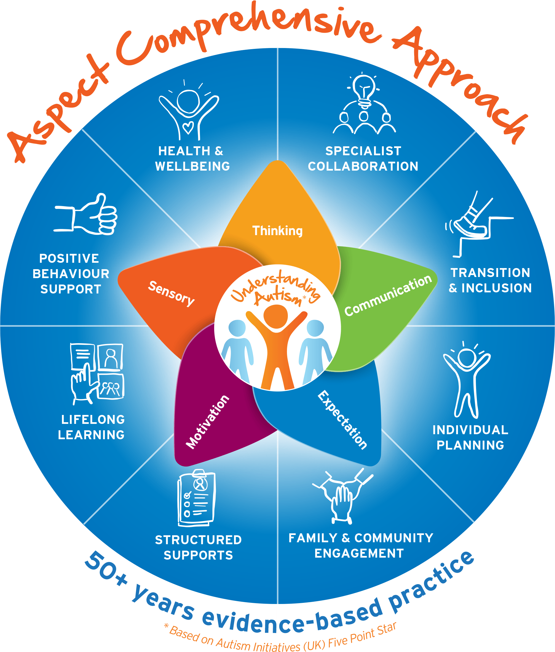 | - To develop, implement, assess, evaluate and monitor a range of special education and therapeutic support activities designed to meet the individual needs of students, including an Individual Program (IP) for each of their students  - Plan and effectively implement class and individual student programs that meet the Australian Curriculum and Aspect’s requirements and ensure that individual student outcomes are attained as noted in each IP.  - Work towards provision of educational programs that will prepare students for transition to a mainstream or support class setting and aid their participation in their local community.  - Lead and implement Aspect’s Visual Support and Positive Behaviour Support principles | - Develop and implement professional class and individual programs that meet the expectations of Aspect’s ACA and Australian curriculum  - Individual Education Programs have clear plans for progress of students to mainstream and support classes and the local community  - Students are positively supported at all times using the tools and principles Aspect’s Visual Support and Positive Behaviour Support. Ensure others, including Teachers’ Aides, are aware of and implement the specific tools for each student as required
Students’ Progress | - Develop and implement an annual IP for each student following Aspect’s IP process and in accordance with Aspect’s Individual Plan Policy.  - Maintain and provide regular reports and program documentation as established under Aspect’s Individual Plan Policy. | - Every student has an up to date and approved IP (and Behaviour Support Plan if required) that assists the student to meet their goals  - Reports and documentation is provided on time, is accurate, professional and comprehensive
Teamwork (internal & external) | - Lead, supervise and provide training to teacher aides assigned to their classroom and at times also supervise volunteers and students on practicum.  - Partner with Learning Support Team to formulate a supportive IP for students – leveraging from each other’s qualifications, skills & experience  - Liaise with members of the wider educational and local community to provide opportunities for participation of students in more inclusive settings.  - Establish effective and professional relationships with students, parents, carers and the wider school community  - Understand and make effective use of support services within Aspect and outside Aspect.  - Participate in and contribute to staff meetings, curriculum groups, working parties and assist in extra-curricular activities within the school as required by the school principal | - Teacher’s Aides, volunteers and students in the classroom are provided clear direction, support and learning opportunities  - Positively access the expertise of the team and external services and implement agreed strategies  - Relationships are built and maintained with key stakeholder to assist the students to feel support and meet their goals  - Attend staff meeting offering valuable contributions and sharing the team workload
Safeguarding the people we support | Aspect is committed to providing an environment free from abuse, neglect and exploitation of the people we support. Staff are expected to:  - Demonstrate a duty of care to students  - Treat students with dignity and respect  - Complete mandatory Child Protection training and implement into day to day operations and practice  - Be vigilant and maintain a heightened sensitivity to recognising signs of abuse, neglect or exploitation and escalate/report those signs/concerns  - Escalate/report other staff practices which deviate from policy/procedure  - Adhere to student’s individual plans recognising their personal needs, choices and control | - Demonstrated evidence that issues/concerns are escalated/reported to supervisor/manager  - Completion of Child Protection on-line training  - Personal commitment and day to day demonstration of competency in safeguarding
Work, Health & Safety Requirements | It is a requirement for all staff to:  - Take reasonable care for own health and safety  - Comply, so far as the worker is reasonably able, with any reasonable instruction that is given by the person conducting the business or undertaking to allow the person to comply with legislative requirements  - Report unsafe conditions or practices, and make suggestions to their manager on improving work, health & safety at Aspect.  - Exercise duty of care in the health, safety and welfare of pupils and ensure they are treated with dignity and respect  - Participate in the staff consultation process about work health & safety matters | - Aspect’s safety policy and procedures are followed including site specific work practices and management instructions  - All hazards, incidents and injuries are reported to management as per Aspect’s risk management procedures  - Health safety and welfare of self and others is ensured as far as reasonable  - Actively participate in safety consultation as required

PART B: POSITION CRITERIA

Capabilities | Leadership & Collaboration | Lead the learning program for students and set the framework for Teachers Aides to appropriately support students to achieve goals. Working effectively with others in Aspect (outside the line of authority) such as peers to accomplish Aspect and school goals and to identify and resolve problems.
Capabilities | Teamwork (Co-operation) | Active participation in and facilitation of team effectiveness; taking actions that demonstrate consideration of the feelings and needs of others and being aware of the effects of your behaviour on others.
Capabilities | Planning and Organising | Establishing a course of action for self and/or others to accomplish a specific goal; planning appropriate allocation of resources
Capabilities | Tolerance for Stress | Maintaining a stable performance under pressure and/or opposition (such as time pressure, job ambiguity or challenging situations).
Capabilities | Technical/Professional Knowledge | Having achieved a satisfactory level of technical and professional skills/knowledge in job related areas, keeping up with current developments and trends in areas of expertise.
Knowledge & Experience | - Knowledge and/or experience in teaching in the disability sector, particularly with students on the autism spectrum, intellectual disability and/or challenging behaviours.  - Experience in developing IP’s and curriculum suited to students on the autism spectrum or a related disability is preferred.
Job Requirements (essential) | - Recognised University or Tertiary teaching qualifications (as determined by the State Registration Board)  - Depending on the school’s location/requirements it may be essential to have a current, valid driver’s licence  - Working with Children Check or equivalent state clearance to work with children  - Responding to Risks of Harm, Abuse and Neglect (RRHAN) certificate  - International Police Check (IPC) if relevant
Job Requirements (desirable) | - LR class licence to drive a school bus
Functional capacity requirements | In providing services to the people Aspect supports, the nature of the work in Aspect Education inherently involves some exposure to behaviours of concern from our students.  Behaviours of concern are defined by the South Australian Department for Education as, “challenging, complex or unsafe behaviours that are of greater severity, frequency or duration and require more persistent or intensive intervention to address. Does not include low level, developmentally appropriate transgressions that test the boundaries of established rules, standards and norms but are relatively simple to direct and minimise through universal behaviour support strategies.”  Behaviours of concern occur for a reason and communicate important information about a student’s stress, distress and skill development. They are typically outlined in a student’s behaviour support plan, along with the interventions expected, based on a positive behaviour support (PBS) approach. You can learn more about Aspect’s approach to PBS on our website.  Aspect provides comprehensive safety intervention training to all staff who work directly with students. |  | Note: Frequency refers to an approximate percentage of time in a typical shift or period on duty:  Rarely: Up to 7%  Occasionally: 8% to 33%  Often: 34% to 66%  Continuously: More than 66%
Functional capacity requirements | Requirement |  | Frequency
Functional capacity requirements | Resilience to behaviours of concern |  | Often
Functional capacity requirements | Sitting, standing, walking |  | Continuously
Functional capacity requirements | Postural positioning – crouching, kneeling, stooping |  | Often
Functional capacity requirements | Reaching, pulling, pushing, lifting < 10kg, carrying |  | Occasionally
Functional capacity requirements | Fine motor skills – keyboarding, writing |  | Often

PART C: APPROVED BY

Position Approved by: (Date)

PART D: ACKNOWLEDGEMENT OF INCUMBENT

I have read and understood the requirements of the position

Name: (Date)

