
Order Processing
Advisor

- £25,000 per annum, moving to £25,500 after probation
- Company bonus and benefits
- Training in office
- A blend of home and office work post training
- Monday – Friday 8am – 8pm Weekends 9am – 5pm

What will I be doing?

When a customer buys a stairlift or homelift from Stannah they are carefully taken through the buying process by the highly skilled Stannah sales and engineering teams. The customer is sold a high quality, market leading product which is bespoke to their needs and their property. It is built for them by Stannah’s manufacturing team. This role delivers post order customer care.

- At the point of the customer agreeing to make this expensive purchase, it is your role to review all of the order paperwork, check that all of the order details are correct before agreeing and processing the order for manufacture

- Stannah products are technical and complex and therefore you must have an accurate eye for detail to check all of the information is present and correct. From engineer drawings to stock levels and payment details you will check it all before validating the order

- When queries or problems arise, you will communicate with internal Stannah teams and individuals as well as with the customer to resolve these issues before processing the order

- You will work to deadlines, whilst aware that customers want their lifts installed quickly but accurately

- You will communicate by both email and phone and therefore you must be confident with both. You will also use Excel as an important tool and so experience of this is useful

- This role is critical to Stannah’s success as it not only stops mistakes from happening which would upset the customer and be expensive for Stannah but such checks also gives Stannah and its customers further confidence in Stannah’s high quality approach which it is well known for

- The work load in this role varies greatly and every day brings very different and complex challenges of varying importance. You need to be happy working under this pressure and be able to prioritise your time and work efficiently. Experience of prioritising under time pressures in any situation would be useful

- In this role you will be supporting other parts of customer care which could include taking reception phone calls, supporting the reception desk and administrative tasks




Is this job for me?

Stannah’s customers and potential customers are the heart of our successful business. Your role is vital to keeping our business successful by helping to maximise our sales and keep our customers happy with our service. Stannah has well-developed successful procedures in place to help you succeed and you will work with support of strong management teams to ensure success.

Stannah is the leading UK brand in home and stairlifts and our customers love the brand because of our company values and excellent customer service. As a front-line customer advisor, it is important that you relate and commit to these values so that our customers feel them when dealing with you.

A customer’s purchasing journey with Stannah will finish with you making sure that everything is present and correct, therefore your ability to work accurately and to deadlines will go a long way to ensuring the customer’s high-quality experience.

What skills do I need?

You do not need any particular work experience to be successful in this job but you do need;

- Confident written and verbal communication skills with a friendly and positive approach

- A natural desire to help and a willingness to listen to customers to offer them the best solution that Stannah can provide. Your approach needs to be delivered with empathy as this purchase is often an emotional one

- An ability to problem solve and an enjoyment of it. You will have previous examples of times that you have overcome challenges or problems to positive results whether in or outside a workplace

- An ability to prioritise and organise and am enjoyment of challenges requiring these skills

- A keen eye for detail and able to work accurately with data

- You must enjoy working to targets and be able to show that you have done so before in any setting; in work, studies or in social situations such as sports

- An organised approach and an enjoyment of completing varied and complex tasks

- Experience of using Excel

- You must look forward to getting to know and working with the wider Stannah teams throughout this large organisation and building strong relationships with them to help solve customer problems

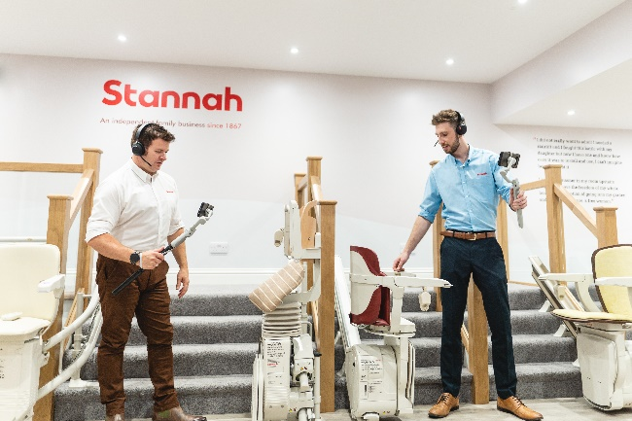


Who is Stannah?

Stannah is a global leading business producing homelifts and stairlifts. It is highly successful UK business, now leading globally in its field. Over 150 years old and still independent, proudly run by the Stannah family and the fantastic Stannah teams.

Stannah is known by customers for its quality of product and service. It is respected by customers as a company and brand to rely on.

Stannah’s core values can be felt right throughout the company and by its customers. It leads as an ethical and successful business with high morals.

Stannah has an enviable ‘one team’ approach which makes the customer journey excellent.

Where in the world of Stannah will I be working?

You will be working in the homelift and stairlift customer service team. You and the team will take great pride in helping your customers buy a Stannah product which will in turn help them stay mobile and in their home for as long as possible.

The team is based at Stannah’s head office in Andover. You will sit with your 20 colleagues and be supported by a team manager and senior management team who will coach and develop your success.

After you have been trained successfully and delivered your job you will have the opportunity to work in the office or partly in the office and partly at home.
Stannah values

- We take care of our customers
- People are at the heart of our business
- We respect our suppliers
- We strive to continue to improve

