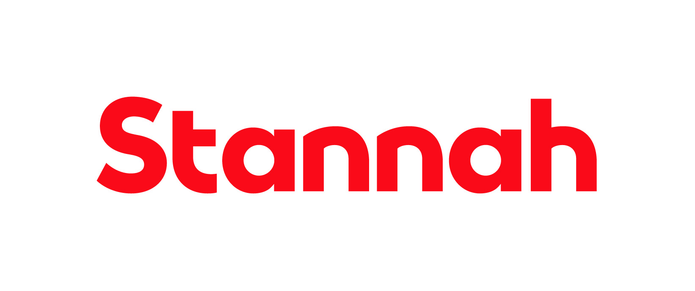

Company: Stannah Management Services Ltd

Function: IT

Reports to: IT Service Desk Manager

Purpose

As an IT Service Desk Administrator, your primary duty is to efficiently manage user queries, IT issues, and requests by logging them into our ITSM tool and ensuring they adhere to SLAs, while also validating and triaging them for further processing. Additionally, you'll be responsible for keeping users informed about the progress of their requests. You'll play a pivotal role in process optimisation by continuously analysing, reviewing, and reporting on these processes, fostering improvement through automation, knowledge sharing, competence building, and other organisational enhancements—all within the framework of our required IT skill set.

Key Responsibilities
- Act as the single routine contact point, receiving and handling requests for support from the Stannah Business. Supporting users at offices in various geographical locations
- Respond to a broad range of incidents and service requests by providing information to fulfil or enable resolution
- Provides first line investigation and diagnosis and promptly allocate unresolved issues as appropriate
- Control of incidents and service requests to facilitate a timely resolution, liaising with 3rd parties, and internal resolver groups. providing updates to the users
- Following agreed procedures, identify, register, and categorise incidents and service requests. Gather information to enable resolution and promptly allocate tickets as appropriate
- Action service requests resulting from the Joiners/Movers/Leavers process
- Assist in identifying and implementing service improvements
This list is not exhaustive and the jobholder will be expected to undertake any duties within their capacity to meet the needs of the business and/or the IT function.

Key Outputs/Results:

- Customer satisfaction measures
- Managing down average time to resolve support tickets

Skills and Experience
- Experience of working in an IT environment
- Ability to effectively prioritise and execute tasks under pressure
- Experience of recording and tracking information in an ITSM tool
- Experienced in coordinating efforts to resolve issues with multiple stakeholders
- Excellent communication skills required, good command of the English language spoken and written
- ITIL Foundation or knowledge and understanding of ITIL framework (desirable)
- Qualifications within IT or computing such as Comp TIA, Microsoft Fundamentals or equivalent (desirable)

Personal Attributes and Behaviours

- Methodical approach, attention to detail and accuracy of recording information
- Active listener who can demonstrate empathy
- Ability to prioritise and multi-task, have a sense of urgency whilst remaining calm under pressure
- Excellent communication at all levels. Able to explain complex matters simply
- Self-motivating and able to work under own initiative
- Must be able to work well in a team and work collaboratively in cross-functional environments
- Patience and tenacity

Relationships

Internal

- IT Service team, including IT Service Desk Manager and Service Technicians
- IT Department, including IT support groups
- Business users

External

- IT suppliers and integration partners

