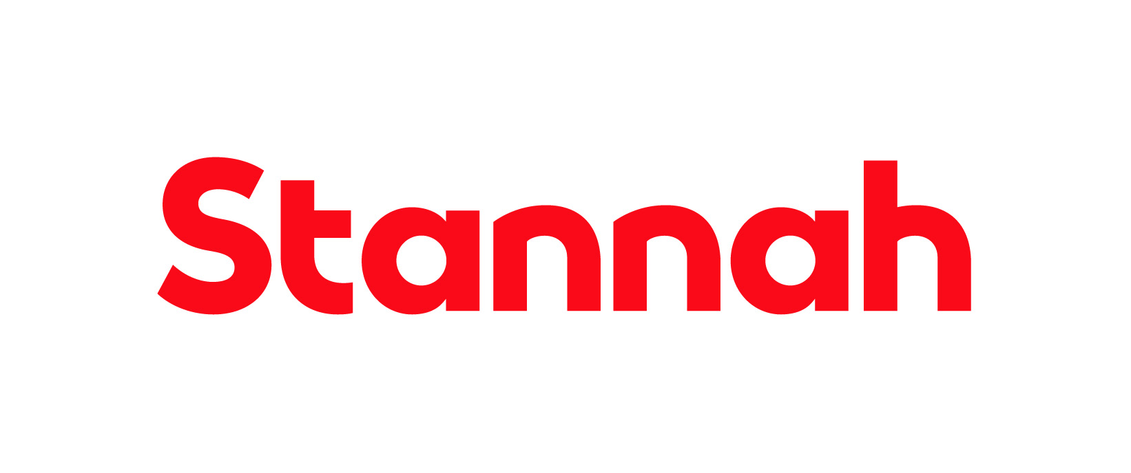

Function: IT

Reports to: IT Service Desk Manager

Purpose

The role of the Senior IT Support Technician is to provide technical support to the computer users and smart device users throughout the Stannah group of companies. The Senior IT Service Technician will work independently on support tickets, and will provide guidance and support to other members of the department and end users. This is an office-based role, and requires on-site attendance in Andover.

Key tasks and responsibilities

- Log and process support requests using an ITSM (IT Service Management) tool.

- Aim to ensure that tickets are completed within an agreed SLA.
- Escalate recurring issues to the IT Service Desk Manager.

- Effectively interact with other members of the department and third-party providers to provide solutions to technical issues.

- Build, configure and support computers running Microsoft Windows operating system and associated applications.

- Configure and support Apple and Android smart devices.

- Assist the Infrastructure team with the support of Microsoft and Linux Servers.

- Become an SME (Subject Matter Expert) for one of more systems, ensuring best practice configuration followed.

- Travel to Stannah sites (UK and Subsidiaries).

- Occasional out of hours work.

This list is not exhaustive and the jobholder will be expected to undertake any duties within their capacity to meet the needs of the business and/or the IT function.

Skills and Experience
- Ability to plan, prioritise and organise workloads
- Hold a full valid UK Driving Licence
- Flexible to travel to UK and Subsidiaries as requested, sometimes at short notice

Personal Attributes and Behaviours

- Excellent communication skills with the ability to interact at all levels and with different departments
- Calm & effective under pressure
- Able to work independently when required

Relationships

Internal

The jobholder will be expected to maintain close and effective personal working relationships at all levels of the organisation. The communication skills required include the ability to communicate complex technical and sensitive information.

External

External agencies including suppliers and customers.

Education and Qualifications
Desirable (or equivalent):
- BTEC Diploma in Computing
- Microsoft AZ-900 + SC-900 + MD-102
- Linux+ CompTIA
- GCSE Maths and English
- ITIL Fundementals

Managerial and Supervisory Responsibility

- No supervisory responsibility required
Other Information

