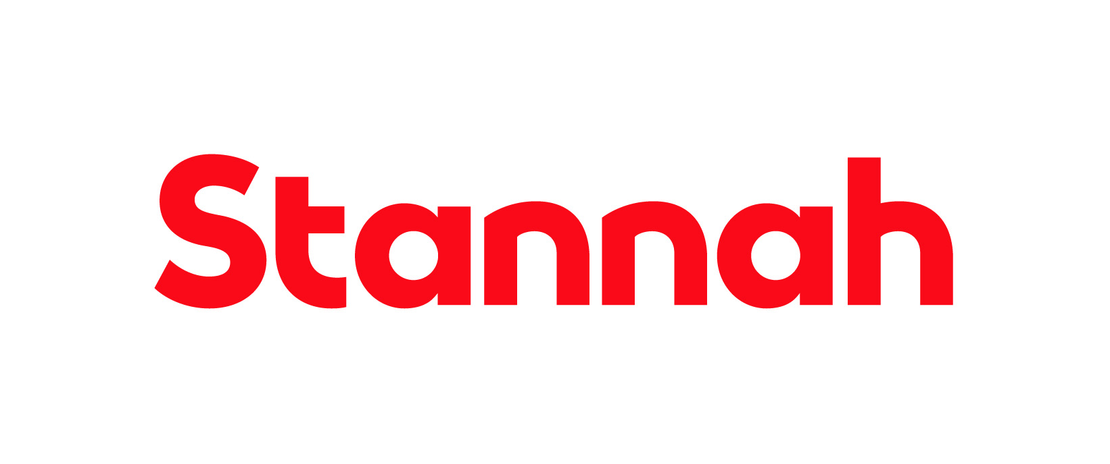

Job Title: Health, Safety, and Environment Advisor

Business Unit: Lifts Distribution and Service, including HA Commercial (S&I) including the field operations of Stannah Homelifts (Uplifts)

Reports to: Head of HSEQ, Lifts Distribution and Service

Purpose
The Health, Safety, and Environment Advisor will assist in our efforts to work safely and minimise our impact on the environment. They will be responsible for advising the business in matters concerning Health, Safety, and the Environment (HS&E), assisting the Head of HSEQ in driving continuous improvement and implementation of our HS&E management system, policies and procedures, carrying out training and supporting and guiding our teams in fulfilling their HS&E responsibilities.

Scope
The scope of the role is as follows
- Advising on matters of H,S&E and for implementation and maintenance of the HS&E Management System for the Lifts Distribution & Service and the Home Accessibility Commercial (S&I) businesses including the field operations of Stannah Homelifts (Uplifts).

Key Responsibilities

Lifts Distribution and Service
- Work with the Lifts Distribution and Service HS&E team to ensure they contribute to the HS&E plans and objectives and that their development needs are identified and supported
- Assist in the regular review, continuous improvement and implementation of our HS&E management systems, policies, procedures, and systems
- Contribute to the achievement of annual HS&E objectives and targets, and act where necessary to maintain progress
- Take part in the HS&E meetings with relevant divisions, departments, and teams
- Give advice, assistance and guidance on HS&E matters and issues including attending customers sites to ensure the working environment is safe and without risks to our employees and customers.
- Investigate accidents and incidents reporting with the aim of ensuring we identify the root and secondary causes of both and implement robust corrective action. Support more complex investigations as required, including signing off high risk accidents and incidents.
- Develop an annual internal audit schedule and conduct audits and monitoring activities once suitable training is in place.
- Assist the business in maintaining third party certifications to ISO 45001 and ISO 14001
- Assist in the provision of HS&E information to the business
- Carry out the field induction for all new members of the field engineering teams.

Group
- Attend and support group HS&E meetings
- Work with others across the Group to develop HS&E Policies and Procedures with the aim of adopting best practice across the Group
- Keep up to date with HS&E laws, regulations, and codes of practice relevant to our business, ensure our policies and procedures are updated as required, and that any changes are communicated to relevant people

This list is not exhaustive, and the jobholder will be expected to undertake any duties within
their capacity to meet the needs of the business and/or the HS&E function.

Competencies

Skills and Experience
- Able to effectively and efficiently plan, prioritise and organise workloads and meet deadlines
- Good people management skills
- Good presentation and communication skills
- Good IT skills
- Good at interpreting and reporting data
- Proven experience in HS&E within an engineering and operational business, and ideally experience within the lift industry

Personal Attributes and Behaviours
- Calm & effective under pressure
- Leads by example
- Ability to work unsupervised at and travel to all locations around the UK

Education and Qualifications
- Appropriate Professional qualifications
- Membership of appropriate recognised professional bodies
- Relevant industry experience

Managerial and Supervisory Responsibility
- None

Relationships
Internal
- Lifts Distribution & Service and the Home Accessibility Commercial (S&I) businesses including the field operations of Stannah Homelifts (Uplifts).
- Liaison with other HS&E roles across the Group including the Group Sustainability Manager
External
- Certification bodies
- Trade association (LEIA)
- Enforcing authorities
- Insurers and Legal Advisors

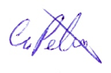
Glen Peters, Head of Health, Safety, Environment & Quality

