
New Business Sales Advisor

- £24,750 per annum + performance related pay
- Company bonus and benefits
- Training in office
- Monday to Friday, 8am – 8pm
- Saturday – Sunday, 9am – 5pm
- A blend of home and office work post training

What will I be doing?

When a customer contacts Stannah to enquire about having either a stairlift or a homelift fitted, you will be the first person that they speak to (customers can contact you through the phone, email or through the website).

- You will find out from the customer about their need for the product. Questions like “where is it going” and “where do you need it”. From this fact-finding you will be able to advise on whether Stannah can help and if so, you will book an appointment for a Sales Consultant to visit them

- You will handle this communication with care and sensitivity, giving the customer a high-quality experience. This way you will maximise the number of appointments secured therefore sales of Stannah products made

- You will communicate and build rapport with customers by phone and email and capture the detail of the communication on Stannah’s systems

- You will get as much detail from the customer as possible. This will ensure that your Sales Consultant colleague has everything they need before going to the customer’s property to measure, design and quote for the lift. You will ensure that Stannah can definitely help before sending the Consultant colleague out to the customer.

- You will schedule a Survey appointment with the customer and book the appointment in the Consultant’s diary. You will book these appointments considering Google maps so that the Consultant’s time is scheduled as efficiently as possible

- You are a key contact to the Sales Consultant team. They will contact you for further customer information or with any queries about their diary of appointments with customers

- After an initial enquiry, if you don’t book a field sales appointment immediately you will send the customer a standard email with a Stannah brochure. You will then need to keep in touch with that customer to try to convert them to a Field Sales appointment

- When the web enquiries arrive you and the team will contact the customer to discuss the enquiry. If you can’t contact the customer, you will continue to try for a reasonable period of time




Is this job for me?

Stannah’s customers and potential customers are the heart of our successful business. They are your reason for being! Your role is vital to keeping our business successful by helping maximise our sales and keep our customers happy with our service. Stannah has well-developed successful procedures in place to help you succeed and you will work with support of strong management teams to ensure success.

Stannah is the leading UK brand in home and stairlifts and our customers love the brand because of our company values and excellent customer service. As a front-line customer advisor, it is important that you relate and commit to these values so that our customers feel them when dealing with you.

A customer’s journey with Stannah will start with you. You will be the first impression of the company, responsible for getting them on their journey with to buying a product. Therefore, you will work to sales targets, always with a compassionate and high-quality approach.

What skills do I need?

You do not need any particular work experience to be successful in this job but you do need;

- Confident written and verbal communication skills with a friendly and helpful approach
- An empathetic and caring approach to sales. You do not need professional sales experience but examples of times when you have dealt with personal situations or challenges and have got to a solution by influencing others will help
- A natural desire to help and a willingness to listen to customers in order to offer them the very best solution that Stannah can provide
- Great listening skills to understand customer concerns and offer solutions to these problems
- You must enjoy working in a team towards one purpose and goal and look forward to getting to know new people throughout this large organisation
- You must be happy to learn and to train in new skills. Stannah lift products are complex and some of the details is technical, you will be fully trained to understand these

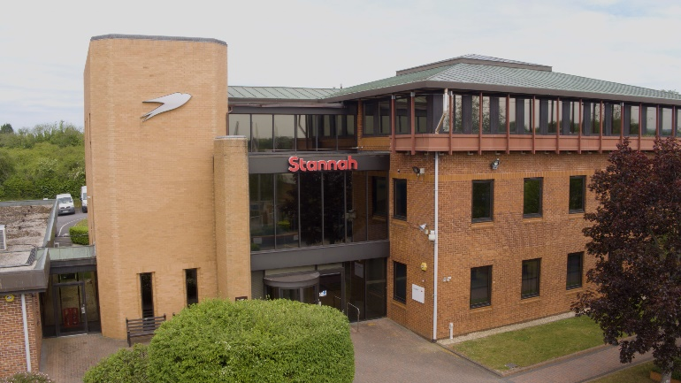
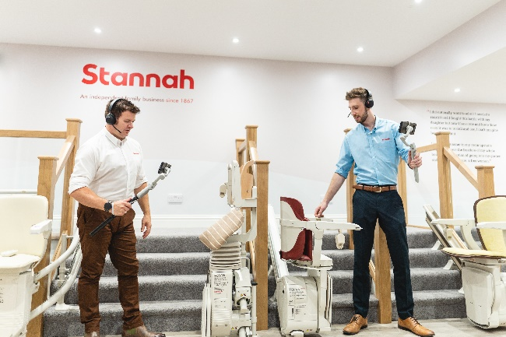


Who is Stannah?

Stannah is a global leading business producing homelifts and stairlifts. It is highly successful UK business, now leading globally in its field. Over 150 years old and still independent, proudly run by the Stannah family and the fantastic Stannah teams.

Stannah is known by customers for its quality of product and service. It is respected by customers as a company and brand to rely on.

Stannah’s core values can be felt right throughout the company and by its customers. It leads as an ethical and successful business with high morals.

Stannah has an enviable ‘one team’ approach which makes the customer journey excellent.

Where in the world of Stannah will I be working?

You will be working in the homelift and stairlift customer service team. You and the team will take great pride in helping your customers buy a Stannah product which will in turn help them stay mobile and in their home for as long as possible.

The team is based at Stannah’s head office in Andover. You will sit with your 20 colleagues and be supported by a team manager and senior management team who will coach and develop your success.

After you have been trained successfully and delivered your job you will have the opportunity to work in the office or partly in the office and partly at home.
Stannah values

- We take care of our customers
- People are at the heart of our business
- We respect our suppliers
- We strive to continue to improve

