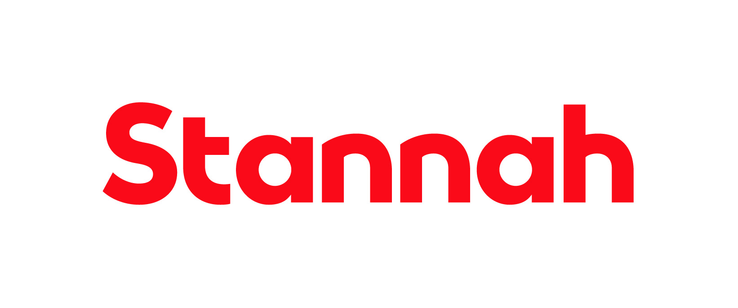

Function: HA Stannah Lift Services

Reports to: Technical Sales Lead

Purpose

Stannah is seeking a detail-oriented and proactive CAD Drawer / Technical Administrator to join our team. This is an office-based role supporting the design and delivery of through-the-floor lifts, ceiling track hoists, and step lifts for local authority customers. Working closely with the Technical Sales Lead and wider technical sales team and Sales consultants, you will be responsible for producing accurate CAD drawings from site surveys, preparing quotations, and supporting administrative and CRM activity.

Key Responsibilities

CAD & Technical Drawings
- Produce accurate CAD drawings based on surveys provided by Sales Consultants
- Create layout drawings for through-the-floor lifts, ceiling track hoists, and step lifts
- Ensure designs meet customer requirements and internal standards
Quotations & Customer Support
- Prepare detailed quotations for local authority customers
- Liaise with internal teams to ensure pricing accuracy
- Support project documentation and specification preparation
Technical Sales Support
- Work closely with the Technical Sales Lead and support the wider sales team
- Assist with investigating and resolving CRM cases
- Help close down outstanding CRM items in a timely manner
- Provide general technical and administrative support
General Administration
- Maintain accurate customer and project records
- Handle general office-based administrative tasks
- Support coordination between departments where required

This list is not exhaustive and the jobholder will be expected to undertake any duties within their capacity to meet the needs of the business and/or the CAD Drawer/ Technical Administrator function.

Skills and Experience
- Ability to plan, prioritise and organise workloads
- Capable of interpreting and reporting data
- Experience using CAD Software (SolidWorks and AutoCAD)
- Experience working in the Lift Industry is desirable
- Read and interpret survey
- Technical Knowledge in the lift industry

Personal Attributes and Behaviours

- Experience using CAD software (e.g., AutoCAD or similar)
- Strong attention to detail and accuracy
- Good organisational and time management skills
- Ability to interpret technical survey information
- Strong communication skills and team collaboration
- Comfortable handling administrative tasks alongside technical work
- Experience in the lift, accessibility, or construction sector is desirable but not essential

Managerial and Supervisory Responsibility

- Not Applicable
Relationships

Internal

The jobholder will be expected to maintain close and effective personal working relationships at all levels of the organisation. The communication skills required include the ability to communicate technical complex and sensitive information.

Education and Qualifications
- Schooling level
- CAD Experience is Essential

