
Customer Sales Advisor

- Basic £25,500 per annum - OTE £33,000
- Company Profit Share Bonus Scheme
- 25 days holiday, plus Bank Holidays
- Training in office
- Monday – Friday 8:30am-18:00 - Sat 09:00-17:00

What will I be doing?

When a customer contacts Stannah to enquire about having either a stairlift or a homelift fitted, they will first talk to a New Business Sales Advisor who will answer their immediate queries. The customer will then be visited in their home by a Consultant who will provide them with a detailed quote personal to them and their home. It will then be your job to keep in touch with that customer and to close and agree the sale where possible.

As well as being motivated to maximise every sale, your customer service skills will be critical too. Stannah customers often have many questions and queries before finally confirming their purchase.

These could involve anything from detailed technical questions to requests for more general information on product, services or prices.

This job will also involve supporting our sales channels through telephone, webchat and live video communications, including providing live online demonstrations of our product range and functionality while helping customers make informed decisions about our stairlifts and homelifts.

You will be an important link between the Consultant who has visited the customer site and Stannah. After each appointment the Consultant attends, they will contact you or your team colleagues to debrief on the customer’s needs and the appointment’s results and follow up actions. You will record this onto the Stannah customer system and then keep in touch with the customer.

Completing a sale can take a number of conversations with the customer. You will use the Stannah customer system to record these conversations and you will use this information to remember each customer’s back story so that you can build rapport and a relationship with them on each call to maximise the trust and sale.

By understanding the full range of Stannah’s products, you will offer the best solution to the customer’s need. This is a sales through excellent service role.




Is this job for me?

Stannah’s customers and potential customers are the heart of our successful business. They are your reason for being! Your role is vital to keeping our business successful by helping to maximise our sales and keep our customers happy with our service. Stannah has well-developed successful procedures in place to help you succeed and you will work with support of strong management teams to ensure success.

Stannah is the leading UK brand in home and stairlifts and our customers love the brand because of our company values and excellent customer service. As a front-line customer advisor, it is important that you relate and commit to these values so that our customers feel them when dealing with you.

You will be responsible for closing a lengthy customer journey by securing a sale. To do this in the Stannah way you must be customer friendly and deliver your sales with a high quality and compassionate approach. This will help you to ensure Stannah’s success and growth by giving great customer experience throughout this lengthy sales journey.

What skills do I need?

- Confident written and verbal communication skills with a friendly and positive approach

- An empathetic and caring approach to sales. You do not need professional sales experience but examples of times when you have dealt with personal situations or challenges and have got to a solution by influencing others will help

- A natural desire to help and a willingness to listen to customers in order to offer them the very best solution that Stannah can provide

- You must enjoy working in a team towards one purpose and goal and look forward to getting to know new people throughout this large organisation

- You must be happy to learn and to train in new skills. Stannah lift products are complex and some of the details is technical, you will be fully trained to understand these

- You must enjoy working to targets and be able to show that you have done so before in any setting; in work, studies or in social situations such as sports

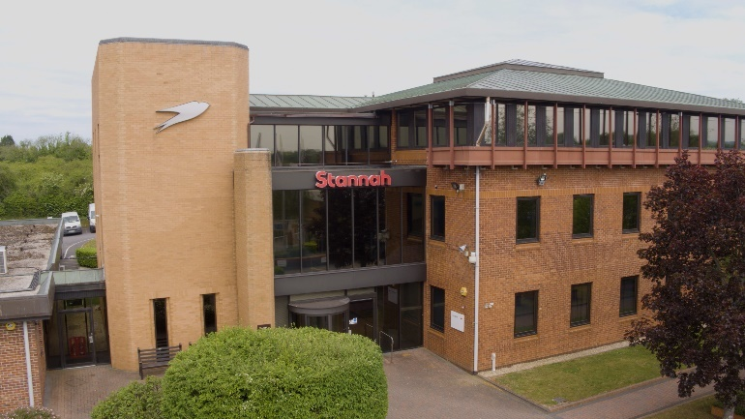
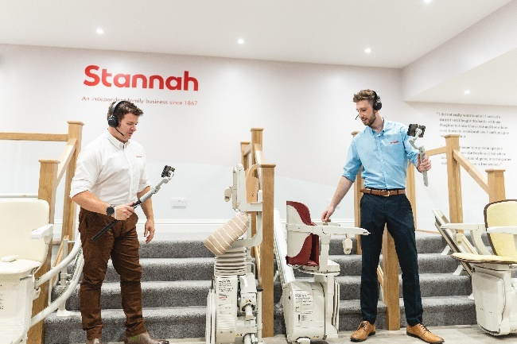


Who is Stannah?

Stannah is a global leading business producing homelifts and stairlifts. It is highly successful UK business, now leading globally in its field. Over 150 years old and still independent, proudly run by the Stannah family and the fantastic Stannah teams.

Stannah is known by customers for its quality of product and service. It is respected by customers as a company and brand to rely on.

Stannah’s core values can be felt right throughout the company and by its customers. It leads as an ethical and successful business with high morals.

Where in the world of Stannah will I be working?

You will be working in the homelift and stairlift Customer Care team. You and the team will take great pride in helping your customers buy a Stannah product which will in turn help them stay mobile and in their home for as long as possible.

This position is based at the Audenshaw showroom where you’ll sit alongside a small Team.

Stannah values

- We take care of our customers
- People are at the heart of our business
- We respect our suppliers
- We strive to continue to improve

