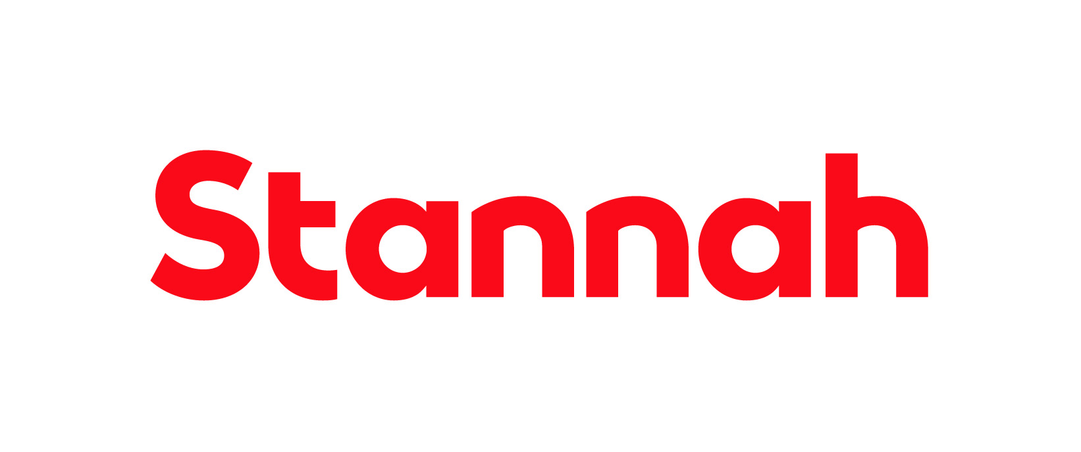

Company: Stannah Management Services

Function: Human Resources

Reports to: Head of HR

Purpose

Working within the HR team and partnering with the Lift Distribution and Service (LD&S) business unit across multiple sites to provide a fully comprehensive and integrated HR Service to the business at a strategic level. The HRBP works with senior leaders and managers to achieve both the Stannah Blueprint and HR objectives through effective strategic use of people resources and talent practices.

Key Responsibilities

- Build collaborative relationships to provide thought leadership on people and organisational-related strategy and deliver coaching support to the leaders within LD&S.
- Develop and sustain a strong understanding of the Stannah Blueprint, LD&S and HR strategies to drive alignment between these, enabling the delivery of business plans, strategy and the anticipation of relevant people issues and solutions.
- Grow organisational capabilities to attract, retain and develop the best people so they can reach their full potential by assisting business leaders with workforce and succession planning, identifying critical roles to build a pipeline of talent, identify future labour requirements and development pathways for high-performing employees.
- Work with the Head of HR and HR Analyst to analyse internal and external trends to anticipate, diagnose and resolve gaps and challenges, in areas including but not limited to retention, attrition, attendance, engagement, compliance, policy, performance and reward.
- Drive the continual development of an open, inclusive and diverse culture and embed across the business throughout policies, procedures, practices and everyday behaviours.
- Seek opportunities to enhance employee experience to exceed expectations and reflect the ambition to be employer of choice, delivering against social value and sustainability objectives and facilitating employee voice initiatives by promoting the employee engagement survey and continually exploring opportunities to engage our people.
- Take ownership of key people initiatives as assigned by the Head of HR, providing clear visibility of strategic and ad-hoc projects, priorities, progress and impact – supporting on recommendations and actions in collaboration with the leadership team.
- Collaborate with Learning and Development to ensure systems are in place to create a performance led culture with a focus on enhancing the capability of leaders and managers and promote effective performance feedback and interpersonal communication.
- Support on complex or sensitive employee relations cases and assist with the appeals process as appropriate.
- Act as liaison between business leaders, HR Operations (People Relations and HR Services) and COEs (Talent Acquisition, Learning and Development and HR Analytics) to ensure the HR provision is aligned to business needs and expectations to add strategic value.
- Become a trusted coach and mentor to other members of the HR team, supporting continued growth and development within the team, whilst sharing best practice across the functions to facilitate and drive continuous improvement.
- Continually reflect on own performance and development, seeking opportunities to keep abreast of changes in employment legislation, best people practices and market developments, taking professional advice when appropriate and participating in industry networking opportunities.
This list is not exhaustive and the jobholder will be expected to undertake any duties within their capacity to meet the needs of the business and/or the HR function. Regular travel to national business sites is a requirement of this role.

Skills and Experience
- Experience of working as a Senior HR Advisor, HR Business Partner or Transformation Specialist in a fast-paced environment is essential
- Experience of working with Senior Management and Senior Leadership teams
- Experience of working in a fast-paced multi-site environment is desirable
- Demonstratable understanding of the link between HR initiatives and business strategy
- Understanding of change management methodologies and how they apply to business strategies and transformation (desirable)
- Ability to plan, prioritise and organise workloads in a pressurised environment
- IT proficiency in a range of professional software packages – Microsoft Excel, Word, Outlook, Teams, OneDrive and HRIS, case management and data reporting platforms
- Fully conversant and up to date with all aspects of UK employment law and HR best practice
- Excellent attention to detail
- Ability to work autonomously and flexibly
- Proven competence in supporting and coaching managers through complex strategic and employee relations activities to support positive and proactive outcomes

Personal Attributes and Behaviours

- Excellent communication skills with the ability to confidently interact and influence at all levels
- Diplomatic and demonstrates honesty and integrity at all times
- Calm and effective under pressure
- Pro-active and self-motivated
- Co-operative, empathetic and supportive team player
- Good cultural awareness and understanding of diversity
- Ability to work flexibly to suit the requirements of the business including travel to other sites within the UK
- Excellent coaching rapport and skills
- Credible and able to build deep and lasting relationships at all levels of an organisation

Relationships

Internal
The jobholder will be expected to maintain close and effective personal working relationships at all levels of the organisation, particularly at a senior level. The communication skills required include the ability to communicate technical complex and sensitive information.

External
External agencies including trade unions, benefit providers, suppliers of other HR products and services, training providers and educational, governmental and charitable organisations.

Education and Qualifications
- Degree or equivalent qualification
- CIPD part or fully qualified (or equivalent experience)

