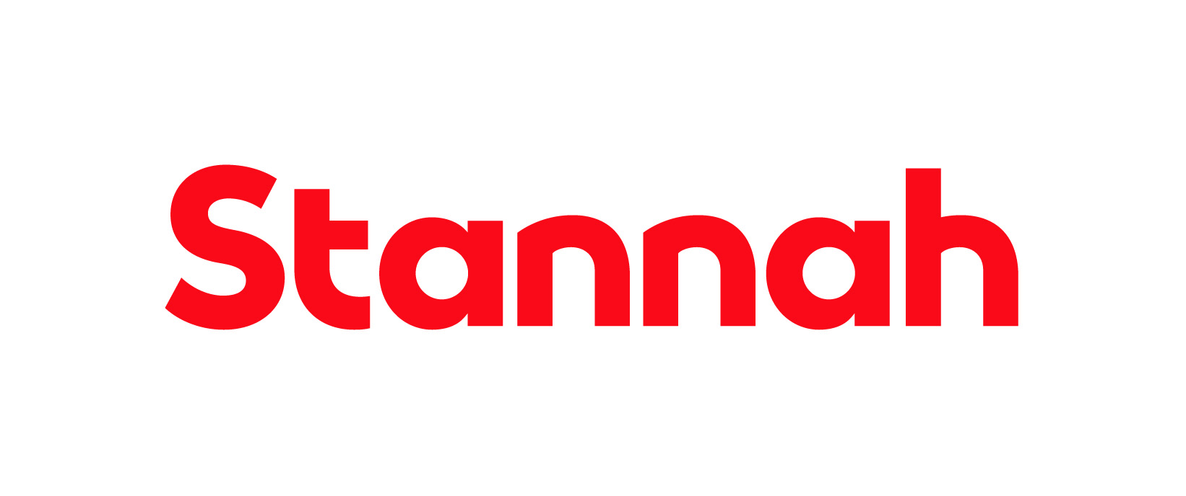

Company: Stannah Home Accessibility

Function: Business Planning & Analytics (Data & Analytics)

Reports to: Head of Data & Analytics

Purpose

The Senior Data Analyst transforms data into actionable business insight, combining strong analytical capability with stakeholder engagement skills, while bringing the experience and technical knowledge needed to mentor and develop analysts and bridge the gap between data and business outcomes.

Working closely with business stakeholders, the role develops reporting solutions, analyses operational and commercial performance, identifies trends and opportunities, and supports data-driven decision making across Stannah Home Accessibility.

Key Responsibilities

- Reporting, Insight & Performance Optimisation – Develop and maintain Power BI dashboards, reports, KPIs and scorecards that support business decision-making. Analyse operational and commercial performance, identify trends, risks and opportunities, improve reporting efficiency through automation, monitor data quality, and translate findings into clear recommendations.

- Analyst Mentoring & Capability Development – Bring experience, technical knowledge and business understanding to support, mentor and develop other analysts within the team. Share best practice in analysis, reporting, data visualisation and stakeholder engagement, helping to build confidence, capability and consistency across the analytics function.

- Stakeholder Support – Partner with business leaders to understand reporting and analytical requirements. Act as a trusted advisor on data and performance measurement. Facilitate workstreams to define metrics and reporting standards and present findings and recommendations to management teams.

- Continuous Improvement – Identify opportunities to improve business processes. Introduce new techniques and approaches to improve insight generation. Support data transformation and digital improvement initiatives. Mentor other analysts and stakeholders and contribute to capability development within the analytics team.

- Data Quality & Governance – Promote data governance standards and best practices Support the definition and maintenance of business data definitions. Identify data quality issues and work with relevant teams to resolve them and ensure consistent application of KPIs and reporting methodologies.

This list is not exhaustive, and the jobholder will be expected to undertake any duties within their capacity to meet the needs of the business.

Skills and Experience
- Passion for data and using data visualisation to deliver insights.
- Advanced Excel and Power BI (DAX), Looker, or similar BI reporting tools.
- Experience with ETL and maintaining semantic models in Microsoft Fabric.
- Strong SQL skills with experience querying large datasets (PostgreSQL, T-SQL).
- Strong stakeholder management and communication skills.
- Ability to present complex data clearly to non-technical audiences.
- Experience mentoring and developing other analysts.
- Experience with sales or manufacturing businesses.
- Experience using Python, R or other analytical languages.
Personal Attributes and Behaviours

- Analytical and inquisitive, with an interest in improving processes.
- Commercially focused, unafraid to have a point of view and challenge with data.
- An appreciation for data visualisation and the importance of effective presentation.
- Excellent team working skills and communication skills.
- Ability to communicate complex information clearly and concisely.
- Resilient and adaptable, able to remain focused on the task at hand.
- Good organisational skills and able to work unsupervised if required.

Managerial and Supervisory Responsibility

- No direct reports
Relationships

Internal

The jobholder will be expected to maintain close and effective personal working relationships at all levels of the organisation. The communication skills required include the ability to communicate technical complex and sensitive information.

External

External agencies including suppliers and customers.

Education and Qualifications
- Degree in Data Analytics, Business Analytics, Mathematics, Statistics, Computer Science or similar discipline or qualified by experience.
- Minimum 5 years' experience in a data analyst or business intelligence role.
Other Information

- The role is based in our Andover head office with the option of hybrid working arrangements (2/3 days a week in Andover).
- Domestic and international travel will be required from time to time to support business requirements (up to 1 week).

