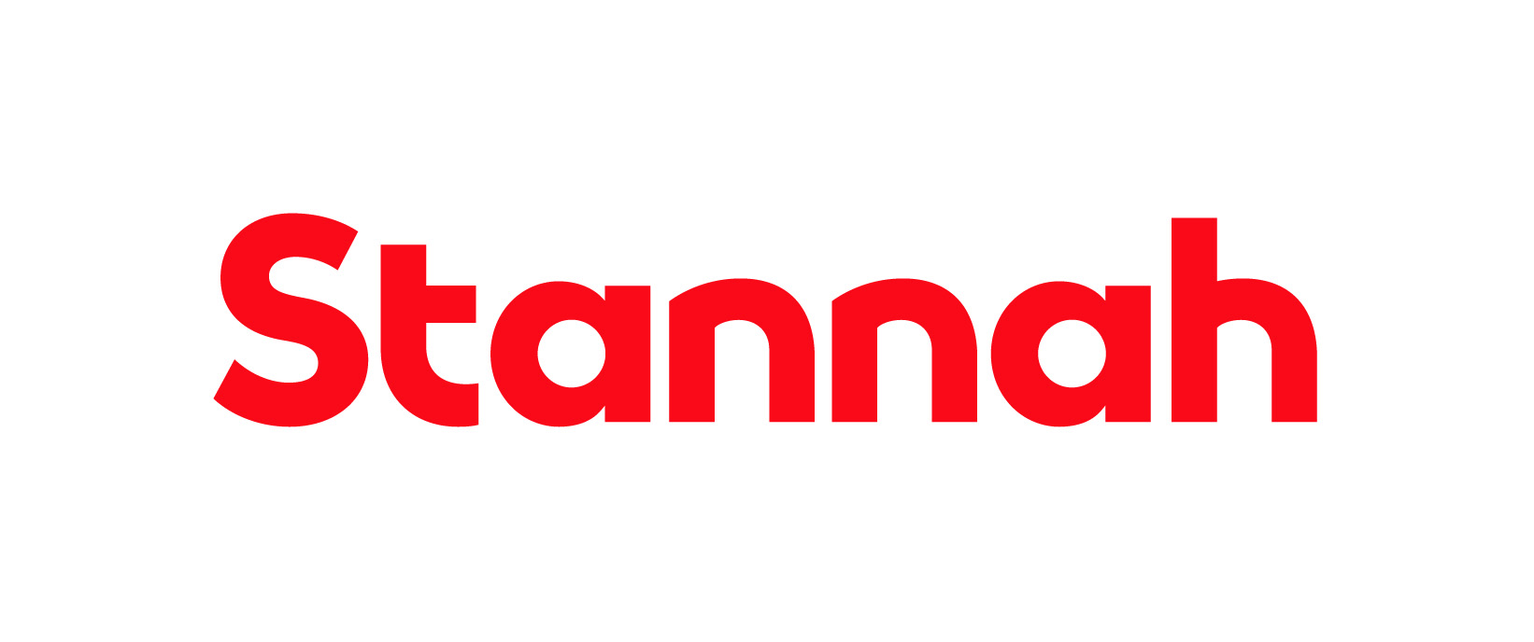

Company: Stannah Lift Services Ltd

Function: Home Accessibility - Operations

Reports to: Installation Manager

Purpose
To conduct the installation and removal of Stairlift products

Key Responsibilities
- Working within customers’ homes to install and remove stairlifts to the manufactures, customers and sales specifications and ‘Stairlift Installation and removal Standards’
- Awareness of your scheduled work and loading/unloading requirements
- Collecting stairlifts and equipment from the depot to take to site
- Resolving issues to customer satisfaction, this may include a return visit to site complete a go back
- Follow the ‘Customer Care Standards’ and ‘Company Behaviour Standards’:
- Maintain a high standard of appearance
- Conduct courtesy calls with customers and feedback any issues found
- Checking lift specification when loading is to the customer requirements
- Maintain agreed van stock levels
- Follow the Driver Handbook:
- Drive safely and economically
- Complete a monthly Vehicle Check sheet
- Submit all previous month’s mileage by the 3rd the following month
- Keep the van clean and tidy inside and out
- Ensure all administration is accurately completed and by the required deadlines:
- Complete relevant electronic forms
- Complete and send timesheets by 9am on the first working day of each week
- Check and action emails daily
- Achieve the highest standards of health, safety and environmental performance
- Record any incidents and report any accidents as appropriate
- Develop and maintain an appropriate level of technical knowledge of products
- Complete approved Stannah Installation training via WWTS
This list is not exhaustive, and the jobholder will be expected to undertake any duties within their capacity to meet the needs of the business and the Operations function.

Skills and Experience
- Basic understanding of health and safety requirements, including asbestos awareness
- Ability to use, or learn to use, an Android smart device
- Basic hand tool experience
- Basic mechanical and electrical knowledge (desirable)
- Experience of finding and implementing best practice in all areas of our operations
- Commitment to continuous Improvement
- Knowledge and understanding of relevant legislation, standards, codes of practice
- Recording and updating information

Personal Attributes and Behaviours

- Approachable and supportive
- Ability and willingness to learn
- Flexible and proactive
- Effective communicator
- Methodical problem-solving approach
- Calm & effective

Relationships

Internal

The jobholder is expected to keep close and effective personal working relationships at relevant levels of the organisation. The communication skills needed include the ability to communicate technical and sensitive information.

External

External agencies including suppliers, customers and sub-contractors

Education and Qualifications
- Full driving license
- DBS
- Relevant manufacturers product training
- Non-Licensable work with Asbestos
- IOSH working Safely (includes manual handling)
- First Aid

