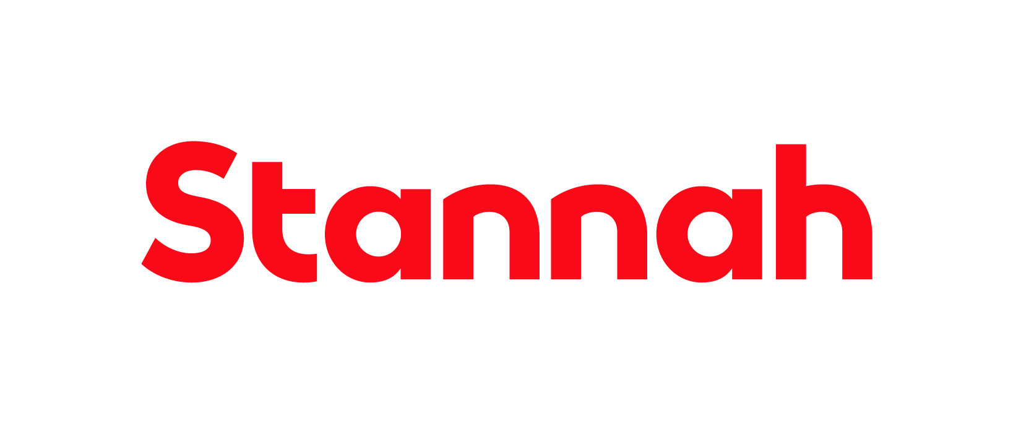

Company: Stannah Home Accessibility

Function: PMO

Reports to: Head of Programme Management

Purpose

At Stannah, we are pursuing an exciting program of transformation and growth, and we’re searching for a Project Coordinator to join our dynamic and expanding team.
The ideal candidate is a highly effective communicator, who is passionate about working with people, is flexible and adaptive, can work collaboratively and independently, continuously seeks opportunities to improve business activities and is looking for continuous personal development. This is a hybrid role.

Objectives of this Role

- Provide a confidential, smooth, professional, and effective support service to the Stannah HA PMO team, to ensure the achievement of all operational and strategic objectives and successful delivery of projects.
- You will work closely with the HA PMO & Project teams to provide administrative support, helping them to make the best use of their time by dealing with administrative and project tasks using your skills and knowledge of the organisation, knowing who key personnel are (both external and internal) and using your understanding of Stannah’s aims and objectives.
- You will be working alongside the HA PMO team & workstream leads on key project activities relating to the needs of the Programme.

Key Responsibilities

- Support the HA PMO team undertaking both administrative and project tasks, working independently as required.
- Track project performance, specifically to analyse the successful completion of short- and long-term goals.
- Organise internal and external meetings & support with the drafting, updating and circulation of communications with stakeholders, both internally and externally.
- Administration of the project management tool - assist in developing and maintaining the project documentation, reports, filing, recording, and governance with support from the Project Team.
- Support as required on specific work streams and tasks as directed by Project Team, including following up on actions with cross-functional teams.
- Adhere to existing PMO processes and contribute to recommendations / proposals to streamline and enhance administration of the PMO.
- Support with exporting, analysing and distributing data to the Project Team on projects as needed to support with project tasks.
- Act confidently and with sustained effectiveness when faced with changing priorities.
- Assist in the preparation and circulation of agendas and action lists for relevant meetings, as well as taking notes and preparing minutes.
- Occasional business travel as required.

This list is not exhaustive, and the jobholder will be expected to undertake any duties within their capacity to meet the needs of the business.

Skills and Experience
- Good working knowledge of Microsoft products.
- Language skills: English. Any additional European languages are a bonus.
- Demonstrable experience managing varied project deliveries & and understanding of standard project governance is preferred.
- Experience of a manufacturing or technology business is preferred.
- Working knowledge of Smartsheet (project management tool) is a bonus.

Personal Attributes and Behaviours

- Excellent communication, listening and interpersonal skills.
- Excellent organisational and time keeping skills.
- Reliable and keen to learn, with a flexible, adaptable approach and an eye for detail.
- An enthusiastic, driven self-starter with the ability to thrive in an evolving environment.

Managerial and Supervisory Responsibility

- No direct reports.
- Reporting to Head of Programme Management.
Relationships

Internal

The jobholder will be expected to maintain close and effective personal working relationships at all levels of the organisation. The communication skills required include the ability to communicate technical complex and sensitive information.

External

External agencies including suppliers and customers.

Education and Qualifications
- Any project management qualifications are a bonus.

