Job Title | Regional Communications Manager Netherlands | Function/Region | Marketing
Reports To | Country Marketing Manager | Band | 4
Location | Roermond

Our Mission
‘To create the finest retail experiences.’

Our Purpose
‘Making the extraordinary possible’

Purpose
Lead the development and execution of consumer and corporate communications strategies for Designer Outlet Roermond and Designer Outlet Roosendaal, ensuring alignment with business and marketing objectives. As part of the Netherlands Marketing Team, the role is responsible for strengthening brand reputation, increasing market visibility and supporting commercial performance across key markets.
The role requires a high level of strategic ownership, commercial awareness and provides strategic communications counsel to senior stakeholders, combined with hands-on communications expertise and senior agency leadership across the Netherlands, Germany and Belgium.

Reports to the Country Marketing Manager, The Netherlands, and works closely with Centre Management teams, Group Communications and external agency partners across the Netherlands, Germany and Belgium.

Key Responsibilities
- Develop and implement annual communications and PR strategies for the centres in the Netherlands, aligned with the overall marketing strategy.
- Lead all consumer and corporate communications activities for Designer Outlet Roermond and Designer Outlet Roosendaal, tailoring strategies to the specific audiences in the domestic and cross border markets, positioning and commercial priorities of each centre.
- Manage and provide strategic direction to three external PR agencies across the Netherlands, Germany and Belgium, including setting objectives, managing performance, budgets and deliverables, and ensuring strong strategic alignment and impact.
- Provide strategic communications counsel to senior stakeholders, supporting key business priorities, projects and reputational matters.
- Drive media relations, influencer engagement and reputation-building initiatives across key markets.
- Monitor media, consumer and cultural trends to identify opportunities that enhance brand visibility, relevance and engagement across key markets.
- Partner with centre teams and PR agencies to translate business developments, brand partnerships and new store openings into compelling media and storytelling opportunities.
- Lead initiatives that enhance and protect the reputation of McArthurGlen and its centres through consistent and impactful brand storytelling.
- Identify and leverage consumer, cultural and market trends to develop relevant communications opportunities and strengthen the positioning of the centres across their key catchment areas.
- Act as a senior communications advisor and key point of contact for internal stakeholders, working closely with the Country Marketing Manager, Netherlands Marketing Team, centre management and wider regional teams.
- Build and maintain strategic relationships with media, influencers, KOL’s, brands and other external stakeholders.
- Lead communications planning around key commercial moments, campaigns, events, partnerships and business priorities.
- Act as the communications lead during reputational and crisis-related matters, coordinating internal stakeholders, external agency partners and designated spokesperson(s) to ensure aligned and effective communications responses.
- Monitor, evaluate and report on media, influencer and partnership performance, providing insights and recommendations to optimise impact and ROI.
- Own annual communications objectives, budgets, KPIs and agency deliverables for the centres in the Netherlands, in the domestic and cross border markets.

Skills & Experience

- Significant experience in Communications (corporate/brand/marketing), Public Relations, ideally within retail, fashion, lifestyle, hospitality or other consumer-facing sectors.
- Proven success in developing and delivering strategic communications programmes that support business and brand objectives.
- Strong experience in managing and directing external PR/communications agencies, including multiple agencies across different markets and cultures.
- Proven ability to operate across multiple markets, with experience managing international stakeholders and adapting communications strategies to local market dynamics.
- Excellent stakeholder management and influencing skills, with the ability to build trusted relationships and provide strategic guidance at senior leadership level.
- Strong understanding of media relations, storytelling, reputation management with the ability to identify opportunities and translate business priorities into compelling communications.
- Commercially aware, highly organised and able to manage multiple priorities in a fast-paced, matrix environment.
- Excellent written and verbal communication skills in Dutch and English. German language skills are advantageous.

Our Success Framework

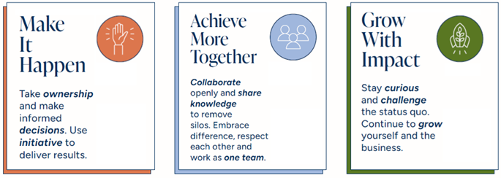

McArthurGlen, an Extraordinary Experience for Everyone.
At McArthurGlen we value the diversity of our people.
We celebrate differences and believe that everyone is extraordinary.
We are committed to building a culture where our opinions and contributions
are listened to and respected and anyone can be themselves.
We learn and grow together, we all belong.

