Job Title | Legal Manager | Function | Legal
Reports To | Senior Legal Manager | Function/Region
Location |  | Band | 4

Our Mission
‘To create the finest retail experiences.’

Our Purpose
‘Making the extraordinary possible’

Purpose of Role

Assist the Leasing team in the effective implementation of the property leasing strategy for each centre to minimise risks and voids and maximise income for the portfolio whilst maintaining the desired merchandise mix.

Responsibilities

- Interface between tenants and the Leasing Managers to facilitate the flow of information and ensure the best practice is maintained.

- Proactively assist Leasing Managers to negotiate lease renewals and new leasing deals to ensure the optimum outcome.

- To forward all the necessary economic and not economic information to the external Legal Firm to prepare the proper lease text to be sent to the tenants.

- To have a proactive role in the process of exchange of information between Tenant and Leasing Managers.

- Provide support to Leasing Department on resolving outstanding commercial points once the deal is in Solicitors hands so that the deal is not jeopardised when advantageous to the business.

- Proactively seek opportunities for operational efficiency and suggest ways to improve the leasing function to save the business time and money.

- To have a constant focus on the leases to propose amendments in the light of problems that have emerged over time.

- To manage her own workload and to coordinate the workload of the Legal Administrator.

- To support / substitute the Senior Legal Manager when and if needed.

- To have a role of support in the management (judicial and extrajudicial) of the “bad debtors”.

- To autonomously manage the requirements coming from the other Departments.

- At all times acting in the company’s best interests and in the best interests of those entities which we represent.

Requirements

- Law Degree
- Fluent English
- Knowledge of product, tenants and working environment
- Knowledge of “going concerns” lease agreements
- Experience of lease renewal/licensing process
- Experience of working with legal specialists to process leases
- Experience in negotiation and conflict resolution
- Provide legal advice
- IT skills: Intermediate level Microsoft Office

Our Success Framework
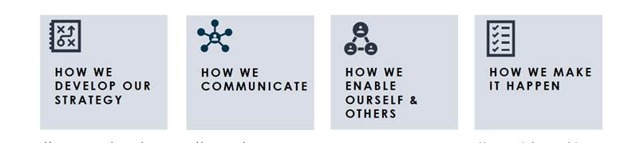

McArthurGlen, an extraordinary experience for everyone.

At McArthurGlen we value the diversity of our people.
We celebrate difference and believe that everyone is extraordinary.
We are committed to building a culture where our opinions and contributions
are listened to and respected and anyone can be themselves.
We learn and grow together, we all belong.

