Position Description

Position Title | Verge Control Officer
Position Number | COMO05, COMO06, EOFO01, EWTD46
Directorate | Planning and Development
Business Unit/s | Development Services
Reports to | Coordinator Verge Control and Swimming Pools
Classification | Level 6/7 – Inside Workforce Agreement

Organisational Overview
The City of Stirling (the City) is located eight kilometres north of Perth’s central business district and covers an area of around 100 square kilometres from Scarborough, Trigg and North Beach in the west to Balga and Inglewood in the east, and from Beach Road in the north to Herdsman in the south.
The City is the largest local government by population in WA with over 243,000 residents. We provide more than 200 services to our thriving community, including recreation centres, libraries, home and community care, safety, and events.
The City has a workforce of around 1,500 people and a genuine commitment to invest in our employees to achieve an inclusive, diverse, engaged and capable workforce. The City is recognised for supporting work-life balance through a wide range of flexible work options and offering a range of policies and benefits to create opportunities and an enjoyable and fulfilling employment experience.

Organisational Vision, Mission Statement and Values
Vision
A sustainable City with a local focus.
Mission Statement
To serve our community by delivering efficient, responsive and sustainable service.
Values
The City of Stirling’s core values are:

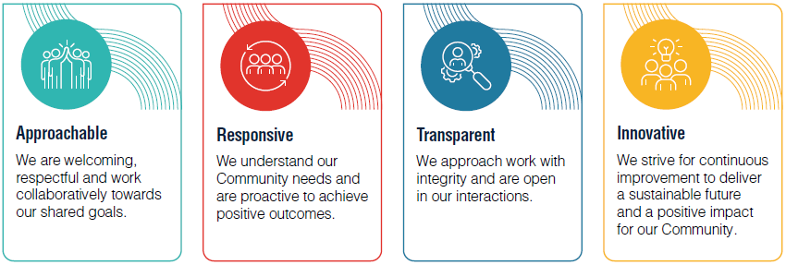

Reporting Relationships
This position reports to the Coordinator Verge Control and Swimming Pools

Business Unit Objective
To provide effective and efficient regulatory and compliance services for the benefit of the community.

Position Overview
The Verge Control Officer is responsible for enforcement of the provisions of the City of Stirling Thoroughfares and Public Places Local Law 2009, the Local Government Act (Uniform Local Provisions) Regulations 1996, other applicable legislation and various City of Stirling administrative polices involving the use of the road reserve in association with building, development, demolition activities, crossovers, verge treatments and street trees.
Resolution of customer enquiries and complaints relating to verge control matters and assisting other business units associated with approval processes in relation to meeting the City’s statutory obligations, Business Plans, operational procedures and Council policies.

Position Objectives
Key Accountabilities/Duties
Administration
- Prepare, maintain and document accurate records in relation to the City’s road reserve assets and their condition as related to various verge application types.
- Meeting the requirements of the State Records Act 2000 in relation to electronic storage of all relevant records within the City’s databases.
- Provision of prompt and accurate information to administration officers in relation to address of properties, name of permit holder, offence types, and offence dates.

Process
- Conducting pre-construction, post completion and random inspections in accordance with the business unit operational practices for various application types.
- Assess and report on the condition of the road reserve assets in accordance with City’s and other applicable policies, standards and specifications.
- Investigate and prepare cost estimates for asset repair or replacement within the road reserve associated with Verge Permits/Approvals in accordance the City’s standard charges or policies.
- Assessment and determination of contributions for crossover subsidy applications in accordance with operational procedures.
- Prepare and communicate assessments, determinations and findings to the responsible business unit for bond refund and or asset repair/replacement.
Enforcement
- Application and administration of the Local Government Act and associated Regulations pertaining to the verge including the Thoroughfares and Public Places Local Laws, and any other local laws or City’s policies relating to the verge.
- Collection and assessment of evidence, issuing of infringements, writing reports and recommendations on prosecutions, attendance at Court or State Administrative Tribunals as required on verge control matters.
- Compliance with the City’s enforcement policy, management practice and operational procedures in relating to verge control matters.
Customer Service
- Provision of verge permit/approval advice on building development, demolition, crossovers and verge treatments and verge hazards to the general public, Management and Council.
- Investigation and reporting on requests for service in respect of breaches of the City of Stirling Thoroughfares and Public Place Local Law, Local Government Act 1995 and associated Regulations, other City local laws and Council Policies.
- Investigate and resolve customer enquiries and complaints relating to verge control matters in accordance the City’s Customer Service Charter.
- Assist the Coordinator Verge Control and Swimming Pools in resolving complaints requiring a high degree of experience and political sensitivity.
Other
- Assist the Coordinator in undertaking special projects.
- Assist with the training and development of new staff member on verge control matters.
- Work closely with other Business Units to achieve the City’s objectives and priorities in relation to road reserve infrastructure.
- Testing and reporting of new technologies to transition verge control to a predominately field based operation utilising mobile computer solutions.
Subsidiary Duties
- Verge Control Officers are appointed as part of the City wide Planning and Development Team, and as such may be required to undertake work or be temporarily transferred to work or undertake development opportunities in any of the Planning and Development Directorate Business Units.

Corporate Responsibilities
- Undertake duties and responsibilities in accordance with corporate Policies, Management Practices and Procedures and demonstrate expected behaviours aligned with the City’s Values and Code of Conduct.
- Observe all safe working practices in accordance with relevant Policies, Management Practices and Procedures.
- Contribute to the achievement of corporate objectives by ensuring that stakeholders are responded to in a professional and timely manner.
- Takes responsibility for and actively promotes the importance of the City’s Risk Management processes, encouraging others to apply it and achieve positive results from it throughout their work.
- Undertake duties and responsibilities in accordance with the City’s Customer Service Charter
- Undertake Community Engagement where required, to optimise trust, inform decision-making, share knowledge, and strengthen relationships with the community in accordance with the City’s Community Engagement Policy.
- Perform other duties as reasonably directed.

Selection Criteria
Qualifications/Education Level
Tertiary level qualifications in Town Planning/Building Surveying/Civil Engineering or demonstrated equivalent experience/competency in planning, building or engineering compliance matters. | Essential
Certificate in basic traffic management on construction works | Essential
Knowledge, Skills, Experience & Abilities
Ability to interpret building plans, crossover plans and verge treatment plans for verge control purposes | Essential
Demonstrated sound level of understanding and application of the principle and practices of local law control of Thoroughfares and Public Places and or Building Control in a local government environment. | Essential
Ability to exercise complex decision-making and judgement in a logical, balanced lawful and accountable manner. | Essential
Excellent planning, record keeping and organisational skills. | Essential
Competent computer skills using the City’s core applications and the MS Office Suite (Word, Excel, Outlook, PowerPoint). | Essential
Ability to deal with difficult and demanding customers. | Essential
Strong results oriented coordination, planning and organisational skills in order to meet varying deadlines without supervision | Essential
Well-developed interpersonal skills, relating to verbal and written communication, negotiation, instruction, dispute resolutions, liaising with the public and the provision of technical advice. | Essential
Ability to conduct inspections and investigations and produce effective outcomes within the parameters of relevant legislation, local laws and policies. | Essential
Knowledge of occupational health and safety principles and practices and an ability to promote and maintain a safe work environment. | Essential
Experience in dealing with Development matters at the State Administrative Tribunal or Magistrates Court. | Desirable
Demonstrated experience in conducting compliance inspections | Desirable
Experience in works auditing and reporting. | Desirable
Relevant local government experience | Desirable
Other
National Police Clearance (under 3 months). | Essential
Current Driver’s Licence | Essential

Office use only
Position Creation Date | Date | September 2017 | Officer | Manager Development Services
Last reviewed/Modified | Date | January 2019 | Officer | People Coordinator

