Position Description

Position Title | Team Leader Day Clubs
Directorate | Community Development
Business Unit/s | Community Services
Reports to | Service Lead Community Services
Classification | Level 6 – Inside Workforce Agreement

Organisational Overview
The City of Stirling (the City) is located eight kilometres north of Perth’s central business district and covers an area of around 100 square kilometres from Scarborough, Trigg and North Beach in the west to Balga and Inglewood in the east, and from Beach Road in the north to Herdsman in the south.
The City is the largest local government by population in WA with over 250,000 residents. We provide more than 200 services to our thriving community, including recreation centres, libraries, home and community care, safety, and events.
The City has a workforce of around 1,500 people and a genuine commitment to invest in our employees to achieve an inclusive, diverse, engaged and capable workforce. The City is recognised for supporting work-life balance through a wide range of flexible work options and offering a range of policies and benefits to create opportunities and an enjoyable and fulfilling employment experience.

Organisational Vision, Mission Statement and Values
Vision
A sustainable City with a local focus.
Mission Statement
To serve our community by delivering efficient, responsive and sustainable service.
Values
The City of Stirling’s core values are:

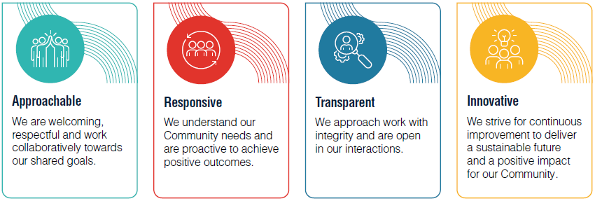

Reporting Relationships
This position reports to Service Lead Community Services.

Business Unit Objective
To provide services which support, engage and improve the quality of life for all sections of the community while providing real opportunities.

Position Overview
The Team Leader Day Clubs is responsible for supporting the effective day-to-day coordination and delivery of the City of Stirling’s Community Day Club services. The role provides operational leadership across staff, volunteers and service activities to ensure customers who are older people, living with disability or requiring social support receive safe, inclusive, person-centred and engaging programs.

The position contributes to customer intake, assessment, support planning, program development, stakeholder engagement, reporting, policy and procedure review, and the management of facilities, equipment and vehicles. It requires sound knowledge of aged care, disability and community service delivery, strong relationship-building skills, attention to detail and the ability to adapt services in a changing sector environment. The role operates across various City of Stirling Community Day Club locations and supports continuous improvement, quality service delivery and positive outcomes for customers, carers, employees and volunteers.

Position Objectives
- Support the effective coordination and delivery of Community Day Club services across City of Stirling locations, ensuring customers receive safe, inclusive, engaging and person-centred support.
- Oversee day-to-day operations including activity planning, staff and volunteer rostering, scheduling, customer support, service administration and the effective use of facilities, vehicles and resources.
- Lead, support and develop employees, volunteers and students through recruitment support, induction, supervision, training, performance guidance and ongoing team engagement.
- Coordinate customer intake, wellness reviews, support planning and related administration, ensuring customer records, case notes and service information are accurate, timely and up to date.
- Provide information, advice and support to customers, prospective customers, carers and families to assist them to access appropriate Community Services and referral pathways.
- Work with customers to identify goals, interests and support needs, and contribute to individual support plans that promote independence, wellbeing, connection and choice.
- Plan, implement and evaluate meaningful activities and programs that respond to customer needs, cultural diversity, ability levels and changing community expectations.
- Support the development, review and implementation of policies, procedures, training programs and service guidelines to ensure safe, compliant and contemporary service delivery.
- Assist with petty cash, purchasing and budget-related processes in accordance with City of Stirling requirements and approved service budgets.
- Contribute to service planning, review, continuous improvement and adaptation within the changing aged care, disability and community services environment.
- Build positive working relationships with customers, carers, employees, volunteers, service providers, City staff and community organisations to promote and strengthen Community Day Club services.

Corporate Responsibilities
- Contributes to the achievement of corporate objectives by ensuring that stakeholders are dealt with in a professional and timely manner.
- Observe all safe working practices and work as directed by your supervisor.
- Ensure that you take reasonable care to ensure your own safety and health at work and that of others.
- Understand the principles of customer service and undertake duties and responsibilities in accordance with the City’s Customer Service Charter.
- Undertake duties and responsibilities in accordance with corporate policies, management practices and procedures and demonstrate expected behaviours aligned with the City’s Code of Conduct.
- Demonstrates willingness and ability to apply and develop the City’s Risk Management processes in order to make a positive difference to the way things are done, keeping up to date with any changes.
- Perform other duties as directed.

Selection Criteria
Qualifications/Education Level
Tertiary qualification in aged care, disability, community services or a related discipline, or equivalent relevant professional experience. | Essential
Mandatory Certificates, Licences, Tickets, Memberships, Registrations
Essential requirements for the position that is not equivalent experience | Essential
Knowledge, Skills, Experience & Abilities
Demonstrated ability to supervise, lead, support and motivate employees, volunteers and students in a community service environment. | Essential
Demonstrated ability to engage, motivate and support customers in ways that promote independence, wellbeing, connection and choice. | Essential
Intermediate to advanced skills in Microsoft Office applications, including Word, Excel and Outlook. | Essential
Ability to learn, maintain and effectively use customer record management systems and other relevant software applications. | Essential
Well-developed written and verbal communication skills, with the ability to communicate effectively with customers, carers, employees, volunteers, service providers and other stakeholders. | Essential
Strong organisational and administrative skills, including the ability to use technology to support scheduling, reporting, record keeping and day-to-day service coordination. | Essential
Demonstrated ability to use initiative, sound judgement and problem-solving skills to respond to operational issues and support service improvement and change. | Essential
Ability to work within allocated budgets, coordinate petty cash and undertake purchasing in accordance with City of Stirling policy requirements. | Essential
Excellent organisational skills, including the ability to set priorities, manage competing demands and coordinate the work of employees and volunteers. | Essential
Demonstrated experience developing, implementing, reviewing and maintaining customer support plans or care plans. | Essential
Demonstrated experience delivering services in accordance with person-centred and consumer-directed care principles. | Essential
Demonstrated experience working with customers who have diverse, changing or complex support needs. | Essential
Demonstrated experience implementing contemporary programs and activities for older people and people living with disability. | Essential
Demonstrated experience coordinating and delivering group-based programs, events or activities | Essential
Demonstrated experience supporting people living with dementia. | Essential
Sound understanding of cultural diversity and the ability to support culturally safe and inclusive programs and services. | Desirable
Experience using customer or client record management systems. | Desirable
Other
Current National Police Clearance, issued within the last three months. | Essential
Current Driver’s Licence | Essential
Current First Aid Certificate | Essential

Office use only
Position Creation Date | Date | 4 April 2021 | Officer | Manager Community Services
Last reviewed/Modified | Date | 4 August 2026 | Officer | Manager Community Services

