Job Title - Assistant Director Young People and Families
Job Description and Personal Specification
Job title: | Assistant Director Young People and Families
Place of work: | Home Based (with travel across various national sites)
Hours of work: | 37 hours per week
Salary/Grade: | Assistant Director Grade, Various Zones
Reports to: | Director, Young People and Families
Level of screening: | Enhanced DBS

Who we are
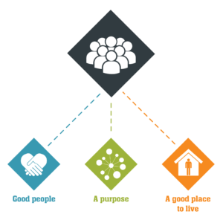
Catch22 is a social business which designs and delivers services that build resilience and aspiration in people and communities. We believe that people can thrive when they have a good place to live, good people around them, and a fulfilling purpose. We call these our '3Ps'.
All Catch22 services deliver at least one (and often all three) of these outcomes.
If you share our values and commitment to transforming people’s lives, get in touch!

Where you fit in
About Catch22’s Young People and Families (YPF)
Catch22 delivers a wide range of integrated support services designed to help resolve complex difficulties experienced by young people and their families/carers.
Support is provided to people who find themselves in a range of circumstances; they may be missing from home, at risk of exploitation or have emotional, housing or substance misuse issues. We also support families where parents/carers are experiencing substance misuse, emotional issues, homelessness or unemployment. Whatever the situation, we work alongside young people and their carers to reduce risk and build resilience to support them to stabilise their lives.

This role will involve working in close partnership with Corporate, Voluntary Sector and Public Sector organisations to promote and deliver our services and achieve the required outputs and outcomes.

You will be responsible for ensuring all services are demonstrating impact, are contractually compliant and meet Catch22’s reporting mechanisms. You will develop service provision to ensure best practice and leading-edge services are available to all service users.

You will be accountable for creating an environment in which staff are engaged and empowered to achieve greater impact and understand the strategic vision of Catch22.

You will proactively promote the values, aims and objectives of Catch22 and show understanding and commitment to the needs of service users and their local communities and how Catch22 YPF services can most effectively address these needs.

The successful candidate will work as part of our Senior Leadership Team, in partnership with the Business Development team and other Catch22 Hubs to provide subject matter expertise to assist in the identification & tendering of future contracts, thus enhancing and expanding our organisational footprint.

Ultimately, you will lead our teams to achieve our Young People and Families Strategy objectives.

Main Duties & Accountabilities
- To be responsible for a portfolio of Catch22 contracts within the Young People and Families Division.
- To provide strategic oversight and management of Catch22’s vision, aims and objectives alongside those of the customer/commissioner.
- To support the Director in the development and delivery of a growth plan appropriate to the opportunities and potential presented by their area of business.
- Through monitoring and management, to be accountable for the delivery of high quality, cost effective services in line with commissioner and organisational requirements.
- To implement Catch22 evidence based performance improvement systems and processes in order to continuously improve the efficiency and effectiveness of service delivery and organisational performance and ensure compliance with contractual requirements and standards.
- To ensure that effective performance and impact monitoring and management information systems are in place to support both contract compliance and organisational reporting requirements.
- To ensure that contractual and operational risks are effectively and transparently assessed and managed.
- To maximise the performance and contribution of staff in meeting set objectives through staff supervision, performance management, appraisal, training, consultation and service/team meetings.
- To assist the SLT in developing systems to ensure effective service delivery within an equal opportunities framework and promote anti discriminatory practice in all aspects of the work.
- To collaborate with service users to ensure that they are involved in co-creating the service so that it addresses their priorities and needs.
- To ensure that your professional awareness of best practice and service innovation is maintained and shared with all staff.
- To act as an ambassador for Catch22 upholding and promoting our organisational values
- To deliver organic growth from the service and funding base for which they have management responsibility – developing and maintaining local commissioner and stakeholder relationships and networks and ensuring that opportunities for Catch22 to grow are encouraged, promoted and acted upon.
- To inform and deliver a service-based development and growth plan as a part of a wider growth strategy, to manage and maximise the key relationships for which the post holder is responsible and the key opportunities it is agreed they will lead on.
- To ensure positive relationships and intelligence sharing with existing commissioners – acting to encourage growth opportunities and to ensure that Catch22 benefits from those.
- To identify opportunities to promote the work and achievements of Catch22 and its Service Users and progress these in consultation with the relevant media advisors in accordance with organisational policy.
- To recruit, coach, develop, motivate and manage the post holder’s direct reports in accordance with the Catch22 competencies and staffing policies and to ensure Catch22 Employment Policies are adhered to.
- To be accountable for the people management practices in their services, taking active steps to ensure that these reflect organisational policy and good practice, and that staff feedback is considered and acted upon where appropriate (e.g. Staff Surveys)

Organisational Relationships

- Reports to the Director of Young People and Families.
- Liaises closely with key stakeholders such as Trustees, Chief Officers, Directors, Assistant Directors, Service Managers, Employees, Volunteers, Commissioners, and Representatives of other local stakeholder groups.

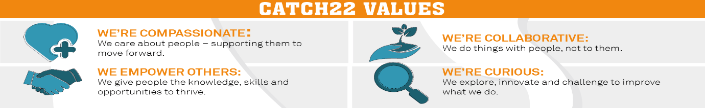

Job Title: Person Specification
COMPETENCY | ESSENTIAL | DESIRABLE | ASSESSMENT
QUALIFICATIONS / EXPERIENCE | Experience of delivering services in the Youth, Children’s Social Care Sector.  Experience of leading multi-site teams working with vulnerable children and young people.  Experience of planning and providing services to children, young people and families  Experience of working in partnership with commissioners, stakeholders/other providers and funders to deliver high quality services.  Experience of leading, engaging and motivating staff in a challenging organisational environment.  Experience of delivering local innovation within corporate frameworks  A track record of developing and using relevant management information/quality systems to ensure high levels of operational and contractual performance | A qualification in leadership and management (or working towards).  A qualification relevant to working with under-supported people.  Project Management experience and/or relevant qualification. | A, I  A, I  A, I
KNOWLEDGE | Understanding of the complexities of multi and inter-agency working  .  Knowledge and understanding of context and issues facing the young people & families that we work with  Knowledge and understanding of the legislative framework relevant to working with children young people and families  Knowledge and understanding of how business processes and infrastructure impact on organisational effectiveness and efficiency | An understanding of contracts and contractual practice in a service delivery environment | A, I  A, I  A, I  A, I  A, I
SKILLS & ABILITIES | Ability to work within an organisations policies and procedures, including those relating to health and safety, confidentiality and handling sensitive information  Excellent contract management, performance monitoring & business development skills  Excellent commercial, financial understanding and awareness  Ability to tailor communication style to engage different audiences  Proven ability to lead high performing teams |  | A, I  A, I  A, I  A, I
OTHER | Share Catch22 values  Awareness of and commitment to Equality & Diversity  Willing to travel and work flexibly  Desire to develop and undertake training as required |  | A, I

