Job Title
Job Description and Personal Specification
Job title: | People Team Systems Administrator
Place of work: | Hybrid/Brasted
Hours of work: | 25 hours flexible
Salary/Grade: | C
Reports to: | System Manager
Level of screening: | N/A

Who we are
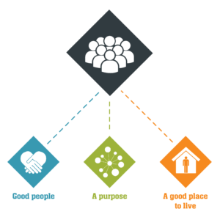
Catch22 is a social business which design and delivers services that build resilience and aspiration in people and communities. We believe that people can thrive when they have a good place to live, good people around them, and a fulfilling purpose. We call these our '3Ps'.
All Catch22 services deliver at least one (and often all three) of these outcomes.
If you share our values and commitment to transforming people’s lives, get in touch!

Where you fit in
About Catch22’s Corporate Services
Our corporate services in Catch22 include finance, IT, The People Team, Health and Safety (incorporating human resources, learning and development and employee relations), development (including business development, partnerships and communications). We service staff across the Catch22 hubs: Justice, Education, Employability and Skills and Young People and Families.
About the People Team
In this role you will be responsible for the day-to-day system administration and development of our integrated HR and Payroll system, iTrent (HouRS) whilst providing support and guidance to managers and staff on the effective utilisation of the system. Additionally, you will also support with the administration of any other HR systems such as Business Objects, SAC Analytics, the Reward Gateway, and Learning and Development system Moodle.

Main Duties & Accountabilities

HouRS (HR and Payroll)
- Acting as the first point of contact for all systems related enquiries:
- Notifying/discussing system problems, outages and bugs which need to be addressed by iTrent and escalating these accordingly.
- Providing technical advice, support and guidance to system users (e.g. log in issues) and be able to provide ad hoc training to users to resolve these issues
- Provide support on the effective management of the HouRS system by ensuring all organisational level system changes to processes are clearly documented.
- User account/role set up, maintenance and control:
  - Ensure all users have appropriate access to fulfil their role and functions within the system.
  - Ensure all new starters and leavers are given access / access withdrawn in accordance with SLA timescales.
- Security maintenance – ensuring any changes or creation of new security profiles work (ie are tested following any build or maintenance)
- To support with the performance of system upgrades, patches and fixes.
  - Liaise in a timely manner with Catch22 (HR, Payroll); and other Catch22 umbrella organisations respectively on the timing of patches/upgrades
  - Ensure relevant parties are aware of improvements/impacts of any upgrades e.g. new functionality, standard reports, etc.
  - Supporting with any post upgrade actions
- Data conversion – support Catch22 HR and Payroll with any data conversions required.
- Supporting with the timely implementation of annual general pay uplifts across various groups of employees and annual leave actions
- Support Catch22 HR and Payroll with the writing any complex workflows and business objects reports as and when required.
- Plan and carry out audits on the HouRS user base to ensure system integrity and security, ensuring that the output from the audit reports are reviewed and escalate any issues as appropriate.
- Support with training of HR team and other new starters within the organisation.
- Participate in special projects and perform additional duties as needed.
- Maintain data accuracy and quality within the system.
- Support with the completion of the Schools Workforce Census and liaise with administrators across the schools to get this completed.
- Be able to extract reports and data out of the HR system as requested.

Learning and Development Administration support

- Support with the creation of training courses within the HouRS system and create the associated zoom links and send out invites to the participants. Place the course details onto our Sharepoint site.
- Manage the uploading and removal of leavers from the Moodle training platform
- Monitoring of the Learning and Development mailbox, and respond to queries or direct to appropriate person
- Support with the creation of impact report when required and collate feedback stats and narrative
- To comply with Health and Safety policies and procedures.

Other

- Manage the uploading and removal of leavers from the Reward Gateway System and respond to queries
- Support with the administration and development of any other HR systems as required.
- To carry out such other relevant duties, as may be required and as are commensurate with the nature and grading of the post.

What does good look like for this role?

- Employees experience positive interactions with any questions or queries they raise, and these are resolved or appropriately signposted to resolve these
- The system is maintained and updated and reflects the current organisational structure, and employees are in the correct role in the structure and employee have the correct security profiles within the system. Ultimately to ensure that people are paid correctly and in a timely fashion
- Other systems within the People Team function and are supported

Organisational Relationships

- Reports to People Systems Manager
- Liaises closely with People Services and People Services team, & Payroll Manager
- Liaison with Catch22 HR, Payroll; and other Catch22 umbrella organisations.
- Liaison with all managers and staff within Catch22, both at Head Office and in the services.
- Liaison with relevant 3rd party suppliers

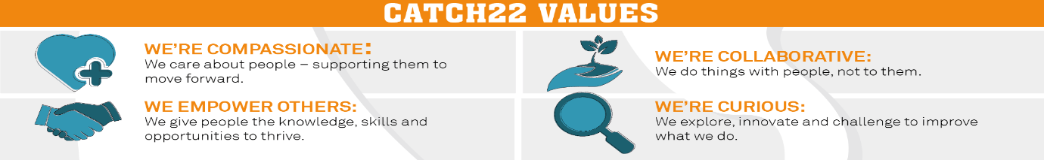

Job Title: Person Specification
COMPETENCY | ESSENTIAL | DESIRABLE | ASSESSMENT
QUALIFICATIONS | Level 2 qualifications including – English and Maths
KNOWLEDGE | Must be PC-literate and self-sufficient in the Microsoft 'Office' suite of products.  Knowledge of HR databases and business intelligence reporting tools at the highest level, and how they can be used to provide people data | Knowledge of HR and/or Payroll  Knowledge of SQL
EXPERIENCE | Experience of working with and maintaining HR and Payroll systems  Experience of providing help/support and technical guidance on HR systems to Users  Experience of maintaining system security profiles and passwords | Experience of supporting and configuring the following specific Business Systems:  - iTrent  - Business Objects  - Moodle  - maintaining reports  Experience of developing and implementing iTrent modules to meet operational requirements
SKILLS & ABILITIES | Ability to build and develop good working relationships at all levels and with external suppliers.  Excellent communication skills including ability to convey complex technical information to a range of audiences.  Ability to work in a systematic manner organising activity to meet deadlines, maintaining accurate records and able to resolve day to day conflicting priorities  A pro-active approach to work and ability to identify issues and inaccuracies quickly  Ability to review and document processes and procedures in order to find a technical solution  Ability to produce reports and management information  Pro-active, customer-focused and solutions-oriented  Able to work effectively under pressure.  Able to maintain confidentiality.  Willingness to work flexibly as required.
OTHER | Share Catch22 values  Awareness of and commitment to Equality & Diversity  Willing to travel and work flexibly  Desire to develop and undertake training as required

