Job Title
Job Description and Personal Specification
Job title: | Administrator / Receptionist
Place of work: | Community Links, 105 Barking Road, E16
Hours of work: | Sessional
Salary/Grade: | £10.94 (Grade C)
Reports to: | Faciliities Manager
Level of screening: | Enhanced DBS

Who we are
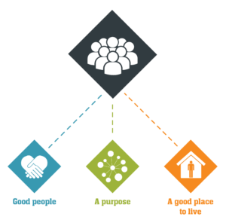
Catch22 is a social business which design and delivers services that build resilience and aspiration in people and communities. We believe that people can thrive when they have a good place to live, good people around them, and a fulfilling purpose. We call these our '3Ps'.
All Catch22 services deliver at least one (and often all three) of these outcomes.
If you share our values and commitment to transforming people’s lives, get in touch!

Where you fit in
About Community Links
Community Links is a hub tackling health and social inequality in East London and beyond. We work alongside the community helping people of all ages reach their full potential. We take our local knowledge of what works to influence national decision making. We are proud to be part of Catch22.
Mission - We work towards a world where your potential is not limited by your health or social circumstances.
Vision - We believe everyone can thrive if they have 3 basic things: good people around them, a good place to live and a purpose in life. We call these our 3Ps.
Values - Our ethos is to be driven by dreams and judged by delivery.
About the Administration / Facilities Team
You will be joining an energetic and passionate team with a fun but hardworking culture, all relentlessly committed to Community Links core mission and purpose. The Team is currently made up of four individuals; a Facilities Manager, Facilities Assistant and two Administrator / Receptionists. The ethic of the team is one of team work and collaboration – with the team covering for each other as necessary. Importantly, the reception at 105 Barking Road is the main conduit through which our 3,800 annual enquiries for advice and guidance come through, so the sessional reception will need to be emotionally resilient and compassionate when it comes to dealing with the challenges faced by members of the community.

Main Duties & Accountabilities

Reception
- Receive visitors to the organisation and inform the appropriate person of their arrival
- Basic assessment of clients requiring advice and/or form filling services and refer to relevant department or signpost to other agencies.
- By agreement with line manager, capture key information which may assist other teams in meeting their service level requirements.
- Ensure that all staff and visitors are signed in, to comply with health and safety procedures
- Maintain the tidiness and cleanliness of the reception and public areas
- Keep up to date on all services and events provided by the organisation to provide information to service users
- Process all mail Both incoming and outgoing
- Be responsible for receiving incoming calls in a friendly and professional manner
- Operate the switchboard ensuring all call are screened, answered promptly, announced and transferred to the appropriate person and messages are taken accurately and passed on
Administration
- support other Administrators with their day to day work
- Provide other directorates with administrative support as requested, including inputing client details into the relevant databases and booking appointments as instructed.
- Assist with maintaining stationery, beverage and cleaning supplies stock levels
- In the absence of the Facilities Assistant, action and monitor the facilities inbox and forward emails to the relevant department
- Update global email and telephone extension lists
- Responsible for the coordination of archiving documents and maintain archiving records for the whole organisation
- Support members of staff to use office equipment (printers and telephones)
- Ensure that all health and safety issues are reported and maintain fully stocked first aid boxes
- Provide induction of new staff in administrative functions.
Facilities
- Responsible for taking room bookings including furniture requirements, equipment and catering
- Cover daily housekeeping tasks for the facilities assistant in their absence
- Keep the internal and external notice boards tidy and updated
- Responsible for locking up of the building each night.

What does good look like for this role?

You will be someone who is customer-focused, reliable, punctual and with a positive ‘self-starter’ mentality.

Organisational Relationships

Community links are proud to be part of the Catch22 group. Catch22 exist to help build a society where everyone has a good place to live, good people around them, and a fulfilling purpose. We call these our '3Ps'.

We achieve this in two ways. We improve lives on the frontline through delivery of public services. Secondly, we use our knowledge to change 'the system', to fix the complex web that can trap and disempower those it was set up to help. With the heart of a charity and the mindset of a business, we are uniquely placed to deliver on this challenging agenda.

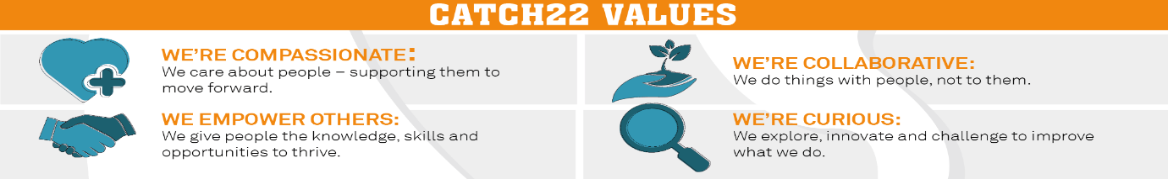

Person Specification – Administrator
Specification | Essential | Desirable
Relevant experience | - Experience of working with members of the public in a busy reception setting within a diverse community.  - Confidence and ability to deal with challenging individuals in person and over the telephone.  - Working knowledge of IT systems including Microsoft Office, in particular word, excel and outlook.  - Experience of working with databases and CRM software (customer relationship management software). | - Knowledge of issues affecting people living in Newham and/or east London  - Basic knowledge regarding welfare benefits, housing, debt and employment issues
Relevant skills/Aptitudes | - Ability to work flexibly to vary start and finish times to accommodate other administrators’ absence.  - Excellent interpersonal skills, both in person and on the telephone.  - Ability to work as part of a team, act on own initiative; prioritise own workload and the ability to work to tight deadlines  - Able to present a professional and positive image at all times  - Reliable time keeping and excellent time management skills  - Willingness to undertake training  - Ability to be resourceful, think creatively and willing to find solutions to own problems  - Ability to work alongside a wide range of people from different backgrounds  - Able to identify and troubleshoot problems, resolving them promptly and efficiently, demonstrating at all times excellent interpersonal and customer service skills.  - Confidence and ability to perform the locking up procedure alone in a large public building inside and out. | - Fluent in Bengali, Urdu, Hindi, Punjabi or African languages
Education/Training/ Knowledge | - A good general education | - First aid qualification  - Fire warden trained

