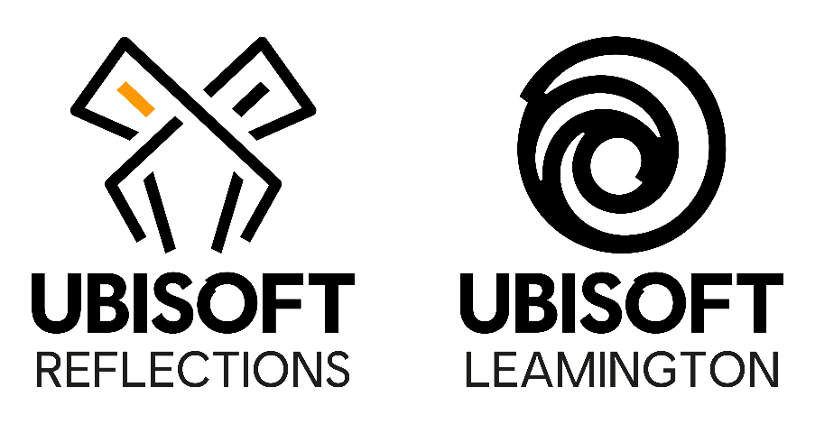
Junior Material Artist

Job Purpose
Deliver, with support, basic artistic content for the project and ensure that the integration of the work is in line with the project’s technical constraints and artistic direction.

Reports To
Lead Environment Artist

Responsibilities
- With guidance, assist in planning out the space, with consideration of narrative and visual storytelling, while documenting intentions;
- Create functional assets which can be shared across the project in respect of the technical and artistic constraints;
- Track and update the progress of day to day tasks using the designated tracking tools;
- Communicate and collaborate with key stakeholders to confirm task direction and consistency of own work;
- Ensure the technical and artistic quality of the project by collaborating with technical artists and senior artists and make changes when necessary;
- Implement and incorporate feedback from Art Director and Leads into work;
- Assist with optimisation and debugging to fix the issues raised by testers;
- Fully realise a space with the assets available to tell an interesting and varied story;
- Reference game design documents to develop an understanding of the environments, objectives, atmospheres, story and style of the project;
- Develop an understanding of project tools and their functions, the project file classification system and the process of updating engine data;
- Develop an understanding of best practices, production pipelines and workflows;
- Support the Lead Environment Artist in any ad hoc tasks and duties.

Skills and Knowledge
- Good interpersonal and communication skills;
- Ability to create interesting, detailed and visually appealing materials;
- Ability to adapt to new processes and pipelines;
- Working knowledge of industry leading 3D modelling packages and techniques;
- Understanding of composition visual story telling;
- Knowledge of level editors;
- Understanding of Physically Based Rendering systems;
- Familiarity with data management software (such as Perforce) is desirable;
- Basic gameplay and level design knowledge is desirable;
- Knowledge of optimisation techniques (e.g. 3D Studio Max);
- Knowledge of the video game industry and awareness of typical video game development processes is desirable;
- Exposure to industry game engines and production pipelines is desirable.

Relevant Experience
- Experience working with materials in a 3d or game environment or other relevant experience;

