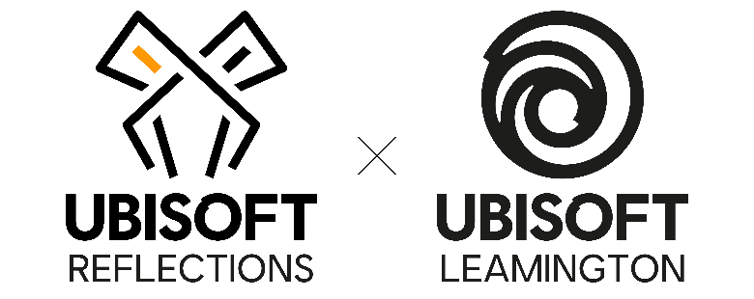

LEAD ANIMATOR
Job Purpose
Lead, mobilise and develop an animation team within a collaborative, multidiscipline environment; define and track the schedule for the team, manage and mentor team members, and be a key player in the artistic style of the project.
Reports To
Studio Art Manager
Direct Reports
Members of the animation team at all levels
Leadership Responsibilities
- Build an effective team to ensure it is fully resourced, a manageable size and a good mix of levels and foster the team player culture.
- Plan, prioritise and set inspiring objectives for your team members all year long.
- Contribute toward project and milestone planning with production and other relevant stakeholders.
- Empower your team members with clear expectations and hold them accountable for their key results.
- Provide your team members with ongoing and meaningful feedback on performance and development.
- Engage and positively influence team members and stakeholders around a vision.
- Navigate through ambiguity and embrace change with a positive mindset.
- Create the environment for initiatives and ideas to emerge and grow.
- Be inclusive, empathetic, flexible and care about people.

Job Responsibilities
- Support the Animation Director by executing on the creative vision and with the creation of an Art Bible and Style guild.
- Ensure the best-in-class art in accordance with the project's animation & artistic direction and production timelines.
- Be the main contact for Animation with the project and its partners.
- Cultivate the team with timely feedback, growth and development and training opportunities.
- Work in close liaison with all disciplines fostering synergies between departments and individuals.
- Conduct performance reviews and participate in interviews and ensure proper staffing and team make-up.
- Identify and set up the best workflow and pipeline practices.
- Find resourceful solutions to any problems encountered.
- Work with your respective Production representative to help inform planning, schedules, and strategies by levering the knowledge you hold in your specialist area.
- Conduct any ad-hoc tasks when required.

Skills and Knowledge
- Strong working knowledge of relevant software (e.g. Maya, Motion Builder etc.)
- Knowledge of industry game engines and production pipelines.
- Excellent knowledge of animation principles and how to apply them effectively.
- Familiarity with animation state graphs.
- Experience editing mocap data, (understanding and/or using) of in-house mocap capture solutions and directing mocap shoots.
- Ability to adopt and effectively communicate using different styles when working with
team members across the world with various cultural backgrounds.
- Good knowledge of scheduling and team tracking software and techniques (Jira etc).
- Exemplary written, interpersonal and communication skills.
- Strong leadership, team building and people management skills.
- Strong emotional intelligence.
Relevant Experience
- Experience in a team with direct line management.
- Relevant training in animation or equivalent.

