MID-TERM REVIEW CRAFT
TERMS OF REFERENCES

1. Purpose of the Review
The Project Mid-Term review will be carried out for the Climate Resilient Agribusiness for Tomorrow (CRAFT) consortium, led by SNV as lead implementing agency and will provide an advisory and possible curative action to all the CRAFT consortium partners and the Netherlands Ministry of Foreign Affairs (DGIS), the donor of the CRAFT project. CRAFT is a flagship program in climate adaptation and aims to inform the DGIS with results on policy directions for the integration of climate change effects in private sector development/agriculture sector development programs.
The main objective of the MTR is to: -
- To assess whether project strategies are appropriate and leading to the expected results. Validating project design and implementation approach being a climate flagship program.
The specific objectives of the MTR of CRAFT are:
- To identify project strategies that can be scaled in the existing value chains / replicated in other value chains
- To assess if the collaboration between the consortium partners is effective
- To assess the extent to which the project is reaching its targets, how feasible were these in the first place and recommendations for how CRAFT could ensure to meet those targets (within project timeline or possible extension) and ensure the sustainability of results.
- To assess the impact of COVID-19 pandemic on project implementation and results.
The mid-term review will look at project progress and results, based on an assessment (assessment of project data/reports), stakeholder consultations and discussions with project staff, consortium partners and project participants (mainly the Small Medium Enterprises (SME), cooperatives and farmers involved with CRAFT through the Climate Innovation Investment Facility (CIIF)).

1.1 Background to the CRAFT Project
In May 2018, the Netherlands Ministry of Foreign Affairs/DGIS awarded SNV (Netherlands Development Organization) the Climate Smart Agriculture East Africa (CSA-EA – now known as the CRAFT) project to be implemented in Kenya, Tanzania, and Uganda (Activity #4000000819). This five-year project, valued at approximately €36 million, is implemented by SNV in partnership with Wageningen University (WUR) and Wageningen Environmental Research (WEnR), CGIAR’s Climate Change Agriculture and Food Security Programme (CCAFS), Agriterra, and Rabo Partnerships (RP).
The project is expected to leverage at least €10 million in additional private sector investment.
On the onset of the global COVID-19 pandemic in 2020, €3 million of the obligated funding was repurposed to support the implementation of the CORE-Africa initiative (COVID-19 Response & Resilience Initiative for Food Value Chains in Africa).
The CRAFT project aims to achieve the following objectives: -
- Increasing production and income for 300,000 smallholder farmers (30% of which are youths and women) through adoption of Climate Smart Agriculture (CSA) practices & technologies in arable crop production farming systems
- Improve business performance for 50 agribusiness SMEs and 30 cooperatives (25% of which are managed by youths and women) through accelerating investments and business growth in selected value chains
- Promote climate resilient and sustainable food production on 600,000 Hectares by creating an enabling environment for scaling out Climate Smart Agriculture practices.
The project shall achieve its objectives by delivering the following:
- Promoting use of climate smart practices and technologies for farming systems and SMEs
- Promoting an enabling environment for development and scaling climate-smart technologies and practices
- Promoting (climate smart) investments in inclusive value chains
- Promoting learning and knowledge sharing
- Gender/youth inclusion.

1.2 Project approach / workstreams
The implementation strategy of CRAFT is based on complementary interventions at three levels: (a) farming systems, (b) inclusive value chains, and (c) the enabling environment. Technical assistance and interventions meant to target key stakeholders (farmers, SMEs, cooperatives, private sector, financial institutions, government agencies, etc.) through five (5) different workstreams that guide implementation process to achieve expected results at output, outcome, and impact level.
The five highly interrelated workstreams are:
1. CSA Practices and technologies for resilient farming systems & SMEs.
2. Climate smart Investments in inclusive value chains.
3. Enabling environment for development and scaling of CSA.
4 Learning and Knowledge sharing (cross-cutting).
5. Gender & Youth inclusion (cross-cutting).

Work stream one: CSA Practices and Technologies for resilient farmer systems and SMEs
The CRAFT teams in the three countries work with selected SMEs, cooperatives, and smallholder famers to test and facilitate the introduction of CSA practices and technologies and build the capacity of various value chain actors to ensure they are better able to cope with or adapt to the impacts of climate change.
Description of CIIF projects

This was done by developing – jointly with CCAFS - an inventory of CSA practices and technologies appropriate for each value chain and ecological zone, developed training manuals and conducted field training by awareness creation, and continued adoption through farmer field schools (FFS), demonstration sites as well as training by local service providers (LSPs) in the form of training of trainers (ToT). Available climate smart practices and technologies need to be backed by sound farm and business economics (‘farming as a business’) and financing options. A supportive service and market system around the farmer and his or her crop(s) is crucial, as are effective enablers for SMEs and the wider value chain.
A wide range of climate smart practices and technologies already exists and has been developed in past years by agricultural research institutes and private sector partners. At the level of the farming system, they can include techniques, tools and technologies on improved soil management, crop production, water management, (agro-) forestry and energy management, among others. Also, for SMEs, a range of options exist to climate-proof their value chains. Their application and implementation at scale in concrete producing areas and for concrete farming systems and value chains, however, remains limited. Through this workstream, the programme partners will address the main barriers for adoption of climate smart technologies and approaches by smallholders and SME’s.
Work stream two: Climate Smart Investment in Inclusive Value Chains
The CRAFT project is a private sector-led agribusiness intervention focused on promoting viable business cases that are climate smart, scalable, inclusive and have clear value proposition to all stakeholders with ultimate beneficiaries being the smallholder farmers.
The CRAFT Project country teams conduct business and financial management trainings to selected SMEs following a credible capacity gap assessment. Agriterra supports with capacity building of cooperatives through capacity building efforts/training sessions that target the most common weaknesses cooperatives are confronted with – based on the scoping and assessments outcomes. This helps in preparing the cooperatives for investment readiness as well as providing support during the implementation of the approved business plan.
Following the Climate Risk Assessments (CRA) (link to example CRA Kenya) and different stakeholder workshops held during the inception phase (by crop and by country), several VC stakeholders manifested themselves in having a keen interest in engaging in and collaborating with business cases on climate smart interventions. As such, selected SMEs are supported to generate competitive business concepts, through a co-creation process. Depending on their level of engagement, positioning in the value chain, and needs, some are considered for development as partnership to the business champion of a particular business case, yet others evolve into stand-alone business cases and are considered to benefit from the Climate Innovation Investment Facility (CIIF).
SNV takes the lead and front lines communication with business champions (BCs) during the co-creation and implementation phase of the business cases. RABO partnership - in collaboration with all partners- leads the awareness raising among financial institutions (FIs) on the impact of climate changes on their portfolio to encourage investments in climate smart interventions.
Work stream Three: Enabling Environment for Development and Scaling of CSA
An initial study and review of existing services, products and providers was undertaken by CCAFS during the inception phase. This indicated that more in depth knowledge is needed to ensure that climate information service providers indeed better respond to user needs. The project team (WEnR and CCAFS) proposed to identify and promote innovations that target existing weather/ climate information services to meet users’ interest that facilitate access to credible weather/climate information services and index insurance and other bundled up services integrated in private sector-led business models that are competitive and sustainable. SNV and Agriterra supports partnership development between service providers and business case champions, as well as cooperatives and other climate information users, as an integral component for the inclusive business case development approach.

Workstream four: Learning and Knowledge Sharing.
Knowledge sharing and learning are cross-cutting elements of the CRAFT project. To inform the scaling of practices, technologies, approaches, and methodologies that have proven to be successful. Two PhDs trajectories ongoing on adoption and impact of CSA interventions.

Workstream five: Gender and Youth Inclusion.
Cross-cutting throughout the project workstreams and activities is the drive towards gender equality and creating better income and employment opportunities for rural youth. The project takes the different knowledge levels, perspectives, needs, risk levels and challenges of male, female and young farmers and entrepreneurs as a starting point in its interventions with each group through the project GESI strategy.

1.3. The Climate Innovation and Investment Facility (CIIF)
Majority of SMEs, Cooperatives and other actors involved in staple food value chains face challenges in accessing and acquiring climate smart technologies. Without access to appropriate funding, the SMEs, Cooperatives, and smallholder farmers are prevented from making productive investments in climate change resilience and adaptation. Many SMEs and Cooperatives are highly exposed to financial risks, and do not take the additional step to investing in basic climate smart infrastructure, agronomic technologies, and other production related practices for their smallholder farmer out grower base ensuring the sustainable production of climate resilient foods.
The CIIF is an important tool to drive investments in the climate smart agriculture. The CRAFT project supports SMEs and Cooperatives who are collectively engaging smallholder farmers and promoting inclusion linked to climate smart agriculture innovations and solutions - as part of their business model to be more responsive to the wider market system.
Recognizing that the legacy of these business partnerships lies in their sustainability, the project places strong emphasis on the strategic approach to partnerships - one that focuses on relationship building with organizations that have the capacity to reach small holder farmers at scale. The CRAFT team invests time in a co-creation exercise to develop climate smart, scalable, and inclusive business ambitions of business champions and their collaborating businesses.

1.4 Focus countries and focus crops
Following the May 2018 and May 2019 inception period, the project embarked on a full implementation phase. Focus was on integrating climate smartness value chains selected in each of the three countries of East Africa by engaging different SMEs/private sector entities and Cooperatives collaborating with various stakeholders upstream and downstream the targeted value chains to address the effects of climate change on their business. The districts of operation per country is in the appendix. The value chain focus per country is as follows:
Kenya: Potato, Sorghum, Green gram, and Common beans
Tanzania: Potato, Sunflower, Sorghum and Beans
Uganda: Sunflower, Sesame, Potato and Soybean

1.5 Theory of Change
The CRAFT Theory of Change (ToC) (see attached ToC for CRAFT) explains how a given intervention or set of interventions are expected to lead to a specific development change. The Theory of Change exemplifies three interrelated Impact pathways.
Each impact pathway links field interventions to immediate outcomes resulting from field interventions and moving towards intermediate outcomes and then impact. The Theory of Change makes the assumptions explicit that underly the pathways. These assumptions could hold true or change as the context changes or when results are being achieved. Regular reflection and updating of the ToC take place to ensure that such contextual changes and emerging opportunities are adjusted to in the project strategies.
The project results framework is directly linked to the ToC, as it assesses project implementation in direct relationship to progress in achieving results, at the outputs, outcomes, and impact levels. The results framework integrates intermediate results, sub-intermediate results, and indicators from DGIS, national level, but also those derived from the Project Proposal. In addition, a number of custom results and indicators were developed that aims for performance results reporting and indicator monitoring for achievements specific to the implementation of the project.

1.6 Diversified partnership portfolio
CRAFT considers two levels of partnership i.e., Business Champions, and Partnership within consortium partners.
Business Champions: Business champions are SME’s and Cooperatives, which aim to strengthen market access by developing new marketing strategies or distribution channels to serve existing and new consumer segments especially farmers. CRAFT’s role is to technically support Business Champions climate financing efforts and ensure development of bankable Business Plans.
Consortium partners: All consortium partners provide technical expertise and strategic input on the fine tuning of the different tools to ensure that key project concepts relating to climate smartness, inclusiveness and financial viability of businesses, opportunities for scaling, as well as gender and youth mainstreaming are systematically integrated

1.7 Adaptive management
At the centre of CRAFT’s CIIF approach is the concept of adaptive management—a learning process that allows the project to build on successes, learn from failures, learn from responding to shocks of COVID-19 and making timely evidence-based course corrections to improve outcomes. Success factors from continuous learning allow the project to constantly evolve and pivot in response to the needs of private sector, while also promoting scalability, sustainability, and inclusion, and staying grounded.

2. Midterm Evaluation Focus.
The mid-term evaluation will answer the following specific evaluation questions: -
Relevance:
- To what extent has CRAFT addressed Climate Change (CC) adaptation constraints, addressed CC risks and capacities within the respective value chains at different levels (SME, Cooperatives, SHF, SP)?
- Assess the choice of crops to work on, to what extent are the selected crops relevant to the farmers? And assessing the choice in relation to the effects of climate change on the selected crops.
- Assess how the project chose business champions, and partners in the light of the scaling climate smart value chains.
- Are the CS strategies responding to the needs and challenges in the market systems?
Effectiveness:
- To what extent have the planned outcomes and (strategic) objectives of the project been achieved thus far?
- Identify barriers that limit the project to achieve its expected targets and results.
- Validate contribution by the consortium partners to the overall results, the effectiveness and value of the collectivity. How have the Consortium Partners progressed in as far as implementing their scope of work, and how have they taken advantage of their expertise to reach optimum results?
Efficiency:
- How was the project able to adapt its intervention strategies to the changing conditions as a result of COVID-19?
Impact:
- Validate the feasibility of achieving the targets, project outcomes and impact within the remaining project time frame? Assess how realistic the targets are at BC level, paying attention to the effects of COVID-19?
- What are the effects of the project so far; intended or unintended, positive, or negative, short term and/or long term? To what extent are these effects in line with the impact the project aims to achieve?
Sustainability:
- Assess the extent to which the interventions and benefits of the project, through the business case will continue by the Business Champion, service providers and farmers?
Gender mainstreaming:
- To what extent was the design and implementation of the intervention gender and youth responsive?
Scalability:
- Assess the potential within the value chains for Agribusinesses (SME and Cooperatives) for wide-scale adoption of climate smart practices in selected crop and specific value chains, or other scaling possibilities?
- To what extent can CRAFT intervention strategies influence country policy/strategies.
- Under which conditions are the CRAFT approaches replicable in other countries or value chains?
Learning:
- Identify best practices and lessons learned. Based on project successes or failures, identify areas where knowledge generation and sharing are required and the right channels for knowledge sharing.
- Assess the contribution of the PhDs to the project’s learning.
- Validate the updated project theory of change (ToC) and determine if it provides the most effective route towards expected results.
- To what extent does the CRAFT project intervention strategies score against the Rio climate marker.
- How to strengthen the exit strategy of the project, ensuring sustainability, when to ideally exit as a program (is the current timeline sufficient for sustainable results?)
- How does the project make use of the available knowledge in-country or internationally and other initiatives in the field of CSA and value chains initiatives funded by others, CSA research initiatives in the same countries or regions?
Coherence:
- What is the coherence between this project and other initiatives in the field of CSA and value chains (even non-CS value chains) in the three countries? (Other Dutch FS initiatives, CSA and VCD initiatives funded by others, CSA research initiatives, in the same countries or region).

3. Approach and methods
The Consultant Team will visit the three countries and interact with 4 Business champions per country (2 on boarded early 2019/20 and 2 onboarded in 2021 Jan to June, a mix of SME, Coop and Service Provider, and divided over the different VC’s) and 2 Business Cases’ partners per country for indepth interviews. However, the Consultant Team will interact with all business champions in the three countries through an (online) focus group discussion. The selection criteria of focus-BC’s to be determined during inception phase.
The Mid-Term review should include, but not be limited to, the above-mentioned methods. The OECD DAC Evaluation Quality Standards will be applied, meaning: all data of beneficiaries will be collected and interpreted in a sex and age disaggregated manner and will be treated confidentially. It is expected that the bidder develops a proposal that has a low environmental footprint and takes the different restrictions under COVID-19 into account.
The consultant should propose the methodology to be used to carry out the review. The proposed methodology should address sufficiently the preliminary issues and questions in the ToR, specifying the methods of data collection and data analysis that will be undertaken. It should encompass a combination of both qualitative and quantitative methods. It should also allow for wide consultation with partners and stakeholders. Consultants must propose their own methodology and justify it. The mid-term review will consist of the following: -
a) Desk study: Both public and internal documents are to be reviewed. Including, but not limited to:
- CRAFT results frameworks and Theories of Change
- CRAFT proposal 2018
- Public appraisal memos and grant decision of DGIS
- CRAFT offer document
- CRAFT annual plans, thematic strategies, and scoping reports
- CRAFT knowledge products (e.g. CRA, info notes, Climate and Business narratives, etc)
- CRAFT CIIF protocol, Partnership Agreements, Description,
- CRAFT Annual reports
- CIIF Manual and guidelines
- CRAFT M&E Plan and guidelines
- CORE-Africa Service Delivery Model assignment reports
- Review of indicators achieved to date to compare with expected targets
b) Interviews and Focus group discussions will be conducted with:
- Country team leads, partnership facilitators, consortium management and other program staff (in country and HQ)
- Business champions, producer organization, smallholder farmers, service providers, local government representatives and other value chain actors,
- Policy offers at the Ministry of Foreign Affairs and Dutch embassies,
- Supportive Partners, knowledge institutes, NGOs, financial service providers etc.
- As well as external experts (e.g., from CCAFS, WUR, 2Scale, CORE, DFCD).
c) Field Visits:
- 4 Business champions per country (2 on boarded early 2019/20 and 2 onboarded in 2021 Jan to June)
- 2 Business Cases’ partners (including a processor, service provider and agro-input dealer) per country
- 2 Farmer groups per Business champion, giving a total of 8 Farmer groups per country.
- Local government representatives in each of the districts the 4 Business Champions are operating in.
- Relevant national stakeholders in the countries.

4. Deliverables and planning
The assignment should be completed by mid-April 2022 with the following expected outputs:
- Inception report
  - A comprehensive description of the consultant’s understanding of the ToR
  - A detailed methodology for the MTR including tools to be used
  - The proposed team members and a description of their roles
  - A complete work plan for the MTR
  - Detailed proposal for field activities in the three countries, including a COVID-19 risk mitigation plan
  - A proposal for the final layer out of the Report
- First Draft Report
  - First draft report with first findings of the desk study and interviews will be presented to SNV for review and discussion with the reference group.
- Second Draft report:
  - Easily readable, not exceeding 40 pages.
  - Input from the refence group incorporated into the report by the consultant.
  - Include concrete future looking recommendations and answering the specific research questions mentioned in the ToR.
- Final report:
  - Incorporating recommendations from the 2nd reference group meeting
  - Detailed MTR report covering items outlined in the scope of this ToR with special attention to key findings, conclusions, lessons learned and recommendations. The final payment will be paid upon submission of high quality and acceptable MTR report.

Planning CRAFT Mid-Term review
Period | Activity
2021
November 17 | Receive Request for proposals (both technical and financial) from researchers (companies or group of consultants)
 | Review all proposals and selection of 2 or 3 consultant companies to be assessed by the Evaluation Committee against the Evaluation Criteria
 | Selection of winning proposal and signing of contract
December 1 | Intake with evaluation team, develops the Inception Report.
 | Evaluation team starts desk study and inception phase
December 15 | Deadline inception report and proposed field Work plan
 | Reference group meeting
 | Evaluation team starts field activities in Kenya, Tanzania, and Uganda
28 February 2022 | Deadline First Draft Report
15 March 2022 | Deadline Second draft report
 | Reference group meeting
15 April 2022 | Deadline final report

MTR Organization
The reference group for this MTR will consist of representatives of the SNV, representative of consortium partners and DGIS.
The reference group will provide input to the client (SNV and consortium partners) and the researchers at 2 strategic moments: in the middle (to give feedback on the first findings of the literature review and the plans for field studies) and at the end (to give feedback on the final draft report).
The CRAFT Multi-country Monitoring Evaluation Learning Advisor, is the main contact person from SNV for this assignment, meaning overall responsibility and accountability for the Mid-Term review; guidance throughout all phases of execution; approval of all deliverables and co-ordination of the reference group.
The Regional Project manager CRAFT will be the contact person from the CRAFT consortium for this Mid-Term review and will give the researchers access to all relevant documents and data systems, link them to responsible colleagues and introduce them to implementing partners.

Budget and assessment criteria
The Mid-Term review will be conducted by an independent evaluation team selected. The total budget proposed include all costs related to the assignment (plus VAT), however, excluded travel and logistical costs (paid directly by SNV).
The assessment criteria are the quality of the evaluation team, the technical proposal and budget. There is a ‘minimum requirement’ of at least 50% of total score for any applicants to be considered.

Assessment criteria |  | Weighting  factor
1 | Evaluation team |  | 40%
a |  | Expertise of international team leader
b |  | Expertise of other international team members
c |  | Expertise of local team leader / members
d |  | Explanation of how team composition and available expertise (excluding methodology) will guarantee results
2 | Methodology: technical proposal |  | 50%
a |  | Explanation of evaluation approach and methods
c |  | Implementation plan and calendar
d |  | Explanation of who is responsible for which aspect of the consultancy execution
3 |  | Price: financial proposal | 10%

Requirements
Applications are welcome from consultancy firms or group of consultants. Consultants should have international experience in the agri-business sector including climate change related assignments. Good knowledge of agribusiness development, Climate Change, and Inclusive business models and a broad network. Experience in the countries where CRAFT is active and excellent analytical and writing skills.
The proposed consultant team is expected to have a multi-disciplinary team with a team leader. The Team leader requires expertise in the technical areas listed above as well as expertise and demonstrated experience in designing evaluation methodology and data collection tools and demonstrated experience in leading similar reviews/evaluations.
The MTR team will comprise of both senior and more junior experts, including nationally based consultants with the following expertise:
1. A senior level team leader who will lead the overall coordination of the mid-term evaluation and timely submission of deliverables to SNV. The team leader is expected to have at least 15 years of relevant experience in PPP partnering processes, inclusive agribusiness, climate change and policy advise in Africa.
2. A technical consultant with at least 5 years’ experience specialized in inclusive agri-business development and climate change preferably in Africa.
3. At least 3 National consultants with PPP partnering processes, inclusive agribusiness development expertise, climate change knowledge and the right local networks.
The MTR team leader is responsible for: 1) conducting the review; 2) the day–to–day management of assignment; 3) fair and transparent interaction with the program; 4) regular progress reporting to SNV; and 4) production of deliverables in accordance with contractual requirements.
For a firm, the following must be attached
- Registration documentation
- Firm/company constitution (memos and articles of association/company’s act)
- Valid trading License
- C.V.s of proposed team members showing education, employment, or consultancy background.

Submission of proposals
For proposals to be eligible they should include:
➢ A technical proposal.
➢ A financial proposal in Euros
➢ At least two references of work done in the past 3 years.
➢ A list of relevant previous assignments conducted in the past 3-5 years and two sample reports.

Deadline for submission:
The submissions for proposals from qualified consultants will close on 17th November 2021

Annex 1: TOC CRAFT

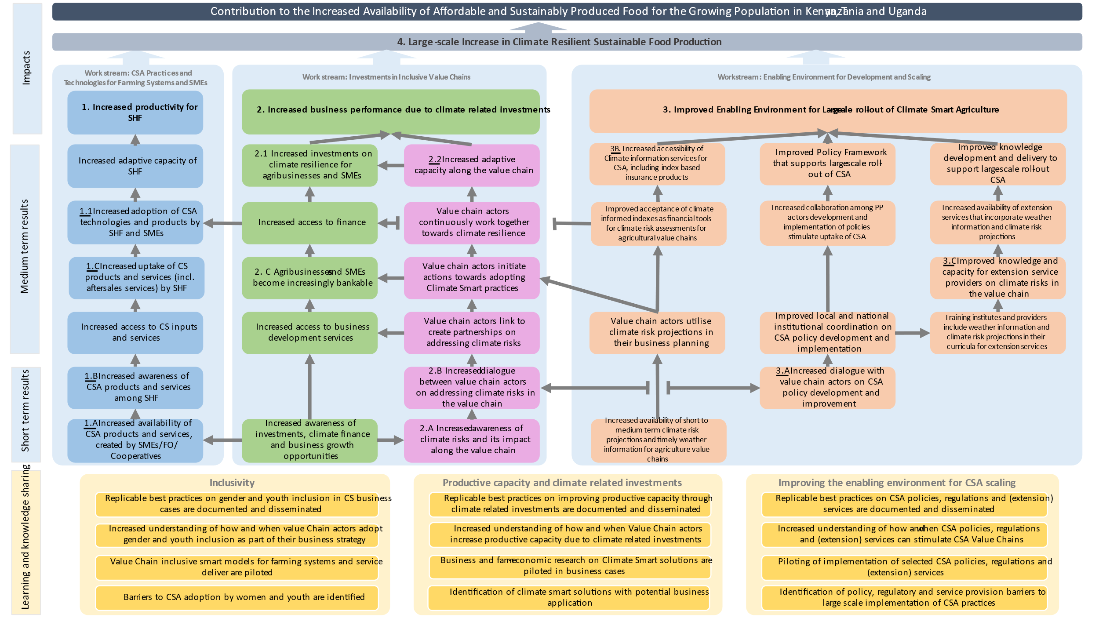

Annex 2: CRAFT Project Areas of Operation

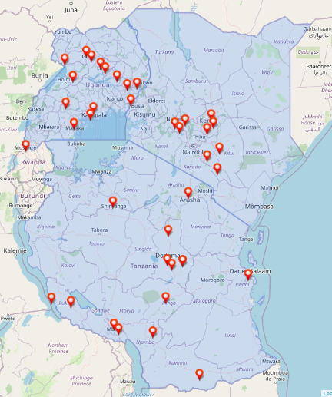

Initial fund allocation was €39 million for CRAFT.
The CORE-AFRICA project, implemented by SNV, aims to strengthen responses to the COVID-19 situation through nine DGIS (Directorate-General for International Cooperation) -funded projects across Africa (including CRAFT), and to capture lessons for interventions and policies more broadly. CORE Africa is not included in the scope of this review.
See: revised-evaluation-criteria-dec-2019.pdf (oecd.org)
Depending on the contracting date

